

University of Central Florida [STARS](https://stars.library.ucf.edu/)

[Electronic Theses and Dissertations, 2004-2019](https://stars.library.ucf.edu/etd)

2012

The Impact of Degraded Speech and Stimulus Familiarity in a Dichotic Listening Task

Anne M. Sinatra   
University of Central Florida

 Part of the [Psychology Commons](http://network.bepress.com/hgg/discipline/404?utm_source=stars.library.ucf.edu%2Fetd%2F4686&utm_medium=PDF&utm_campaign=PDFCoverPages)   
Find similar works at: <https://stars.library.ucf.edu/etd> University of Central Florida Libraries [http://library.ucf.edu](http://library.ucf.edu/)

This Doctoral Dissertation (Open Access) is brought to you for free and open access by STARS. It has been accepted for inclusion in Electronic Theses and Dissertations, 2004-2019 by an authorized administrator of STARS. For more information, please contact [STARS@ucf.edu](mailto:STARS@ucf.edu).

STARS Citation   
Sinatra, Anne M., "The Impact of Degraded Speech and Stimulus Familiarity in a Dichotic Listening Task" (2012). Electronic Theses and Dissertations, 2004-2019. 4686.

[https://stars.library.ucf.edu/etd/4686](https://stars.library.ucf.edu/etd/4686?utm_source=stars.library.ucf.edu%2Fetd%2F4686&utm_medium=PDF&utm_campaign=PDFCoverPages)



THE IMPACT OF DEGRADED SPEECH AND STIMULUS FAMILIARITY IN A DICHOTIC LISTENING TASK

by

ANNE MARIE SINATRA   
M.A. University of Central Florida, 2010   
B.S. University of Central Florida, 2006

A dissertation submitted in partial fulfillment of the requirements for the degree of Doctor of Philosophy   
in the Department of Psychology   
in the College of Sciences   
at the University of Central Florida   
Orlando, Florida

Spring Term   
2012

Major Professor: Valerie K. Sims

© 2012 Anne M. Sinatra

ii

**ABSTRACT**   
 It has been previously established that when engaged in a difficult attention intensive task, which involves repeating information while blocking out other information (the dichotic listening task), participants are often able to report hearing their own names in an unattended audio channel (Moray, 1959). This phenomenon, called the cocktail party effect is a result of words that are important to oneself having a lower threshold, resulting in less attention being necessary to process them (Treisman, 1960). The current studies examined the ability of a person who was engaged in an attention demanding task to hear and recall low-threshold words from a fictional story. These low-threshold words included a traditional alert word, ―fire‖ and fictional character names from a popular franchise—*Harry Potter*. Further, the role of stimulus   
degradation was examined by including synthetic and accented speech in the task to determine how it would impact attention and performance.

In Study 1 participants repeated passages from a novel that was largely unfamiliar to them, *The Secret Garden* while blocking out a passage from a much more familiar source, *Harry Potter and the Deathly Hallows.* Each unattended *Harry Potter* passage was edited so that it would include 4 names from the series, and the word ―fire‖ twice. The type of speech present in the attended and unattended ears (Natural or Synthetic) was varied to examine the impact that processing a degraded speech would have on performance. The speech that the participant shadowed did not impact unattended recall, however it did impact shadowing accuracy. The speech type that was present in the unattended ear did impact the ability to recall low-threshold, *Harry Potter* information. When the unattended speech type was synthetic, significantly less *Harry Potter* information was recalled. Interestingly, while *Harry Potter* information was

iii

recalled by participants with both high and low *Harry Potter* experience, the traditional low-threshold word, ―fire‖ was not noticed by participants.

In order to determine if synthetic speech impeded the ability to report low-threshold *Harry Potter* names due to being degraded or simply being different than natural speech, Study 2 was designed. In Study 2 the attended (shadowed) speech was held constant as American Natural speech, and the unattended ear was manipulated. An accent which was different than the native accent of the participants was included as a mild form of degradation. There were four   
experimental stimuli which contained one of the following in the unattended ear: American Natural, British Natural, American Synthetic and British Synthetic. Overall, more unattended information was reported when the unattended channel was Natural than Synthetic. This implies that synthetic speech does take more working memory processing power than even an accented natural speech. Further, it was found that experience with the *Harry Potter* franchise played a role in the ability to report unattended *Harry Potter* information. Those who had high levels of *Harry Potter* experience, particularly with audiobooks, were able to process and report *Harry Potter* information from the unattended stimulus when it was British Natural. While, those with low *Harry Potter* experience were not able to report unattended *Harry Potter* information from this slightly degraded stimulus. Therefore, it is believed that the previous audiobook experience of those in the high *Harry Potter* experience group acted as training and resulted in less working memory being necessary to encode the unattended *Harry Potter* information.

A pilot study was designed in order to examine the impact of story familiarity in the attended and unattended channels of a dichotic listening task. In the pilot study, participants shadowed a *Harry Potter* passage (familiar) in one condition with a passage from *The Secret*

iv

*Garden* (unfamiliar) playing in the unattended ear. A second condition had participants shadowing *The Secret Garden* (unfamiliar) with a passage from *Harry Potter* (familiar) present in the unattended ear. There was no significant difference in the number of unattended names recalled. Those with low *Harry Potter* experience reported significantly less attended   
information when they shadowed *Harry Potter* than when they shadowed *The Secret Garden*.

Further, there appeared to be a trend such that those with high *Harry Potter* experience were reporting more attended information when they shadowed *Harry Potter* than *The Secret Garden*.

This implies that experience with a franchise and characters may make it easier to recall information about a passage, while lack of experience provides no assistance.

Overall, the results of the studies indicate that we do treat fictional characters in a way similarly to ourselves. Names and information about fictional characters were able to break through into attention during a task that required a great deal of attention. The experience one had with the characters also served to assist the working memory in processing the information in degraded circumstances. These results have important implications for training, design of alerts, and the use of popular media in the classroom.

v

**ACKNOWLEDGMENTS**   
 There are a number people that I would like to acknowledge that helped me get to the point that I am at today. My advisor, Dr. Valerie Sims has provided me with an amazing amount of support over my time in graduate school. She is a fantastic mentor, and has a wonderful ability to make sense of complex concepts. I have greatly enjoyed my time working with her and Dr. Matthew Chin in the Applied Cognition and Technology lab. It has been wonderful having two mentors, and I appreciate the help and guidance he has provided me. Further, I would like to thank Dr. Kimberly Renk, who I worked with as an undergraduate. She has always been a fantastic mentor, and it has been wonderful to work with her again recently. I would also like to thank the rest of my dissertation committee, including Dr. Peter Hancock and Dr. James Szalma. Their comments, suggestions, and encouragements have been extremely important and helpful to me as I have been going through the dissertation process.

I cannot even come up with words to express how thankful I am to my parents. Without their support and encouragement I would not have achieved my goal of completing my dissertation and graduate school. They have always shown me unconditional love, and understanding. I would like to thank my Grandpa Bernie for always believing in me and encouraging me. Additionally, I would like to acknowledge all of my grandparents, family and friends for always being supportive of me in my educational endeavors.

I would like to thank all the graduate and undergraduate students I have worked with in the ACAT lab. Specifically, my wonderful undergraduate research assistants and friends, Maxine Najle, and Shannon Bailey who were with me every step of the way as I developed my   
dissertation, as we ran participants, as we coded data, and at my defense. Further, I would like to

vi

thank Lara Herman, Shannon McEnteer and Rachel Mullins for assistance in running   
participants. I truly appreciate all the hard work that you put in, and wish you the best in graduate school. I also would like to thank Matthew Marraffino and Anthony Selkowitz for providing narration for my voice recordings.

I would like to thank and acknowledge the UCF Learning Institute for Elders, which provided me with a grant that helped to fund my dissertation.

Finally, I would like to thank everyone who has encouraged me, inspired me, and ultimately got me to the point that I am at today.

vii

**TABLE OF CONTENTS**   
LIST OF FIGURES .................................................................................................................. xv LIST OF TABLES ...................................................................................................................xvi LIST OF ABBREVIATIONS................................................................................................. xvii CHAPTER ONE: INTRODUCTION/LITERATURE SEARCH .................................................1 Introduction .............................................................................................................................1 The Dichotic Listening Task: An Historical Review .............................................................4 The Cocktail Party Effect and Low-Threshold Words ...........................................................5 Current Dichotic Listening Research.....................................................................................8 Degraded Auditory Stimuli ...................................................................................................9 Synthetic speech. ...............................................................................................................9 Accents ........................................................................................................................... 11 Implications of Degraded Auditory Stimuli......................................................................... 13 Schema Activation in Dichotic Listening ............................................................................ 13 Purpose Statement .............................................................................................................. 16 CHAPTER TWO: STUDY 1 .................................................................................................... 18 Introduction ........................................................................................................................... 18 Method .................................................................................................................................. 19 Participants ......................................................................................................................... 19 Design ................................................................................................................................ 21 Apparatus/Instruments ........................................................................................................ 22 Passages for Stimuli Creation .......................................................................................... 22

viii

Synthetic voice simulator program .................................................................................. 23 Voice recordings ............................................................................................................. 23 Adobe Soundbooth CS5 .................................................................................................. 23 iPod Touch ...................................................................................................................... 24 Hearing test ..................................................................................................................... 24 Noise cancelling headphones ........................................................................................... 24 Digital audio recorder ...................................................................................................... 25 Working Memory Test........................................................................................................ 25 Harry Potter/Secret Garden Familiarity Questionnaire ........................................................ 25 Procedure ........................................................................................................................... 26 Coding ................................................................................................................................ 28 Shadowing accuracy ........................................................................................................ 28 Reported unattended information ..................................................................................... 29 Correct reported attended information ............................................................................. 30 Results ................................................................................................................................... 30 Harry Potter Experience Groups ......................................................................................... 30 Percentages of Reported Information .................................................................................. 31 Unattended Information ...................................................................................................... 33 Physical characteristics .................................................................................................... 33 Low-Threshold information ............................................................................................. 34 Attended Information.......................................................................................................... 34 Shadowing Accuracy .......................................................................................................... 37

ix

Shadowing accuracy without low-threshold words .......................................................... 37 Shadowing accuracy following ―fire‖ .............................................................................. 38 Shadowing accuracy following Harry Potter words ......................................................... 40 Perceived Difficulty of Stimulus ......................................................................................... 40 Word Span .......................................................................................................................... 41 Discussion ............................................................................................................................. 41 Findings.............................................................................................................................. 41 Theoretical Implications ..................................................................................................... 43 Limitations and Future Directions ....................................................................................... 45 CHAPTER THREE: STUDY 2 ................................................................................................. 47 Introduction ........................................................................................................................... 47 Method .................................................................................................................................. 49 Participants ......................................................................................................................... 49 Design ................................................................................................................................ 51 Apparatus/Instruments ........................................................................................................ 51 Passages for Stimuli Creation .......................................................................................... 51 Synthetic voice simulator program .................................................................................. 52 Voice recordings ............................................................................................................. 53 Harry Potter/Secret Garden Familiarity Questionnaire ........................................................ 54 Procedure ........................................................................................................................... 54 Coding ................................................................................................................................ 55 Shadowing accuracy ........................................................................................................ 55

x

Reported unattended information ..................................................................................... 55 Correct reported attended information ............................................................................. 56 Results ................................................................................................................................... 56 Harry Potter Experience Groups ......................................................................................... 56 Percentages of Reported Information .................................................................................. 57 Unattended Information ...................................................................................................... 59 Physical characteristics .................................................................................................... 59 Harry Potter information.................................................................................................. 60 Investigating impact of Harry Potter Experience on Harry Potter information reported ....... 63 Reported Attended Information........................................................................................... 64 Shadowing Accuracy .......................................................................................................... 66 Shadowing Accuracy without Low-Threshold words ....................................................... 66 Shadowing accuracy following Low-Threshold words ..................................................... 67 Perceived Difficulty of Stimulus ......................................................................................... 69 Word Span .......................................................................................................................... 70 Discussion ............................................................................................................................. 70 Findings.............................................................................................................................. 70 Theoretical Implications ..................................................................................................... 74 Limitations and Future Directions ....................................................................................... 75 CHAPTER FOUR: PILOT STUDY FOR FUTURE WORK ..................................................... 77 Introduction ........................................................................................................................... 77 Method .................................................................................................................................. 78

xi

Participants ......................................................................................................................... 78 Design ................................................................................................................................ 79 Procedure ........................................................................................................................... 79 Coding ................................................................................................................................ 80 Shadowing accuracy ........................................................................................................ 80 Reported unattended information ..................................................................................... 81 Correct reported attended information ............................................................................. 81 Results ................................................................................................................................... 82 Harry Potter Experience Groups ......................................................................................... 82 Percentages of Reported Information .................................................................................. 83 Reported Unattended Information ....................................................................................... 83 Physical characteristics .................................................................................................... 83 Low-Threshold information ............................................................................................. 83 Reported Attended Information........................................................................................... 84 Shadowing Accuracy .......................................................................................................... 85 Shadowing accuracy without low-threshold words .......................................................... 85 Shadowing accuracy following low-threshold names ....................................................... 86 Perceived Difficulty of Stimulus ......................................................................................... 86 Word Span .......................................................................................................................... 86 Discussion ............................................................................................................................. 87 Findings and Theoretical Implications ................................................................................ 87 Limitations and Future Directions ....................................................................................... 88

xii

CHAPTER FIVE: GENERAL DISCUSSION ........................................................................... 89 Overall Findings and Theoretical Implications .................................................................... 89 Practical Implications ......................................................................................................... 93 Limitations and Future Directions ....................................................................................... 94 APPENDIX A: EXAMPLE OF RECALL QUESTIONNAIRE ................................................. 97 APPENDIX B: FAMILIARITY QUESTIONNAIRE ................................................................ 99 APPENDIX C: NAME QUESTIONNAIRE ............................................................................ 106 APPENDIX D: ACCENT QUESTIONNAIRE ....................................................................... 108 APPENDIX E: DEMOGRAPHICS QUESTIONNAIRE ......................................................... 110 APPENDIX F: EXPERIMENTAL SCRIPT ............................................................................ 112 APPENDIX G: EXAMPLES OF SHADOWING ACCURACY GRADING SHEETS FROM EACH STUDY ....................................................................................................................... 121 APPENDIX H: PHOTO OF EXPERIMENTAL SETUP ......................................................... 126 APPENDIX I: PASSAGES USED TO CREATE STIMULI IN STUDY 1 .............................. 128 APPENDIX J: PASSAGES USED TO CREATE STIMULI IN STUDY 2 ............................. 134 APPENDIX K: PASSAGES USED TO CREATE STIMULI IN PILOT STUDY FOR FUTURE WORK .................................................................................................................................... 140 APPENDIX L: IRB APPROVAL LETTER ............................................................................ 144 APPENDIX M: INFORMED CONSENT FORM ................................................................... 147 APPENDIX N: POST PARTICIPATION FORM ................................................................... 152 APPENDIX O: MEANS AND STANDARD DEVIATIONS FOR STUDY 1 ......................... 154 APPENDIX P: MEANS AND STANDARD DEVIATIONS FOR STUDY 2 ......................... 159

xiii

APPENDIX Q: MEANS AND STANDARD DEVIATIONS FOR PILOT STUDY FOR FUTURE WORK .................................................................................................................... 165 REFERENCES ....................................................................................................................... 168

xiv

**LIST OF FIGURES**

Figure 1. Percentages of participants that reported Harry Potter information for each stimulus .. 32 Figure 2. Attended Speech x Unattended Speech Interaction for reported attended information . 36 Figure 3. Harry Potter experience x Attended Speech Interaction for reported attended   
information ............................................................................................................................... 37 Figure 4. Attended Speech x Unattended Speech Interaction for shadowing accuracy following ―fire‖ ......................................................................................................................................... 39 Figure 5. Percentages of participants that reported Harry Potter information for each stimulus .. 58 Figure 6. Harry Potter Experience x Accent Interaction for reported Harry Potter information .. 61 Figure 7. Means of LHP Experience participants for amount of Harry Potter information reported in each condition ......................................................................................................... 62 Figure 8. Means of HHP Experience participants for amount of Harry Potter information reported in each condition ......................................................................................................... 63 Figure 9. Accent x Speech Type interaction for reported attended information .......................... 65 Figure 10. Accent x Speech Type interaction for shadowing accuracy without low-threshold words. ....................................................................................................................................... 67 Figure 11. Accent x Speech Type interaction for perceived difficulty of the stimulus ................ 70 Figure 12. Story x Harry Potter Experience Interaction for reported attended information ......... 85

xv

**LIST OF TABLES**

Table 1. Percentages of High and Low Harry Potter Experience Participants that Reported Unattended Harry Potter information......................................................................................... 33 Table 2. Percentages of High and Low Harry Potter Experience Participants that Reported Unattended Harry Potter information in Study 2 ........................................................................ 59 Table 3. Linear Regression for Type of Experience and Amount of Harry Potter Information Reported ................................................................................................................................... 64

xvi

**LIST OF ABBREVIATIONS** HHP experience is the abbreviation of High *Harry Potter* experience LHP experience is the abbreviation of Low *Harry Potter* experience

xvii

**CHAPTER ONE: INTRODUCTION/LITERATURE SEARCH**

**Introduction**

We live in a world where we are engage in a number of different competing tasks at the same time. It is up to each individual person to selectively attend to what he or she finds to be most important. There are times when additional information that is not actively being paid attention to may be of use to a person. An everyday example of these competing tasks is driving while interacting with a GPS system that speaks using a synthesized voice. In addition, competing tasks are common in aviation situations. It is common for pilots to need to listen to two separate voices for instructions, and determine which instructions are of importance to themselves (Janssen Lok, 2008).

When someone is performing a task that requires a great deal of attention, he or she may miss important signals or information present around him or her. Therefore, it is important to determine what characteristics of an unattended message might make it more likely to be noticed and processed. In order to assess what auditory cues will make a message more noticeable, it is necessary to examine human attention, and selective attention. An ideal paradigm to use to examine selective attention is the dichotic listening task. The dichotic listening task allows one to examine the impact of changing the characteristics of an unattended message, and to determine what type of information is more likely to break into attention when one is actively engaged in a fatiguing attentional task.

The dichotic listening task was developed by Cherry in 1953 in order to study attention. In the dichotic listening task a participant wears headphones that have a different audio messages

1

playing in each ear. The participant is instructed to listen to and repeat (shadow) one of the ears (the attended ear), while ignoring the other ear (unattended ear). The speed of the speech that is to be repeated is relatively fast (approximately 150 words per minute), which makes sure that the task is extremely taxing, and that it requires a person’s full attention. After shadowing has been completed, the participant is asked to report anything that he or she can recall from the   
unattended ear. By asking the participant to recall information from the ear that was not being focused on, it lends insight to what auditory information is processed by the brain when attention is not actively being paid to it.

One phenomenon that has been traditionally examined with the dichotic listening task is the cocktail party effect. The cocktail party effect is one’s ability to hear his or her own name in a crowded room that has a great deal of distracting speech in it. This situation is similar to the set up that is present in the dichotic listening task, as participants are actively engaged with one auditory stimulus while ignoring another. In previous cocktail party effect experiments (Moray, 1959; Wood & Cowan, 1995b) it was found that about 33% of participants were able to notice and then report hearing their own names in the unattended channel. Treisman (1960) suggested that one’s own name, and words that are of particular importance to the person (such as an alert

like ―fire‖), may have the ability to break through into attention when one’s attention is actively engaged on another task.

The cocktail party effect implies that because one’s name is important to them, and linked to themselves, it is likely to get a person’s attention when he or she is engaged in another task. A similar area of research is the self-reference effect, which has found that it is easier to recall information that one has linked or related to themselves (Symons & Johnson, 1997). It has

2

also been shown that linking information to others that one personally knows may aid in recall. One goal of the current studies is to determine if linking information to someone that one knows a great deal about may aid in recall of unattended information, even if that person is a fictional character. Research with autistic children has examined the self-reference effect by using the fictional character *Harry Potter* (Lombardo, Barnes, Wheelwright & Baron-Cohen, 2007; Henderson et al., 2009). While processing information about *Harry Potter* was not found to be as

effective as linking information to one’s own friend, it did appear to have an impact. Other work on schemas for fictional characters has shown that reading passages from *Harry Potter* or *Twilight* can result in narrative assimilation, and influence an individual to identify with wizards or vampires in an Implicit Association Test (IAT) paradigm (Gabriel & Young, 2011). Given that familiar characters appear to invoke some advantages of the self-reference effect, and can impact performance on the IAT, it is expected that their names are subjectively important enough to break through into attention in a dichotic listening task. Therefore, the current research will examine if names and passages from the *Harry Potter* series can break into one’s attention in a

dichotic listening task in a similar way as one’s own name. In order to do so in the current studies, passages from the *Harry Potter* series which were edited to include 4 *Harry Potter* words or names and were used for unattended stimuli. Further, in the current studies, another previously proposed low-threshold word, ―fire‖ was examined to see if it could break through into attention during a dichotic listening task. The performance and reporting of these low-threshold words were used to assist in assessing the impact of the presence of degraded or unfamiliar speech in the unattended dichotic channel.

3

**The Dichotic Listening Task: An Historical Review**   
 The following is a brief historical review of studies that are theoretically relevant to the current studies. While there have been many uses of the dichotic listening task in more current literature, the particular questions addressed in the current studies are more in line with the type of research done early on.

In the 1950s there were a number of theories being proposed and developed regarding attention. Broadbent proposed his filter theory, which stated that when people were not paying attention to an auditory signal they completely blocked it out, and none of it was processed (Broadbent, 1957). Later, Treisman proposed that information may not be blocked out, but rather attenuated or tuned down in volume (Treisman, 1960). Deutsch and Deutsch (1963) proposed a theory that all information was processed, but that a person would become aware of only the information that was given higher weighting of importance. Due to this interest in discerning whether or not information is processed to any degree when it is unattended, the dichotic listening task was developed by Cherry (1953). Cherry investigated attention in two different ways: using mixed speech and unmixed speech. In his mixed speech task, participants listened to two speeches that were recorded simultaneously, and the dual voices were played in both of the participant’s ears. The participant’s task was to separate the two audio messages, and then repeat the one of interest. Cherry found that participants were generally not very good at this task. To further investigate how the processing of language occurs, he created what we now call the dichotic listening task. In this unmixed speech version of his task, participants were instructed to shadow (repeat) information being played in their attended ear while blocking out, or ignoring their unattended ear. He found that participants were much better at this task, than when they

4

were dealing with mixed speech. He found that participants were able to shadow the speech with a great deal of accuracy, but when they did so, they tended to use a monotone voice, and were unable to recall much information about what they shadowed. Further, they were unable to determine much about the unattended information. They were able to recall simple things like the fact that there was speech in the unattended ear, but could not even identify the language of the speech. The participants did not report noticing changes in speaker’s language, speaker’s topic, or if the speech was played backward. Cherry found that participants could tell if the gender of the speaker changed, and if the audio changed to a tone, but could not recall or identify details that were present in the unattended ear. The conclusion that Cherry reached was that while some very minor details of the unattended ear are processed (e.g. pitch), no semantic information is processed. In addition, it has been found that participants are able to more easily block out an unattended voice of a different gender than the attended voice, and that unknown foreign languages provide less interference than English (Treisman, 1964).

**The Cocktail Party Effect and Low-Threshold Words**   
 The cocktail party effect is a phenomenon that has been investigated through the years in psychology. The cocktail party effect is the ability of a person to hear their own name in a busy room where many people are engaged in talking. Moray (1959) used the dichotic listening task to examine, and to try to explain the cocktail party effect. Anne Treisman developed the attenuation theory of attention, which is consistent with the cocktail party effect phenomenon. According to her theory, all incoming information is received, and at least partially processed. As the auditory signals come in, they are sent to a filter that examines the auditory properties of the message (e.g. pitch, intensity). After this step, the filter either adjusts the message such that it is received at full

5

strength (and the person attends to it), or decides that the volume of the message should be turned down, which results in it remaining unattended (Treisman, 1960). She believed that for information that was attenuated or unattended to be processed it had to reach a threshold of importance. The next component in her theory, the dictionary, processes the meanings of words that have met the threshold for attention. She believed that specific words that had meaning to a

person, such as their own name, or a high importance alert word (e.g. ―fire‖) would more easily meet this threshold for attention than words that were deemed less important. In other words, even if a person is heavily overloaded with other information, if their name is spoken it will still be processed, and receive their attention. An explanation that has been provided for this is that the importance placed on the word results in less mental effort being necessary for it to be processed.

In Moray’s original studies that examined the cocktail party effect, participants repeated (shadowed) a prose story while another passage was playing in their unattended channel. In his procedure, a few times, the participant’s name, and then instructions were inserted into the passage that was playing in the unattended channel. His results were that approximately 33% of participants (4 out of 12) noticed the presence of their name in the unattended message. Wood and Cowan (1995b) replicated Moray’s study, and found similar results, such that 34% of participants reported that their names were present in the unattended channel. Further, they found that participants would shift their attention to the unattended ear for approximately 2 words following the presence of their name. In a study that examined the impact of noise on the ability to hear names, Howarth and Ellis (1961) found that people were more likely to indicate that they heard their own name (70%) than other names (50%) when noise masking was present. Conway,

6

Cowan, and Bunting (2001), found that when monosyllabic words were used as stimuli in a dichotic listening task, participants with low working memory spans were more likely to hear their names than those with higher working memory spans. In the current studies, a word span test was included in order to determine if the unattended information that was recalled was related to a participant’s working memory. In the current studies, it is expected that the level of experience that a person has with the subject matter of the unattended stimuli will influence their ability to hear the low-threshold name that is contained within it.

Lewis (1970) did a study in which he used reaction time in shadowing to measure the interference caused by words in the unattended channel. Participants shadowed words as other words were played in their unattended ears. The unattended words were synonyms, antonyms, or completely unrelated to the shadowed words. His results indicated that there were longer reaction times in shadowing when the words were semantically related to those in the unattended ear (synonyms). Previous studies demonstrated that people are able to process certain characteristics of unattended speech (such as pitch). By using the measure of reaction time, he believed that his results support that humans actually go a step further, and semantically process information that

is unattended. MacKay had participants shadow ambiguous sentences such as ―they threw stones toward the bank yesterday‖, as single words were repeatedly played in their unattended ear

(―river‖ or ―money‖). He found that despite not being able to report the unattended word, it changed the way that the participant perceived/recalled the attended information. He believed that although participants may not be aware of what was in their unattended ear, it does not mean that they are not actively processing it, or that it is not impacting what they are semantically processing (MacKay, 1973).

7

**Current Dichotic Listening Research**   
 In the first few decades of research regarding the dichotic listening task, the question that was primarily focused on was one of attention, and determining what information is processed without active attention. In the 1970s, the research split off into a number of different directions.

The fields of linguistics, clinical psychology, neuropsychology and others have all used the dichotic listening task in different ways, to research different aspects of attention. Different areas of focus have included the processing of syllables (c.f., Hugdahl, Carlsson, & Eichele, 2001; Andersson, Llera, Rimol, & Hugdahl, 2008), the deficits children with dyslexia and ADHD have in performing a dichotic listening task (c.f., Foster, Hynd, Morgan, & Hugdahl, 2002; Martin, Jerger & Mehta, 2007) as well as fMRI activity during the task, and brain laterality (c.f., Dos Santos Sequeira, Specht, Moosmann, Westerhausen & Hugdahl, 2010; Moncrieff, McColl, & Black, 2008; Repp, 1977).

Synthetic speech syllables were later used in dichotic listening tasks, as it allowed more control over the created sounds, and could help to further manipulate the variables of particular interest (c.f., Techentin & Voyer, 2005; Wiens & Emmerich, 1999). These researchers were primarily interested in the ability to process syllables, rather than presenting a full passage that was made up of synthetic speech. The current studies are examining the overall processing of synthetic speech on a higher level, and its impact on the ability to shadow. Brungart, Simpson, Darwin, Arbogast and Kidd, Jr. (2005) examined a dichotic listening cocktail party effect situation using three different types of synthetic speech with varying levels of noise. It was found that the level of noise present in the synthetic speech could impact the participant’s performance. The current studies aim to expand on this idea by adding in other types of degraded stimuli such

8

as foreign accents, and examining the amount of and type of low-threshold information retained from the unattended ear. The current studies will also determine if a familiar character name will be treated similarly to one’s own name in a dichotic listening task.

**Degraded Auditory Stimuli**   
 In the real world there are many attentional demands that are on a person at any given time. When someone is listening to another person speak, he or she often blocks out extraneous noise information, as well as recognizes the words that the person is saying. When the audio stimulus that is being processed is degraded or unfamiliar in some way, there is more reliance on high level processing than in an ideal situation. Two types of audio signal degradation that often need to be dealt with are the presence of a foreign accent, and the use of a computer-generated (synthetic) voice. These two forms of degraded, unfamiliar speech were used in the current studies.

**Synthetic speech.** Synthesized speech is generated by a computer and combines different sounds in order to form a word. Synthetic speech is different from natural human spoken speech in many respects, including word spacing, stress, intonation, and rhythm. Further, as synthetic speech lacks certain additional stresses or redundancy that assists in understanding meaning, it is more difficult to understand when noise is present (Duffy & Pisoni, 1992). A person’s   
experience with, and understanding of the languages that they speak allows them to easily process natural speak that they hear. While it is possible for a person to understand synthetic speech, the inherent differences (e.g. spacing and patterns of words) in it makes it more difficult and time consuming for him or her to process what is being said (Duffy & Pisoni, 1992). Due to the differences between natural and synthetic speech, it is believed that the working memory

9

must be more active for a longer amount of time in determining what has been said in a synthesized voice than it would be for normal speech (Paris, Thomas, Gilson, & Kincaid, 2000).

Prosodic cues are characteristics of speech that assist in the understanding of a message that is being heard. Prosody can include inflection, intonation, stress, and speech emphasis.

These cues provide support to help fill in what is being said if the words are not completely heard properly (such as in a noisy environment). One of the reasons that synthetic speech may require additional working memory processing is that it does not have the same prosody as natural spoken speech. When prosodic cues were removed from natural speech, participant recall of words was similar to that of those who heard synthetic speech (Paris, Thomas, Gilson & Kincaid, 2000). Synthesized speech does not have the same pacing or emphasis as natural speech, and without these contextual prosodic cues it takes an increased amount of time to process. It has been suggested that in synthetic speech, the context that a word appears in is more important than in natural speech (Duffy & Pisoni, 1992). Further, it has been shown that when younger (college age) participants were asked to recall words they did better when they had heard the synthetic speech in context, rather than as individual words (Roring, Hines, & Charness, 2007). Therefore, in order to provide context, passages from novels were selected for the current studies, rather than single independent words.

One factor that impacts the ability to process synthetic speech is its intelligibility (how easy it is to understand). The quality of synthetic speech makes a difference in the ability to process and comprehend what it is saying. In Paris, Gilson, Thomas & Silver (1995), participants shadowed normal speech, a low-intelligibility speech synthesizer (*VOTRAX*) and a high-intelligibility one (*DEC-talk*). It was found that participants had more difficulty shadowing and

10

recalling information from the low-intelligibility synthesized speech than the high-intelligibility one. Of particular interest was that while there was no difference for easy passages, for difficult passages, participants did significantly better with natural speech than the high-intelligibility synthetic speech. This suggests that when dealing with a difficult passage with information that takes more processing, even highly intelligible synthetic speech is not as good as natural speech. In Study 1, the impact of shadowing natural spoken and synthetic speech in a dichotic listening task situation were investigated.

In Lancaster, Robinson and Casali (2004) it was shown that the *AT&T Natural Voices* Text To Speech voice, ―Mike‖ has better intelligibility when cockpit noise was introduced than *DEC-talk*. It is to be expected that participants will perform better when shadowing and recalling information from the *AT&T Natural Voices* generated stimuli than they would have from a *DEC-talk* generated one. As it has been shown to still have high-intelligibility in degraded and noisy conditions, the *AT&T Natural Voices* US English Voices were selected to be used in the current studies.

**Accents**. Another form of degraded speech is listening to English speech with an accent one is not accustomed to, such as a foreign or non-native accent. In aviation, it is vital that both pilots and ground control are able to understand the messages that they are trying to convey to each other. As English is the traditional language used in aviation, accents are an important factor in safety. There is a great deal of international travel, and a cockpit has additional noise in it, therefore the intelligibility of foreign or non-native accents is of great importance.

Misunderstandings of non-native English accents often occur in technical terms, unfamiliar words, and when numerical values are involved. It has been suggested that by training non-native

11

English speakers in prosody (stress, intonation, and pause) some of these problems may be alleviated (Tiewtrakul, & Fletcher, 2010). Therefore, the problems that exist with understanding a non-native English accent may be similar to that of listening to, and processing synthetic speech.

In a study that examined differences in the ability to understand native English speech, versus high and low-proficiency English speech by those whose first language was Mandarin Chinese, differences were found when varying levels of noise were introduced. When there was no background noise there was not a large difference in intelligibility between the native English speakers and high-proficiency non-native accented speakers. When noise was introduced, it was found that it was more difficult for participants to understand and process the information said by non-native high-proficiency English speakers than native speakers (Rogers, Dalby, & Nishi, 2004). When asked to identify mispronunciation in native and foreign-accented speech, fewer identifications occurred in the foreign-accented speech. It has been suggested that this is because more processing is involved in listening to this speech, and errors may not be noticed (Schmid, & Yeni-Komshian, 1999).

While non-native English speech of those with English as a second language differs in prosody from natural English speakers, there is an additional factor to consider. There is a difference in the accents and pronunciation between US English speakers and UK English speakers. In a comparison of US English and UK English accents it was determined that vowel duration at the beginning and end of a word is shorter in UK English. Further, overall pitch of vowels and consonants is lower in a UK English accent, but it has a higher pitch change rate, and differences in prosody (Yan & Vaseghi, 2002). Therefore, for a US English speaker listening to

12

and understanding a UK English speaker should take more processing power, and working memory than listening to US English.

**Implications of Degraded Auditory Stimuli**   
 Synthetic speech often is used in automated systems (e.g. customer service phone systems, car mounted GPS), which are designed for use when the user is to be engaged in an additional task. Synthetic speech has also been used to create alerts, such as automated weather warnings, which are also intended to be understood when a person’s attention is elsewhere (―AT&T Natural Voices Text-To-Speech to be New Voice of NOAA/NWS‖, 2010). This is particularly concerning, as the processing of the synthetic voice requires more attention than the processing of a natural voice would in the same situation.

In the real world, people often need to engage with others who have different accents than themselves. Both synthetic speech and foreign accents are forms of degraded, unfamiliar audio stimuli that people often have to interact with on a daily basis. A question that arises is whether natural human speech of a foreign accent is as difficult to process as synthetic speech? Further, if one is engaging with synthetic speech that is modeled after a foreign accent, will they be even less able to process it? The dichotic listening task is an ideal paradigm to use to investigate these questions.

**Schema Activation in Dichotic Listening**   
 The current studies are similar to the dichotic listening task’s original research questions, with the addition of degraded speech and the ability to process information about familiar characters. 1) Can unattended information of importance be processed when the stimulus is degraded? 2) Will a traditional alert word (―fire‖) or familiar character name’s that people have

13

experience with break through into awareness? 3) Will people be able to potentially activate a schema for a particular unattended story and be able to identify it?

Early dichotic listening task experiment articles occasionally neglected to report what they used for stimuli. Some of the different stimuli that were reported as used being in the unattended channel and attended channel were: single unrelated words, digits, syllables, passages from textbooks, sentences from newspaper articles, prose, and excerpts from light fiction. The early studies often report that no semantic information (other than one’s own name or a low-

threshold word such as ―fire‖) is consciously recalled from the attended and unattended ear, due to the demands of performing the activity (Cherry, 1953; Moray, 1959; Norman, 1969).

Treisman (1964) used a novel, *Lord Jim* for both the attended and unattended stimuli in a dichotic listening task. She believed that contextual cues in the novel assisted participants in determining which channel to shadow, but did not examine the type or amount of semantic information recalled by the participants. In the dichotic listening literature it has mostly been

accepted that only preliminary acoustic information was processed (e.g. pitch). In Moray’s (1959) original dichotic listening investigations of the cocktail party effect, he concluded that almost none of the unattended information was able to penetrate the attentional barrier and be processed. Further, he demonstrated that even with the same words being repeatedly presented in the unattended ear, participants showed no evidence of recalling them. He further concluded that it is very difficult to make neutral information break through the attentional block in dichotic listening, and that only information that is subjectively important to a person (e.g. his or her name) would be able to do so easily. Norman (1969) found that participants were able to recall some numbers that were presented to them in their unattended ear, if asked about them

14

immediately following their presentation. If shadowing was continued for 20 seconds after the unattended number presentation ceased, participants were unable to recall any of them. Norman believed that this was evidence that short term memory is actively processing unattended information, but it is not transferred to long term memory. While both Lewis and MacKay indicated that they believed that there was some evidence that individual unattended words may be processed at a semantic level, neither investigated the impact of stories on the ability to recall information in a dichotic listening task (Lewis, 1970; MacKay, 1973).

Wood and Cowan replicated Cherry’s original studies, and instead of using the general type of stimuli used in the early studies (single unrelated words, or newspaper articles) they used excerpts from novels. They used an excerpt of the book *The Grapes of Wrath* in the attended ear, and one from the book *2001: A Space Odyssey* in the unattended ear. They reported that depending on the length of the condition, about 13 – 17% of their participants were able to recall actual content from the unattended message. They found that on average, participants who recalled any content were able to recall about 2 words from the unattended ear (Wood and Cowan, 1995a). Perhaps, one of the reasons that participants were able to successfully report content in this case is that the passage in the unattended ear was from a novel (rather than a newspaper article or textbook). Additionally, the novel used for unattended stimuli may have been familiar to the participants, and important to them. It is possible that by using a familiar story, a level of schema activation occurred, and it allowed them to make more sense of the unattended passage. Evidence has suggested that people have schemas for literary work and stories (c.f., Bartlett, 1932). These schemas may help to alleviate the workload of the working memory when processing the information in the unattended ear. The current studies are further

15

investigating this idea of schema activation and used excerpts from novels as stimuli. Further, in the current studies each novel passage was edited such that it included 4 character names. This was specifically done in order to determine if participants would be able to recall important fictional character names in a similar fashion to their own names in previous cocktail party effect and dichotic listening experiments.

**Purpose Statement**   
 Three studies have been designed in order to investigate the impact of a familiar story, synthetic speech, and other forms of degraded speech on the ability to process unattended information in a dichotic listening task. The primary goal of Study 1 was to examine the impact of synthetic speech when it was included in both the attended and unattended ears. Study 1 also examined whether ―fire‖ or familiar character names can break through into attention, and if they are treated as low-threshold words. The primary goal of Study 2 was to examine the impact of synthetic speech in the unattended ear, as compared to the impact of an additional type of degraded speech, accented speech. Study 2 investigated whether experience with the series that fictional character names are from impacts the amount of low-threshold information retained from it. In addition, a pilot study for future work was conducted in order to examine if   
unattended character names and identification of the source material in the dichotic listening task would be impacted by switching the stories that were attended (*The Secret Garden*) and unattended (*Harry Potter and the Deathly Hallows*) in Studies 1 and 2.

An additional goal of this dissertation was to develop a coding scheme that would allow information recalled from the attended and unattended ears in all 3 studies to be examined. No

16

previous dichotic listening task studies have reported the way in which they dealt with the data reported by the participants or their shadowing performance.

The results of these studies can assist in the design of alerts, as well as lend insight into the amount of extra effort it takes for synthetic speech to be processed, as compared to an accent. Further, the results of the studies will lend insight into how we store information about fictional characters, and if the use of their names can break through into attention in a similar manner as the use of one’s own name. This information can then be applied and taken into consideration when designing alerts, and integrating synthetic speech into interactive systems. In addition, the results of the studies have important implications for the ability to use familiar stories and characters to help people retain and notice information.

17

**CHAPTER TWO: STUDY 1**

**Introduction**

Study 1 set out to investigate whether adding synthetic speech to a dichotic listening task introduces additional demands that lead to less information being recalled and processed. This was done by varying the speech type that was present in the attended and unattended ears (Natural or Synthetic). Further, Study 1 was designed to investigate the ability of proposed low-threshold words, such as ―fire‖ and familiar character names in the unattended story to break through the attentional barrier in a dichotic listening task.

Excerpts from a novel in the *Harry Potter* series were selected for use as the unattended stimuli. The *Harry Potter* series was selected, as students of college age at the time, were in a generation that grew up reading the *Harry Potter* novels, and watching the *Harry Potter* films. They were expected to be very familiar with the characters, and character names. Further, it was expected that the level of *Harry Potter* experience that one had might impact the amount of *Harry Potter* information that one reported. There were three mediums in which to gain *Harry Potter* experience (films, audiobooks, and novels). For the current studies, the total number of films, audiobooks and novels the participants had experience with were totaled. The participants were then divided into two experience groups based on these totals.

Presence of synthetic speech in either the attended or unattended ear of a dichotic listening task has the potential to degrade the message. Therefore, it was hypothesized that when participants shadowed Natural speech they would retain more information from the attended passage, have higher shadowing accuracy and retain more low-threshold information than when

18

they shadowed Synthetic speech. It was hypothesized that when Natural speech was in the unattended ear, participants would retain less information from the attended passage, have lower shadowing accuracy, and report more low-threshold information than when the unattended stimuli were Synthetic. The condition with synthetic speech in both the attended and unattended ear represents an example of double degradation. Therefore, it was expected that in this condition, less unattended low-threshold information would be retained, more attended   
information reported, and there would be less disruption of shadowing accuracy than in the other conditions. A second goal of the current study was to examine whether these effects would be mediated by *Harry Potter* experience. It was hypothesized that participants with high *Harry Potter* experience may have a lower threshold for *Harry Potter* names, and that their   
performance would be less affected by degradation provided by synthetic speech than those with low experience. It was expected that processing *Harry Potter* information would be less effortful and use less working memory power for those with high *Harry Potter* experience than those with low experience. Therefore, it was hypothesized that those who had more *Harry Potter*   
experience would report more low-threshold *Harry Potter* names, and have lower shadowing accuracy around those names than those with less *Harry Potter* experience.

**Method**

**Participants**   
 Twenty-five college students were recruited from the extra credit pool at the University of Central Florida. The data from one participant was not included, as the voice recordings were unintelligible. A further 2 participants were not included in the analysis because they had no *Harry Potter* experience (they had not read a book, seen a movie, or listened to an audiobook).

19

The final sample of 22 participants was fifty-percent male, and fifty-percent female. The participants were between the ages of 18 and 22 (*M*=18.50, *SD*=.964). All of the participants were found to have normal hearing, according to the hearing test given at the beginning of the study.

*Harry Potter* experience was determined by adding together the number of *Harry Potter* novels, audiobooks and movies that the participant had read or watched. After the participants with no *Harry Potter* experience were removed, the sample was then broken into two groups based on the amount of *Harry Potter* experience the remaining participants had. If participants had a *Harry Potter* experience score of 7 or above they were considered to have high *Harry Potter* experience (HHP experience), if they had a score of 6 or lower, they were considered to have low *Harry Potter* experience (LHP experience). The number used for the split (7) was consistent with having seen all of the *Harry Potter* movies available at the time (6), plus having either read one novel or listened to one audiobook. Ten participants were in the HHP experience category, and 12 in the LHP experience category. See the Results section for additional information regarding the participants in both categories.

Of the 22 participants, fifty-nine percent reported that they had read at least one *Harry Potter* novel, 13.6% reported having listened to at least one *Harry Potter* audiobook, and 100% reported having watched at least one film in the series. Twenty-two point seven percent of participants stated that they had read the novel used in the unattended ear, *The Secret Garden*, no participants reported listening to an audiobook version of it, and 27.3% of participants reported having watched a film version.

20

**Design**   
 A mixed design was used in the study, and all the participants were in all conditions.

Further, the participants were split into two groups based on their *Harry Potter* experience. The independent variables that were manipulated were the type of audio playing in the unattended ear (synthetic or natural speech), and the type of audio in the attended ear which was shadowed (synthetic or natural speech). The attended ear always contained audio passages from the novel *The Secret Garden*. The passages were either spoken by a female with an American accent, or by a female synthetic speech voice with an American accent. The unattended ear consisted of passages from the novel *Harry Potter and the Deathly Hallows*, and had two different   
possibilities: female speaker with an American accent, or female synthetic speech voice with an American accent. There were two practice conditions where the participant shadowed stimuli with nothing present in the unattended ear (one with attended synthetic speech, and one with attended natural speech). These practice conditions occurred before any of the experimental conditions began. There were eight distinct stimuli: Practice 1 (Attended: Natural, Unattended: No Speech), Practice 2 (Attended: Synthetic, Unattended: No Speech), A (Attended: Synthetic, Unattended: Natural), B (Attended: Synthetic, Unattended Synthetic), C (Attended Natural, Unattended: Synthetic), and D (Attended: Natural, Unattended: Natural).When the participants arrived they were assigned to a randomized stimulus order (12ABCD, 12BCDA, 12CDAB, 12DABC, 21ABCD, 21BCDA, 21CDAB, 21DABC). The reordering of the stimuli provided a way to avoid order effects.

The dependent variables were accuracy in repeating the story in the attended ear, number words reported representing correct attended information, number of physical properties recalled

21

from the unattended ear, and amount of semantic low-threshold information reported from the unattended ear (―fire‖, *Harry Potter names*).

**Apparatus/Instruments**   
 **Passages for Stimuli Creation**.In previous a dichotic listening experiment (Wood & Cowan, 1995a) books such as *The Grapes of Wrath* and *2001: A Space Odyssey* were used as stimuli. For Study 1 passages from two books were used. The Attended stimuli came from *The Secret Garden* (Burnett, 1911). *The Secret Garden* has a Lexile reading level of 970L (―The lexile framework for reading‖, 2011). *The Secret Garden* was chosen because it has long descriptive passages, and is not extremely familiar to current college students. The unattended stimuli were passages from *Harry Potter and the Deathly Hallows* (Rowling, 2007a) which has a Lexile reading level of 980L. *Harry Potter and the Deathly Hallows* was selected as it has a similar Lexile score to *The Secret Garden*, and as the last in the series, it was expected that less participants would have been specifically familiar with it than the earlier *Harry Potter* novels.

The stimuli were created from 3 spoken recordings and 3 synthetic recordings of passages from *The Secret Garden*. All six of the passages had a *Flesch-Kincaid* grade level score of 10, and the ease scores ranged between 58 – 63. Passages of *The Secret Garden* which were devoid of dialogue were selected and edited down to approximately 170 words. They were then run through a website calculator to find their *Fleisch-Kincaid* Reading Level and Ease scores

(―Readability index calculator‖, n.d.). Further editing was done in order to have the passages conform to 60 seconds, as well as have similar ease and reading level scores.

There were four passages selected from *Harry Potter and the Deathly Hallows* used for the unattended passages*.* Two of the recordings produced were spoken (natural), and 2 were

22

synthetic. The passages were approximately 120 words, and 45 seconds long when read aloud. As with the attended stimuli, dialogue was not included in the passages. Each passage included 4 *Harry Potter* names or words (e.g. Harry, Ron, Diagon Alley). In addition, in the final 30 seconds of each unattended passage the proposed low-threshold word ―fire‖ was included twice.

**Synthetic voice simulator program**. The synthetic speech passages were generated by a computer program, *TextAloud* 2, that allowed for text to be typed in and adjustments of tone, volume, and tempo to be made. The American accented synthetic speech used was the 16 kHz female US English *AT&T Natural Voice* ―Crystal‖. This type of synthetic speech voice was chosen as it is recommended for use in both customer support systems and banking (―AT&T text-to-speech home‖, n.d.). An additional reason that this synthetic speech engine was selected is because *AT&T Natural Voices* had been selected to be used for NOAA weather alerts (―AT&T Natural Voices Text-To-Speech to be New Voice of NOAA/NWS‖, 2010).

**Voice recordings.** A female with an American accent (Natural) read the selected passages from *Harry Potter and the Deathly Hallows* aloud. A microphone was hooked up to a laptop running *Adobe Soundbooth CS5* and the recordings were made. The speaker was asked to speak at a normal pace, and target her speech such that she could complete reading the passage in a little bit over 45 seconds. When the speaker said ―fire‖ she did so continuously without putting extra emphasis on the word. The same female with an American accent was recorded reading the five selected passages from *The Secret Garden*. All gaps were removed, and the generated audio files were approximately 60 seconds in length.

**Adobe Soundbooth CS5***.* The stimuli for the attended and unattended channels were combined using the professional audio editing software, *Adobe Soundbooth CS5*. In all of the

23

files, gaps in speech were removed in order to ensure that both channels in the final file would constantly be playing audio. All of the recorded stimuli were matched to the same decibel level. After the individual files were matched, they were combined into a dual channel .wav file. The attended audio was in the right channel, and the unattended audio was in the left channel. The audio in the unattended (left) channel began 15 seconds after the attended ear audio has started.

By synchronizing the audio into a single file it ensured that all participants in the experiment received identical audio when the study was run.

**iPod Touch.** The audio stimuli were played off of a 32 GB 3rd Generation *Apple iPod Touch*. Individual playlists were created for each randomization of stimuli, to ensure that participants received each stimulus in the correct order. The *iPod* was kept at the 50% volume level, as it is was what was required for the hearing test. The volume was set for 50% using the *Volume Control* App and checked by the experimenter between steps to ensure that all participants received the stimuli at the same volume level. Noise cancelling headphones were connected to the *iPod*.

**Hearing test.**The *iPod Touch* was used to administer a hearing test using the program*, uHear*. It was developed by Donald Hayes, Ph.D., the Director of Audiology at Unitron Hearing, and allowed for a simple hearing test to be given using the touch screen to give responses (―Self assessment for hearing loss‖, 2011). The volume level of the *iPod* was set to 50% for the hearing test.

**Noise cancelling headphones.***Bose Quietcomfort 15* noise cancelling headphones were worn by the participant to ensure the stimuli they heard were crisp and clear. Noise cancelling

24

headphones were utilized to block out any external noise that would interfere with the participant hearing the attended and unattended channels.

**Digital audio recorder.** An *Olympus* handheld digital audio recorder was used to capture audio of the participant repeating the story in their attended ear. The recording was later used to examine the shadowing accuracy of each participant, and to determine if they made any shadowing mistakes. An additional audio recording device, a *Marantz PMD660* field recorder was used to ensure that audio was recorded in the event that the handheld device failed.

**Working Memory Test**   
 A word span test, similar to that described in Daneman and Carpenter (1980) was developed. After the dichotic listening portion of the study was completed, participants engaged in the word span test. They read a series of words off of pages in a book, and then were asked to recall them once they encountered a blank page. Participants received a word span of between 2 to 6 items. Further details of the word span test can be found in the procedure section.

**Harry Potter/Secret Garden Familiarity Questionnaire**   
 For each *Harry Potter* story, and *The Secret Garden*, participants were asked to report how many times they had read the novel, listened to the audiobook and watched the film version.

They also were asked to rate their familiarity with each character that appeared in the audio passages used in the study. Participants also were given an additional survey inquiring as to whether they personally knew anyone who had the same name as a character that was included in the stimuli.

25

**Procedure**   
 When participants arrived, their IDs were checked to confirm that they were over 18.

After this confirmation had been made, they were brought into a small lab room and asked to sit in a chair at an empty desk. They were given an informed consent to read. Once the participant had signed the informed consent it was collected and immediately put in a folder. After consent had been received, the experimenter started the field recorder audio device and stated the participant number. The experimenter looked at the randomization sheet to determine which stimuli order needed to be used in the experiment, and made a note of this on the experiment notes page. The experimenter then read instructions to the participant off of a script on a clipboard.

The experimenter explained the noise cancelling headphones, and gave the participant an opportunity to try them out. After, the experimenter asked the participant to remove the   
headphones. Next, the experimenter showed the participant the *iPod Touch* and explained how it worked. The participant was given an opportunity to tap the screen, and he or she was corrected if the tap was too hard. After the participant had been introduced to the equipment, the   
experimenter explained that a hearing test was to be given. The experimenter explained the procedure for the hearing test, and showed the participant a screenshot of the ―button‖ he or she would be tapping on the *iPodTouch* once the hearing test began.

After the hearing test, the experimenter started the hand-held audio recorder and said the participant number. The experimenter then consulted the randomization sheet, and choose the proper *iTunes* playlist for the condition. Participants had the procedure explained to them, and were instructed to listen to and repeat an excerpt from the novel, *The Secret Garden* that was

26

playing in their right (attended) ear. The participants were told to ignore anything that they heard in their left ear. The practice conditions always came first. If the participant did not begin speaking, he or she was prompted to shadow by the experimenter. After the 1 minute of shadowing was over, the experimenter asked the participant to remove the headphones, and the participant was handed a sheet of paper. The survey which the participants received was consistent with the methodology of Wood and Cowan (1995a), which asked them to report everything they could from their attended and unattended ears. It also asked them if they remembered anything interesting from their unattended ear, and asked them to rate on a scale of 1 to 7 how difficult they believed the task to be. After the practice conditions were completed, the experimenter once again explained the procedure and that audio was going to start in the participant’s unattended ear, and that he or she should ignore it. There was a 15 second practice period in which the story started in the right audio channel, before another unrelated excerpt from a novel began playing in the left audio channel. The left audio channel was an excerpt from the novel, *Harry Potter and the Deathly Hallows.* It included a number of familiar *Harry Potter* names and words (e.g. Harry, Voldemort, Order of the Phoenix). While the name Harry was included, the full name Harry Potter was not present in the passages. In addition, in the second 30 seconds of the unattended recording the word ―fire‖ was included twice. Each condition in the experiment lasted 1 minute, and at the end of each shadowed stimulus the participant was asked to take off the headphones. The participant was then given the survey sheet to fill out. After the final condition was completed, the experimenter set the *iPod Touch* and the headphones aside.

27

To gather information on the participant’s working memory, the participant was given a word span test. The test was a single word span test that was adapted from one reported in Daneman and Carpenter (1980). The participant read a single syllable word aloud. Once he or she had read the word, the experimenter flipped the page of the word span book. Whenever the participant encountered a blank page it was an indication that he or she should list the words that were just read. The word span started with a practice session, and then gradually increased in the number of words that needed to be recalled. The participants started by saying two words, then reporting the words; they repeated different sets of two words three times before moving on to three words. The pattern continued until it reached six words in a row. The experimenter continuously scored the participants so that the word span was determined immediately after participation.

Afterward, the participants were provided with a post participation information sheet that explained what the experiment was about and provided a list of references for further reading if they were interested in the topic. The participants also were given an Experiment Experience form that they could fill out and turn in at the front desk of the Psychology Department.

**Coding**   
 **Shadowing accuracy.** Accuracy checking sheets were generated for use by an experimenter. See Appendix G for examples of these accuracy sheets. The sheets included the original information that was to be shadowed, and had markers to indicate when the low-threshold words were being said in the unattended ear. An experimenter listened to the audio of the participant’s shadowing and crossed out the parts of the original audio that were not said correctly. On the sheet, the experimenter then wrote in anything additional that the participant

28

said. The number of words that were correctly shadowed were then made into a percentage, so that shadowing accuracy would be comparable between the passages. Four different percentages were calculated in regard to shadowing accuracy: the first fifteen seconds of shadowing (without speech in the left ear), shadowing accuracy following the *Harry Potter* words and names, shadowing accuracy following the word ―fire‖, and shadowing accuracy for the passage when speech was in the other ear, that did not include the range immediately following the low-threshold words. Wood and Cowan (1995b)’s results suggested that the attention of participants that recalled their names shifted to the unattended channel for approximately 2 words following the presence of their name. In order to examine the impact of ―fire‖ and the *Harry Potter* names, shadowing accuracy was examined within 2 words of their presence.

**Reported unattended information.** The unattended information that was reported by participants was coded by two independent coders. The coding scheme was developed both through expectations based on previous literature, as well as the information that was present in the participant data for the current study. There were two specific types of coding created. The first was Physical characteristics. There was a maximum of 2 points available for Physical characteristics (1 point was given if the participant noted that voice or speech was present; 1 point was given if the pitch or gender of the voice was mentioned.) The second category was *Harry Potter* information, which looked at the amount and type of information about the *Harry Potter* series that were reported by the participants. Two points were possible for *Harry Potter* information (1 point was given if a *Harry Potter* name was reported; 1 point was given if *Harry Potter* was identified as the source of the unattended passage).

29

**Correct reported attended information.** Participants were asked to write down anything that they could remember that was in their attended ear. Participants would either report exact words shadowed, or the gist of the passage that they shadowed. Almost all of the   
participants reported some information in all of the conditions. Most of the information that reported was correct, and the limited amount of false information reported was removed from the analysis. Participants were not always consistent with their punctuation, therefore the correct information reported by the participant was coded for number of words.

**Results**

Means and standard deviations for each of the dependent variables in Study 1 are provided in tables in Appendix O.

**Harry Potter Experience Groups**   
 A series of independent samples t-tests were run in order to confirm that those in the high *Harry Potter* experience (HHP experience) and low *Harry Potter* experience (LHP experience) groups differed on their amount of experience, and were the same on important attributes. As expected, it was found that those in the HHP experience group (*M* = 11.00, *SD* = 2.449) did have significantly more experience with *Harry Potter* than those in the LHP experience group (*M* = 4.42, *SD* = 1.676), *t*(20) = 7.462, *p* < .001. To confirm that the same pattern existed for each gender, separate independent samples t-tests were run for females and males to establish the difference in amount of overall *Harry Potter* experience between the HHP experience and LHP experience groups. For females, there was a significant difference between the 5 LHP experience participants (*M* = 4.20, *SD* = 2.168) and 6 HHP experience participants (*M* = 10.83, *SD* = 2.714), *t*(9) = 4.406, *p* = .002. For males, there was a significant difference between the 7 LHP

30

experience participants (*M* = 4.57, *SD* = 1.397) and 4 HHP experience participants (*M* = 11.25, *SD* = 2.36), *t*(9) = 5.992, *p* < .001.

Further, as expected, there were no significant differences in age, word span, and *Secret Garden* Experience for those in the HHP experience (*M* = 18.70 years, *SD* = 1.337 years; *M* = 4.60, *SD* = .843; *M* = .400, *SD* = .516) and LHP experience (*M* = 18.33 years, *SD* = .492 years; *M* = 4.60, *SD* = .843; *M* = .583, *SD* = .793) groups, *t*(20) = .884, *p* = .387; *t*(20) = 1.028, *p* = .316; *t*(20) = .538, *p* = .538.

One hundred percent of participants in the HHP experience group had seen at least 1 film, 30% had listened to at least 1 audiobook, and 100% had read at least 1 novel. One hundred percent of the participants in the LHP experience group had seen at least 1 film, 0% had listened to at least 1 audiobook, and 25% had read at least 1 novel.

**Percentages of Reported Information**   
 To be consistent with previous dichotic listening and cocktail party effect papers, the percentages of participants reporting *Harry Potter* information in each stimulus condition were calculated. In the following results, stimulus speech type will be referred to in the following way: Attended-Unattended. When the stimulus was Natural-Natural (Audio D), 22.7% of participants reported a *Harry Potter* name, and 18.18% identified that the unattended passage was from the *Harry Potter* series. When the stimulus was Synthetic-Natural (Audio A), 27.27% of participants reported a *Harry Potter* name, and 9.09% of participants identified the source as *Harry Potter*.

When the stimulus was Natural-Synthetic (Audio C), 4.54% of participants reported a *Harry Potter* name, and 4.54% of participants identified the source as *Harry Potter*. When the stimulus was Synthetic-Synthetic, 4.54% of participants reported a *Harry Potter* name, and 0% identified

31

the passage as originating from *Harry Potter*. See Figure 1 for a graph representing the overall percentages of participants reporting *Harry Potter* information for each stimulus. See Table 1 for the percentages of participants who reported this unattended *Harry Potter* information further broken down for those in the HHP experience and LHP experience groups.

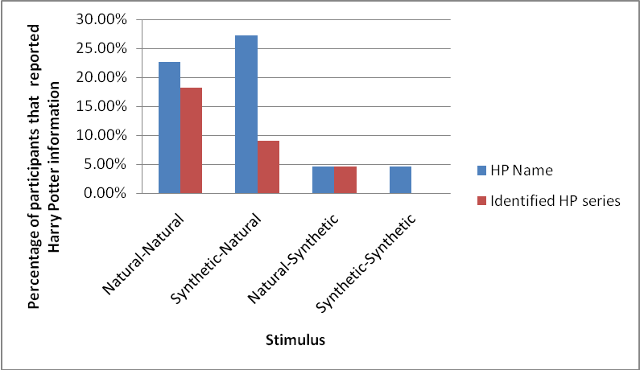

Figure 1. Percentages of participants that reported *Harry Potter* information for each stimulus

32

Table 1. *Percentages of High and Low Harry Potter Experience Participants that Reported Unattended Harry Potter information*

|  |  |  |  |  |  |
| --- | --- | --- | --- | --- | --- |
| Condition (Attended-Unattended)  Natural-Natural Synthetic-Natural  (Audio D) (Audio A) | | | | Natural-Synthetic (Audio C) | Synthetic-Synthetic (Audio B) |
| **High Harry Potter**  **Experience** | | | | 10% | 0% |
| *Harry Potter* name | 30% | | 20% |
| Identified passage as being from the Harry Potter series | 10% | 20% | | 10% | 0% |

**Low Harry Potter**   
**Experience**

|  |  |  |  |  |
| --- | --- | --- | --- | --- |
| *Harry Potter* name | 16.67% | 33.33% | 0% | 8.3% |
| Identified passage as being  from the *Harry*  *Potter* series | 8.33% | 0% | 0% | 0% |

**Unattended Information**   
 A series of 2 (Unattended Stimulus) x 2 (Attended Stimulus) x 2 (*Harry Potter*   
experience) Mixed ANOVAs were performed using PASW SPSS 18.0, for each of the dependent variables related to unattended information.

**Physical characteristics**. For the physical characteristics coding, the minimum possible was 0, and the maximum was 2. There were no significant differences in number of physical characteristics reported when the unattended stimulus was Natural (*M* = .867, *SD* = .555) than when it was Synthetic (*M* = .712, *SD* = .592), *F*(1, 20) = 3.945, *p* = .061, *ηp²* = .165. There was no significant difference in number of physical characteristic reported when the Attended

33

stimulus was Natural (*M* = .738, *SD* = .612) or Synthetic (*M* = .842, *SD* = .676), *F*(1, 20) = .487, *p* = .493, *ηp²* = .024. For those with HHP experience (*M* = .600, *SD* = .489) and LHP experience (*M* = .979, *SD* = .548) there was no significant difference in regard to number of physical characteristics reported, *F*(1, 20) = 2.874, *p* = .106, *ηp²* = .126. These results were to be expected, as traditionally physical characteristics were reported by participants in dichotic listening tasks.

**Low-Threshold information**. No test was done in regard to the reporting of the word

―fire‖ as it was only reported once, and it was used in a specific context (―the man’s scar was on fire‖, rather than ―burning‖). For the *Harry Potter* information coding, the minimum possible was 0, and the maximum was 2. There was a main effect for Unattended stimulus in regard to the amount of *Harry Potter* information that was reported, *F*(1, 20) = 11.106, *p* = .003, *ηp²* = .357.

Significantly more *Harry Potter* information was reported when the Unattended stimulus was Natural (*M* = .396, *SD* = .596) rather than Synthetic (*M* = .071, *SD* = .234). There were no significant differences for amount of *Harry Potter* information reported when the Attended ear was Natural (*M* = .262, *SD* = .529) rather than Synthetic (*M* = .204, *SD* = .367), *F*(1, 20) = .370, *p* = .550, *ηp²* = .018. For those with HHP experience (M = .300, SD = .483) and LHP experience (M = .167, *SD* = .308) there was no significant difference in regard to amount of *Harry Potter* information reported, *F*(1, 20) = .617, *p* = .441, *ηp²* = .030 .

**Attended Information**   
 A 2 (Unattended Stimulus) x 2 (Attended Stimulus) x 2 (*Harry Potter* experience) Mixed ANOVA was performed using PASW SPSS 18.0, for the amount of correct attended information reported.

34

There was a main effect for stimulus in the Unattended ear in regard to amount of attended information reported, *F*(1, 20) = 11.488, *p* = .003, *ηp²* = .365. Significantly more attended information was reported when the Unattended stimulus was Natural (*M* = 37.396, *SD* = 21.236) than Synthetic (*M* = 29.346, *SD* = 14.520). There was no significant difference for amount of attended information reported when the Attended ear contained Natural speech (*M* = 32.354, SD = 16.995) or Synthetic speech (*M* = 33.958, SD = 19.182), *F*(1, 20) = 1.139, *p* = .398, *ηp²* = .054. For those with HHP experience (*M* = .300, *SD* = 16.878) and LHP experience (*M* = .167, *SD* = 17.780) there was no significant difference in regard to amount of attended information reported, *F*(1, 20) = .925, *p* = .348, *ηp²* = .044.

However, there was a significant Attended x Unattended interaction, *F*(1, 20) = 6.589, *p* = .018, *ηp²* = .248. To investigate this interaction, four paired-samples *t*-tests were run. In order to account for the number of tests run, the *p*-value for significance was divided by 4, and results were considered significant at the *p* < .025 level. No significant differences were found between the amount of attended information reported when the stimulus was Attended Natural,   
Unattended Natural (*M* = 32.32, *SD* = 16.960) and Attended Natural, Unattended Synthetic (*M* = 32.00, *SD* = 18.153), *t*(21) = .168, *p* = .868, *ηp²* = .001. However, significantly more attended information was reported when the stimulus was Attended Synthetic, Unattended Natural (*M* = 41.68, *SD* = 28.833) rather than Attended Synthetic, Unattended Synthetic (*M* = 26.18, *SD* = 13.262), *t*(21) = 3.121, *p* = .005, *ηp²* = .317. No significant differences were found between the amount of attended information reported when the stimulus was Attended Natural, Unattended Natural (*M* = 32.32, *SD* = 16.960) and Attended Synthetic, Unattended Natural (*M* = 41.68, *SD* = 28.833), *t*(21) = 2.108, *p* = .047, *ηp²* = .175. No significant differences were found between the

35

amount of attended information reported when the stimulus was Attended Synthetic, Unattended Synthetic (*M* = 26.18, *SD* = 13.262) and Attended Natural, Unattended Synthetic (*M* = 32.00, *SD* = 18.153), *t*(21) = 2.109, *p* = .047, *ηp²* = .175. See Figure 2 for a visual representation of the means.

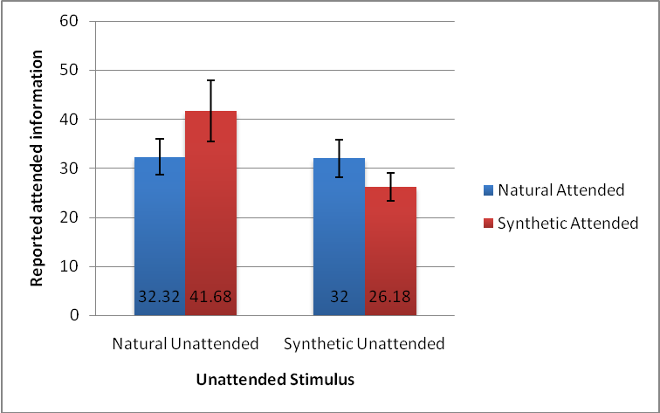

Figure 2. Attended Speech x Unattended Speech Interaction for reported attended information   
 There also was a significant Attended x *Harry Potter* experience interaction, *F*(1, 20) = 5.038, *p* = .036, *ηp²* = .201. To examine this interaction individual paired samples *t*-tests were performed comparing amount of attended information reported from the Natural and Synthetic attended conditions for those with LHP experience and HHP experience. For those with LHP experience, there were no significant differences between amount of attended information reported from the shadowed Natural stimuli (*M* = 31.000, *SD* = 18.027), and shadowed Synthetic stimuli (*M* = 28.583, *SD* = 19.087), *t*(11) = .784, *p* = .450, *ηp²* = .053. For those with HHP experience, significantly more Attended information was reported when the attended stimulus

36

was Synthetic (*M* = 40.350, *SD* = 18.149) rather than Natural (*M* = 33.550, *SD* = 16.517), *t*(9) = 2.668, *p* = .026, *ηp²* = .442. See Figure 3 for a visual representation of this interaction.

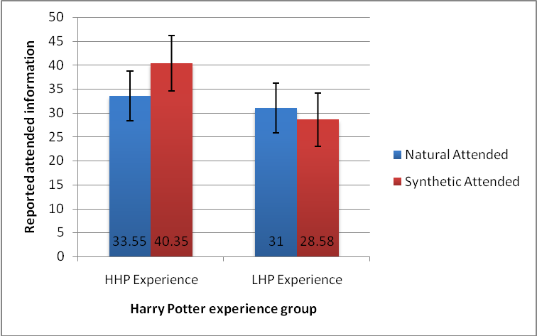

Figure 3. *Harry Potter* experience x Attended Speech Interaction for reported attended information   
**Shadowing Accuracy**   
 A series of 2 (Unattended Stimulus) x 2 (Attended Stimulus) x 2 (*Harry Potter*   
experience) Mixed ANOVAs were performed using PASW SPSS 18.0, for each of the dependent variables related to shadowing accuracy. The first fifteen seconds of shadowing (without the unattended channel present) were not analyzed, as this period served as a practice.

**Shadowing accuracy without low-threshold words**. There was a main effect for Attended channel in regard to shadowing accuracy, *F*(1, 20) = 7.250, *p* = .014, *ηp²* = .266. Shadowing accuracy was significantly higher when participants were repeating Natural speech (*M* = 82.16%, *SD* = 12.81%) rather than Synthetic speech (*M* = 75.07%, *SD* =12.19%). There

37

were no significant differences for shadowing accuracy when the unattended channel contained Natural (*M* = 77.76%, *SD* = 12.15%) or Synthetic (*M* = 79.47%, *SD* = 10.78%) speech, *F*(1, 20) = 1.179, *p* = .290, *ηp²* = .056. For those with HHP experience (*M* = 78.07%, *SD* = 13.57%) and LHP experience (*M* = 79.16% *SD* = 8.67%) there was no significant difference in regard to shadowing accuracy, *F*(1, 20) = .053, *p* = .821, *ηp²* = .003.

**Shadowing accuracy following “fire”**. There was no main effect for the Attended stimulus in regard to shadowing accuracy immediately following the word ―fire‖, *F* (1, 20) = 3.209, *SD* = .088, *ηp²* = .138. Shadowing accuracy was not significantly different after ―fire‖ when the shadowed stimulus was Natural (*M* = 92.08%, *SD* = 15.26%) or Synthetic (*M* = 85.83%, *SD* = 14.59%). There was also a main effect for the Unattended ear, such that shadowing accuracy following ―fire‖ was significantly higher when the unattended channel was Natural (*M* = 95.52%, *SD* = 8.22%) rather than Synthetic (*M* = 82.40%, *SD* = 20.61%), *F*(1, 20) = 9.009, *p* = .007, *ηp²* = .311. For those with HHP experience (*M* = 86.25%, *SD* = 15.53%) and LHP experience (*M* = 91.67%, *SD* = 6.71%) there was no significant difference in regard to shadowing accuracy following ―fire‖, *F*(1, 20) = 1.200, *p* = .286, *ηp²* = .057.

There was an Attended x Unattended interaction, *F*(1, 20) = 12.405, *p* = .002, *ηp²* = .383. To investigate this interaction, four paired-samples *t*-tests were run. In order to account for the number of tests run, the *p*-value for significance was divided by 4, and results were considered significant at the *p* < .025 level. No significant differences were found between the shadowing accuracy following ―fire‖ when the stimulus was Attended Natural, Unattended Natural (*M* = 94.32%, *SD* = 13.21%) and Attended Natural, Unattended Synthetic (*M* = 90.91%, *SD* = 19.74%), *t*(21) = .901, *p* = .378, *ηp²* = .037. Shadowing accuracy following ―fire‖ was

38

significantly higher when the stimulus was Attended Synthetic, Unattended Natural (*M* = 96.59%, *SD* = 11.69%) than Attended Synthetic, Unattended Synthetic (*M* = 75.00%, *SD* = 26.73%), *t*(21) = 3.472, *p* = .002, *ηp²* = .365. No significant differences were found between the amount of attended information reported when the stimulus was Attended Natural, Unattended Natural (*M* = 94.32%, *SD* = 13.21%) and Attended Synthetic, Unattended Natural (*M* = 96.59%, *SD* = 11.69%), *t*(21) = .568, *p* = .576, *ηp²* = .015. However, shadowing accuracy was   
significantly higher following ―fire‖ when the stimulus was Attended Natural, Unattended Synthetic (*M* = 90.01% , *SD* = 26.73%) rather than Attended Synthetic, Unattended Synthetic (*M* = 75.00%, *SD* = 26.73%), *t*(21) = 3.309, *p* = .003, *ηp²* = .343. See Figure 4 for a visual   
representation of this interaction.

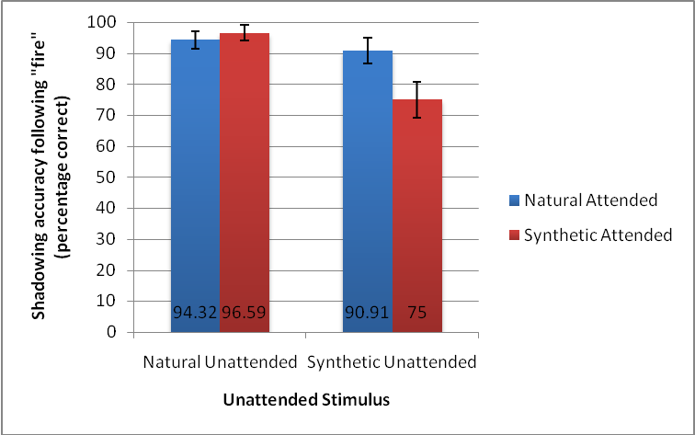

Figure 4. Attended Speech x Unattended Speech Interaction for shadowing accuracy following ―fire‖

39

**Shadowing accuracy following Harry Potter words**. There was a main effect for Unattended stimulus in regard to shadowing accuracy immediately following *Harry Potter* words, *F*(1, 20) = 24.844, *p* < .001, *ηp²* = .554. Shadowing accuracy was significantly lower immediately following *Harry Potter* words when the unattended stimulus was Natural (*M* = 68.70%, *SD* = 20.68%) rather than Synthetic (*M* = 86.09, *SD* = 85.80%). There was no   
significant difference in shadowing accuracy following *Harry Potter* words when the participant shadowed Natural speech (*M* = 80.05%, *SD* = 21.24%) or Synthetic speech (*M* = 74.74%, *SD* = 17.71%), *F*(1, 20) = 1.070, *p* = .313, *ηp²* = .051. For those with HHP experience (*M* = 78.75%, *SD* = 16.12%) and LHP experience (*M* = 76.04%, *SD* = 14.12%) there was no significant difference in regard to shadowing accuracy following *Harry Potter* words, *F*(1, 20) = .176, *p* = .679, *ηp²* = .009.

**Perceived Difficulty of Stimulus**   
 Participants rated the difficulty of task after each minute of participation on a scale of 1 (not difficulty) to 7 (very difficult). When the shadowed stimulus was Synthetic (*M* = 5.929, *SD* = .776) participants rated it as significantly more difficult than when it was Natural (*M* = 5.510, *SD* = .977), *F*(1, 20) = 8.348, *p* = .009, *ηp²* = .294. There were no differences in reported difficulty between the stimuli when the unattended ear contained Natural speech (*M* = 5.51, *SD* = .816) as opposed to Synthetic speech (*M* = 5.93, SD = .945), *F*(1, 20) = 1.773, *p* = .198, *ηp²* = .081. Further, there were no differences in difficulty ratings given by those with HHP experience (*M* = 5.700, *SD* = .911) and LHP experience (*M* = 5.740, *SD* = .773), *F*(1, 20) = .012, *p* = .913, *ηp²* = .001.

40

**Word Span**   
 Participants were able to receive a minimum word span score of 2, and a maximum score of 6. The overall mean word span of participants was 4.41, and the standard deviation was .796.

Correlations were run between word span and each dependent variable in the study. No significant correlations were found, which implies that the word span of the individual did not impact his or her performance on the dependent measures.

**Discussion**

**Findings**   
 Participants were more accurate at shadowing Natural speech than Synthetic speech. The type of speech that was shadowed did not impact the unattended or attended information recalled. The type of speech present in the unattended ear did impact the amount of *Harry Potter* information reported, but did not impact overall shadowing accuracy or attended information reported. *Harry Potter* experience only seemed to play a role in the ability of participants to report attended information when they were shadowing synthetic speech. Overall, while participants in both high and low *Harry Potter* experience groups did report *Harry Potter* names, they did not report the more traditional low-threshold word, ―fire‖.

The hypotheses that shadowing Natural speech would result in retaining more from the attended material, and more low-threshold information were not supported. There were no differences in the amount of attended material reported or in reporting *Harry Potter* information regardless of whether Natural or Synthetic speech was shadowed. Perhaps the amount of working memory required to decode speech that one is hearing then repeating is not great enough to interfere with processing the attended and unattended information. However, the

41

hypothesis that dichotic shadowing accuracy would be higher when the attended speech was Natural rather than Synthetic was supported. While the taxation of working memory required when repeating synthetic speech was not great enough to interfere with reporting unattended information, it appears to have been enough to result in deficits in shadowing. Shadowing accuracy was not higher for either type of attended stimuli immediately following the *Harry Potter* names, or ―fire‖. This finding could be the result of a very small range of words being analyzed in order to produce those specific accuracy scores, as accuracy was examined for only two words following each low-threshold word.

The hypothesis that when Natural speech was in the unattended ear more *Harry Potter* information would be reported than when it was Synthetic was supported. When synthetic speech was present in the unattended ear, the working memory was likely unable to deal with processing the information in the same way it would with natural speech. The hypothesis that when Natural speech was in the unattended ear, participants would retain less information from the attended passage was not supported. In fact, when Natural speech was present in the unattended ear, significantly more attended information was reported. Upon examining a significant Attended x Unattended interaction, it appears that the double degraded condition, Synthetic-Synthetic resulted in significantly less reported attended information than the Synthetic-Natural condition.

Therefore, the ability to report information from the shadowed synthetic speech was only impacted when an additional degraded stimulus was being processed from the unattended ear.

The hypothesis that Natural speech would result in lower dichotic shadowing accuracy was partially supported. Overall, in shadowing accuracy not including the low-threshold words, there were no significant differences in unattended speech type. However, immediately following

42

*Harry Potter* names, shadowing accuracy was significantly lower when the unattended channel was Natural rather than Synthetic. This implies that the *Harry Potter* words may have been interfering with the participant’s ability to shadow speech. Further, the reason for this may be that the working memory is less taxed when natural speech is present in the unattended ear, and it made it more likely for these important low-threshold words to get recognized. Immediately following the word ―fire‖, shadowing accuracy was actually higher when the unattended stimulus was Natural rather than Synthetic. This may be a result of the fact that overall shadowing accuracy was lower when shadowing synthetic speech, and that ―fire‖ was not found to be interruptive enough to break into attention.

While the amount of *Harry Potter* experience that the participants had did not impact the amount of low-threshold *Harry Potter* information reported, or shadowing accuracy, it did impact the amount of attended information reported. When those in the HHP experience group had synthetic stimuli in the attended ear they reported significantly more attended information than when they had natural stimuli. Perhaps their experience with *Harry Potter* is making it such that less working memory is necessary to deal with the unattended channel, and more working memory can be devoted to processing the degraded attended channel that they are shadowing.

**Theoretical Implications**   
 It was found that when the unattended ear contained Natural speech, a fairly high percentage of participants reported a *Harry Potter* name (22.7% when the attended ear was Natural, and 27.27% when the attended ear was Synthetic). While these percentages are not as high as the 33% of participants that traditionally report their own name in dichotic listening tasks, it implies that the *HarryPotter* names themselves do appear to have an effect, even if it is

43

not as strong as one’s own name. This effect is similar to the reduced one found when using the character *Harry Potter* in a self-reference effect experiment (Lombardo, Barnes, Wheelwright & Baron-Cohen, 2007). Few participants reported unattended *Harry Potter* names when the unattended stimulus was synthetic rather than natural. This finding implies that it is easier for the working memory to process an unattended audio channel when it is in natural speech rather than degraded by synthetic speech. Interestingly, level of *Harry Potter* experience did not seem to impact the effect of these names, and overall, all participants regardless of experience level reported them. Therefore, it appears that the name of a fictional character does work in a similar

way to one’s own name in a cocktail party effect situation. These results combined with the previous results of *Harry Potter*’s impact in a self-reference effect study implies that we may have schemas for fictional characters, which are similar to the schemas that we have for people that we know or ourselves.

It has previously been proposed that synthetic speech is more difficult for the working memory to process than natural speech due to its lack of prosody (Paris, Thomas, Gilson, & Kincaid, 2000). However, the current study demonstrated that it is possible to consciously process and repeat synthetic speech, while unconscious processing of it is more difficult. It is important to now examine if there are specific parts of prosody (intonation, pronunciation, pacing) that contribute to synthetic speech being more difficult for the working memory to deal with.

Interestingly, the current study has demonstrated that today’s population seems to be

more apt to react to the mention of a pop culture phenomenon than the alert word ―fire‖. These results indicate that there may have been a shift over the years in what people unconsciously

44

deem to be important. The instances of ―fire‖ that were included in the study were at the same decibel level as the rest of the passage, and were an interruption rather than being embedded in the unattended narrative. In real life, ―fire‖ would be shouted in an emergency situation.

Therefore, it appears that while ―fire‖ may not be able to unconsciously break into attention, it may still be able to gain attention in a real world situation where it is given additional volume and emphasis. Since in an unattended situation using a *Harry Potter* name can draw one’s attention, it suggests that fictional characters can be utilized in a number of different situations in which it might be necessary to get one’s attention. Specific situations in which linking   
information to a fictional character would be advantageous include using movie or television examples to demonstrate concepts in a classroom setting, or even using popular characters to give safety instructions on theme park rides (which actually is a common practice).

**Limitations and Future Directions**   
 In the current study, shadowing accuracy was examined within 2 words of proposed low-threshold words. One of the reasons that this was done in the current study is that some of the low-threshold words were placed closely together. In future studies it would be advantageous to design the stimuli such that there were more than a few words difference between the words of interest. This would then provide a way to examine a larger range of words following the low-threshold word, and determine if it had an impact on shadowing. In the current study, the same synthetic voice was used for both ears, and the same natural spoken voice was used for both ears.

In future studies it would be beneficial to use different voices in both ears to ensure that extra working memory is not being utilized in discerning which ear each voice is coming from. In

45

addition, future studies may want to examine the experience that one has previously had with synthetic speech, to see if practice effects can assist in making it easier to understand over time.

The data show that synthetic speech does appear to take more working memory power to process, as evidenced by difficulty shadowing it, and its presence in the unattended ear resulting in less unattended information reported. This raises the question of whether these results were found because there is something special about synthetic speech that makes it more difficult to process, or that the speech is degraded at all. Synthetic speech has a different pacing and pronunciation than natural speech, and lacks intonation. Therefore, a follow up study should be run that examines the impact of a less degraded form of speech (such as accented natural speech, which contains intonation) on performance in the dichotic listening task.

46

**CHAPTER THREE: STUDY 2**

**Introduction**

The results of Study 1 indicated that when synthetic speech was present in the unattended ear during a dichotic listening task fewer low-threshold words were reported than when the speech was natural. These results support claims that synthetic speech is a degraded stimulus, and that it takes a larger amount of working memory than natural spoken speech to understand and encode. A question that is raised as a result of it is if there is something inherent missing from the synthetic speech, as it often lacks the intonation and stress of natural spoken speech? Or is simply a matter of synthetic speech having a foreign pacing of speech that the listener is not familiar with? To help answer these questions, what is believed to be a less degraded stimulus, natural speech with an accent which is foreign to the listener (UK English), was introduced into Study 2. It was expected that there would be a difference between synthetic and natural speech, and that the inflection and tone inherent in British Natural speech would lead to results similar to that of American Natural speech. To further discern if an accent impacts the amount of low-threshold information reported, a UK English accented synthetic speech was used.

In the results of Study 1, a finding of interest was that less low-threshold information was reported when synthetic speech was present in the unattended ear. For that reason the type of speech in the attended ear was kept constant in Study 2, and a male with an American accent was always shadowed. In Study 1 there were two voices used: a female with an American accent (US English), and a female US English synthetic speech voice. In the Natural-Natural and Synthetic-Synthetic conditions, both the attended and unattended messages were spoken in the same voice.

47

In the current study, two different voices were always used in order to ensure that difficulty was not added by trying to tell the voices apart.

In Study 1, it was established that names of characters from a familiar series were able to

break through attention in a similar way to one’s own name in dichotic listening tasks. While the percentages of participants reporting these names were not as high as traditionally with one’s own name, they were still fairly high, which implies that they did have an impact. The traditional low-threshold word ―fire‖ on the other hand did not break through into attention in Study 1. Therefore, in Study 2, ―fire‖ was not included in the unattended passages, and the 4 *Harry Potter* names were the only low-threshold information present.

As evidenced by Study 1, synthetic speech appears to tax the working memory further than natural spoken speech. In the current study, it was hypothesized that when the unattended ear contained Natural speech (regardless of accent) rather than Synthetic speech (regardless of accent) more low-threshold information would be reported, less attended information would be reported, and shadowing accuracy would be lower. It was hypothesized that when speech was double-degraded by both an unfamiliar accent and synthetic speech (British Synthetic) less unattended *Harry Potter* information would be retained, more attended information reported, and there would be less disruption of shadowing accuracy than in the other conditions. It was hypothesized that high *Harry Potter* experience may result in a lower threshold for *Harry Potter* names, and that performance of those with high experience would be less affected by   
degradation in the stimuli than those with low experience. Further, it is hypothesized that those with more *Harry Potter* experience would report more low-threshold information and have more interruption in shadowing than those with less *Harry Potter* experience. It was believed that

48

having a high level of familiarity with the series would lead to less working memory being necessary to process passages from it.

**Method**

**Participants**   
 The means and standard deviations of the amount of low-threshold information reported from the two conditions from the initial study which had natural speech in the unattended ear were used to estimate the effect size with an online calculator (Becker, 2000). The effect size was estimated to be .225. This effect size was entered into the program *G-Power*, version 3 (Faul, Erdfelder, Lang, & Buchner, 2007), and it was determined that approximately 44 participants would be needed Study 2.

Forty-four college students, who were native speakers of American English, were recruited from the extra credit pool at the University of Central Florida. The data from one participant was not included, as the participant was determined not to have normal hearing according to a hearing test given at the beginning of the study. One participant’s data was not included, as the participant was not run through all the conditions. An additional participant’s data was not included because the participant coughed consistently during the shadowing portion of the study. A further 3 participants were not included in the analysis because they had no *Harry Potter* experience (they had not read a book, seen a movie, or listened to an audiobook).

Additional participants were not run, as time had passed between the decision to delete the participants from the sample, and the initial running of participants. If new participants were run they may have had different experiences with the *Harry Potter* series than the initial participants that were run (e.g. they may have had the opportunity to review the final movie in the series on

49

DVD, while the initial participants were not able to do so). The final sample of 38 participants was 76.3% female (29 females), and 23.7% male (9 males). The reported participant ages were between 18 and 23 (*M*=18.69, *SD*=1.238).

*Harry Potter* experience was determined by combining the number of *Harry Potter* novels, audiobooks and movies that the participant had read or watched. After the participants with no *Harry Potter* experience were removed, the sample was then broken into two groups. If participants had a *Harry Potter* experience score of 9 or above they were considered to have high *Harry Potter* experience (HHP experience), if they had a score of 8 or lower, they were   
considered to have low *Harry Potter* experience (LHP experience). The number used for the split (9) was consistent with having seen all of the *Harry Potter* movies available at the time, plus having either read one novel or listened to one audiobook. Two additional *Harry Potter* films were released between when Study 1 and Study 2 were run, which resulted in a higher cut off score for the HHP experience category in Study 2. Nineteen participants were in the HHP experience category, and 19 in the LHP experience category. See the Results section for additional information regarding the participants in both categories.

Of the 38 participants, 60.5% reported that they had read at least one *Harry Potter* novel, 18.4% reported having listened to at least one *Harry Potter* audiobook, and 100% reported having watched at least one film in the series. Thirteen point two percent of participants stated that they had read the novel used in the unattended ear, *The Secret Garden*, no participants reported listening to an audiobook version of it, and 21.1% of participants reported having watched a film version.

50

**Design**   
 A mixed 2 (Accent) x 2 (Speech Type) x 2 (*Harry Potter* experience) design was employed in the study. The independent variable that was manipulated was the type of audio playing in the unattended ear while the participant shadowed the attended ear. The attended ear always contained passages from the novel *The Secret Garden*, read by a male with an American accent. The unattended ear consisted of passages from the novel *Harry Potter and the Deathly Hallows*, and had four conditions: Male Speaker with an American accent (American Natural), Male Speaker with an English accent (British Natural), Male American accented synthetic speech (American Synthetic), and Male English accented synthetic speech (British Synthetic). There was a practice session that always occurred before the experimental stimuli, and allowed the participant to shadow a passage without an unattended message present. When participants arrived they were assigned to a specific randomized order in which they received the stimuli (ABCD, BCDA, CDAB, or DABC). The reordering of the stimuli provided a way to avoid order effects.

The dependent variables were accuracy in repeating the story in the attended ear, amount of correct information recalled for the attended ear, number of physical characteristics recalled from the unattended ear, and amount of semantic low-threshold information reported from the unattended ear (*Harry Potter names*).

**Apparatus/Instruments**   
 **Passages for Stimuli Creation.**As with Study 1, the Attended stimuli came from *The Secret Garden* (Burnett, 1911), and the unattended stimuli came from *Harry Potter and the Deathly Hallows* (Rowling, 2007a). *The Secret Garden* has a Lexile reading level of 970L, and

51

*Harry Potter and the Deathly Hallows* has a Lexile reading score of 980L (―The lexile framework for reading‖, 2011).

The stimuli from the attended ear consisted of new voice recordings of passages that were originally selected for Study 1, as well as a few additional new passages. All 5 attended and 4 unattended passages had *Flesch-Kincaid* grade level scores of 10 and 11, and ease scores that ranged between 52 – 63. Passages of *The Secret Garden* that were devoid of dialogue were selected and edited down to approximately 171.8 words. They were then run through a website calculator to find their *Fleisch-Kincaid* Reading Level and Ease scores (―Readability index

calculator‖, n.d.). Further editing was done in order to have the passages conform to 60 seconds, as well as have similar ease and reading level scores.

For the new unattended stimuli in Study 2, passages were identified from *Harry Potter and the Deathly Hallows.* The passages were approximately 128 words, 40 seconds long when read aloud, and did not include dialogue in them. The passages included names of characters from the *Harry Potter* series. A brief forty second excerpt of the audiobook, *Harry Potter and the Deathly Hallows* (Rowling, 2007b) was edited and used to create the British Natural stimuli.

The clip was edited such that it included 4 character names, and was consistent with all other passages.

**Synthetic voice simulator program.** As with Study 1, the synthetic speech passage was generated by a computer program, *TextAloud* 2. Rather than using a female voice, as in Study 1, a male voice was used for Study 2. The American accented synthetic speech used was the 16 kHz male US English *AT&T Natural Voice* ―Mike‖. The English accented synthetic speech used was the 16 kHz male UK English *AT&T Natural Voice*, ―Charles‖.

52

**Voice recordings.** A male with an American accent (American Natural) read a selected passage from *Harry Potter and the Deathly Hallows* aloud for use in the unattended ear. The same procedure from Study 1 of recording and editing using *Adobe Soundbooth CS5* was employed for Study 2. The reader was asked to speak at a normal pace, and target his speech such that he could complete reading the passage roughly 40 seconds. A pre-recorded passage of the *Harry Potter and the Deathly Hallows* audiobook (Rowling, 2007b), which features a male with a UK English accent, was cut down, and edited.

An additional male with an American accent was recorded reading the five selected passages from *The Secret Garden,* for use in the attended ear. All gaps were removed, and the speech lasted approximately 1 minute. A different male was used in the attended and unattended ears to ensure that results were not due to the same speaker being in both messages.

The stimuli for the attended and unattended channels were combined using professional audio editing software, *Adobe Soundbooth CS5*. As with Study 1, any gaps in speech were removed to ensure that both channels in the final file would constantly be playing audio. All of the recorded stimuli were matched to the same decibel level. Dual channel .wav files were created, with attended audio in the right ear, and unattended in the left ear. The unattended (left) audio began 20 seconds after the attended ear audio began.

As with Study 1, the *iPod Touch*, *uHear* hearing test, noise cancelling headphones, digital audio recorders, and working memory test were all used.

53

**Harry Potter/Secret Garden Familiarity Questionnaire**   
 A new version of the *Harry Potter* and *Secret Garden* familiarity questionnaire was generated in order to make clear divisions between reporting film, audiobook and novel experience.

**Procedure**   
 The procedure for Study 2 was nearly identical to that of Study 1. When the participants arrived they were given an informed consent form, and sat at a desk facing a blank white wall, in a quiet room. After the informed consent was signed and collected, participants were introduced to the noise cancelling headphones, and took a brief hearing test. Following the hearing test the experimental task was explained to the participant. The participants were instructed to repeat what they heard in their right ears, and ignore anything in their left ears. The experimenter assigned the participants to a stimulus order condition based on a randomization sheet. Before minute 1, the participants were shown the information sheet that they would be filling out after each minute of shadowing. The first minute of shadowing was always a practice session in which the participants repeated American Natural speech with nothing present in their left ears. After the first minute of speech, the participants were asked to fill out a sheet which requested that they report anything that they recalled from their attended and unattended ears. There were four additional minutes in which participants shadowed the dichotic two channeled stimuli.

Participants always shadowed American Natural speech, with the unattended channel containing manipulations in speech type. After each minute of participation, the participants were given the sheet that asked them to report anything that they recalled from their attended and unattended ears. Once the shadowing portion was complete, the participants were given a word span test.

54

After the word span test, participants completed *Harry Potter* experience and general demographics surveys. Finally, participants were given a debriefing form and given an opportunity to ask any questions that they had.

**Coding**   
 **Shadowing accuracy.** As in Study 1, accuracy checking sheets were generated for each of the attended passages. Examples of these sheets can be found in Appendix G. The sheets had the original text of the attended passages that were to be shadowed. The experimenter used these sheets to mark when the participants shadowed the passage incorrectly. An experimenter listened to the audio of the participant’s shadowing and crossed out the parts of the original audio that were not shadowed accurately. The sheets were then used in order to determine three different percentages, which were comparable between passages: the first twenty seconds of shadowing (without speech in the left ear), shadowing accuracy following the *Harry Potter* names, and shadowing accuracy for the passage which did not include the range immediately following the *Harry Potter* names. For Study 2, careful consideration was given to the spacing of *Harry Potter* names in the passage, and it was ensured that there was a considerable gap between them. Therefore, accuracy following *Harry Potter* names was examined for five words following the presence of the name in the unattended ear.

**Reported unattended information.** Two independent coders coded the unattended information that was reported by the participants. The coding scheme used was very similar to the one used in Study 1, and had the same two divisions: Physical characteristics, and *Harry Potter* information. In Study 2, Physical characteristics reported was a percentage, in order to account for the ability to indicate that an accent was present in only 2 of the conditions, and

55

make the stimuli comparable. Participants were given a Physical characteristics point for mentioning each of the following: presence of a voice, gender of the speaker, presence of an accent, loudness of the audio. The Physical characteristics score was then divided by 3 when the accent present was American, and 4 when the accent present was British, in order to have a comparable percentage.

Three points were possible for *Harry Potter* information (1 point was given if a *Harry Potter* name was reported; 1 point was given if *Harry Potter* was identified as the source of the unattended passage; 1 point was given if miscellaneous *Harry Potter* information was provided).

**Correct reported attended information.** As in Study 1, participants were asked to report any information that they could recall from the passage that they shadowed. Many participants reported exact words or the gist of the passage they repeated. Again, participants were inconsistent with their punctuation, therefore number of words provided that represented correct information was used to code attended information.

**Results**

Means and standard deviations for each of the dependent variables in Study 2 are provided in tables in Appendix P.

**Harry Potter Experience Groups**   
 A series of independent samples *t*-tests were run in order to confirm that those in the high *Harry Potter* experience (HHP experience) and low *Harry Potter* experience (LHP experience) differed on their amount of experience, and were the same on important attributes. As expected, it was found that those in the HHP experience group (*M* = 13.05, *SD* = 3.659) did have   
significantly more experience with *Harry Potter* than those in the LHP experience group (*M* =

56

5.00, *SD* = 2.108), *t*(36) = 8.313, *p* < .001. To confirm that the same pattern existed for each gender, separate independent samples *t*-tests were run for females and males to establish the difference in amount of overall *Harry Potter* experience between the HHP experience and LHP experience groups. For females, there was a significant difference between the 15 LHP experience participants (*M* = 5.20, *SD* = 2.21) and 14 HHP experience participants (*M* = 13.43, *SD* = 4.071), *t*(27) = 6.830, *p* < .001. For males, there was a significant difference between the 4 LHP experience participants (*M* = 4.25, *SD* = 1.707) and 5 HHP experience participants (*M* = 12.00, *SD* = 2.12), *t*(7) = 5.910, *p* = .001.

Further, as expected, there were no significant differences in age, word span, and *Secret Garden* Experience for those in the HHP experience (*M* = 18.79 years, *SD* = 1.357 years; *M* = 4.11, *SD* = .737; *M* = .4211, *SD* = .6925) and LHP experience (*M* = 18.59 years, *SD* = 1.121 years; *M* = 4.05, *SD* = .621; *M* = .2632, *SD* = .5620) groups, *t*(34) = .482, *p* = .633; *t*(36) = .238, *p* = .813; *t*(36)= .772, *p* = .445.

One hundred percent of participants with HHP experience had seen at least 1 film, 26.3% had listened to at least 1 audiobook, and 100% had read at least 1 novel. One hundred percent of the participants with LHP experience had seen at least 1 film, 10.5% had listened to at least 1 audiobook, and 21.1% had read at least 1 novel.

**Percentages of Reported Information**   
 In previous dichotic listening experiments, the percentages of participants who reported low-threshold information were reported. Therefore, the number of participants reporting *Harry Potter* information in each stimulus condition was calculated. When the unattended ear contained American Natural speech, 15.8% of participants reported a *Harry Potter* name, and 10.5%

57

identified that the unattended passage was from the *Harry Potter* series. When the unattended channel was British Natural, 18.4% of participants reported a *Harry Potter* name, and 18.4% of participants identified the source as *Harry Potter*. When the unattended channel was American Synthetic, 5.3% of participants reported a *Harry Potter* name, and 2.6% of participants identified the source as *Harry Potter*. When the unattended channel was British Synthetic, 5.3% of participants reported a *Harry Potter* name, and 5.3% identified the passage as originating from *Harry Potter*. See Figure 5 for a graph of the overall percentage of participants that reported *Harry Potter* information for each stimulus. See Table 2 for the percentages of participants who reported this unattended *Harry Potter* information further broken down for those in the HHP experience and LHP experience groups.

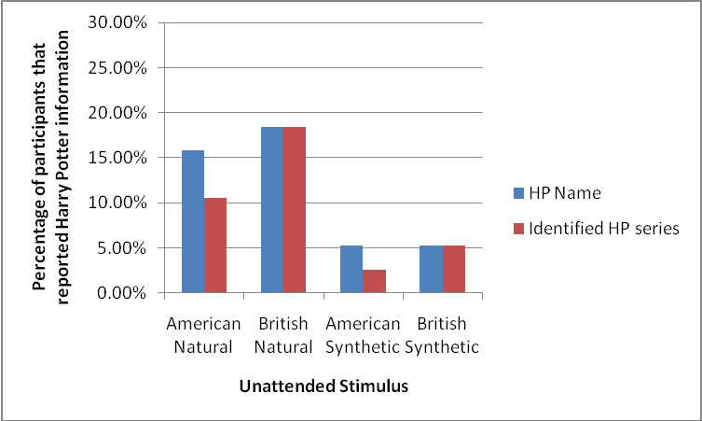

Figure 5. Percentages of participants that reported *Harry Potter* information for each stimulus

58

Table 2. *Percentages of High and Low Harry Potter Experience Participants that Reported Unattended Harry Potter information in Study 2*

|  |  |
| --- | --- |
| **High Harry Potter Experience** | Unattended Audio  American British  Natural Natural |

|  |  |
| --- | --- |
| American Synthetic | British  Synthetic |

|  |  |  |  |  |
| --- | --- | --- | --- | --- |
| *Harry Potter* name | 15.8% | 36.8% | 10.5% | 10.5% |
| Identified passage as being from the Harry Potter series | 15.8% | 36.8% | 5.3% | 10.5% |

**Low Harry Potter**   
**Experience**

|  |  |  |  |  |
| --- | --- | --- | --- | --- |
| *Harry Potter* name | 15.8% | 0% | 0% | 0% |
| Identified passage as being  from the *Harry*  *Potter* series | 5.3% | 0% | 0% | 0% |

**Unattended Information**   
 A series of 2 (Accent) x 2 (Type of Speech) x 2 (*Harry Potter* Experience) Mixed ANOVAs were performed using PASW SPSS 18.0, for each of the unattended information dependent variables.

**Physical characteristics**. The percentage of possible physical characteristics was coded so that it could be compared between conditions. When the accent was British, there were four possible aspects to be coded, and when it was American there were three. As expected, there were no significant differences for percentage of physical characteristics reported when the accent was British (*M* = 36.18%, *SD* = 25.13%) or American (*M* = 40.35%, *SD* = 27.57%), *F*(1,

59

36) = 2.359, *p* = .133, *ηp²* = .061. There also were no significant differences for percentage of physical characteristics reported when the speech type was Natural (*M* = 39.36%, *SD* = 24.59%) rather than Synthetic (*M* = 37.17%, *SD* = 37.17%), *F*(1, 36) = .581, *p* = .451, *ηp²* = .016. Further, there were no differences between those with HHP experience (*M* = 36.07%, *SD* = 26.82%) and LHP experience (*M* = 40.46%, *SD* = 23.47%) in percentage of physical characteristics reported, *F*(1, 36) = .288, *p* = .595, *ηp²* = .008. These results were consistent with previous dichotic listening tasks, as traditionally physical characteristics of the unattended ear stimuli were reported.

**Harry Potter information**. For the *Harry Potter* information coding, the minimum possible was 0, and the maximum was 3.There was a main effect for type of speech for amount of coded *Harry Potter* information reported from the unattended ear. Significantly more *Harry Potter* information was reported when speech was Natural (*M* = .329, *SD* = .629) than Synthetic (*M* = .105, *SD* = .371), *F*(1, 36) = 9.356, *p* = .004, *ηp²* = .199. There was no significant   
difference between amount of *Harry Potter* information reported when the Accent was British (*M* = .250, *SD* = .567) or American (*M* = .184, *SD* = .426), *F*(1, 36) = 1.324, *p* = .258, *ηp²* = .035.

There was a main effect of the between subjects factor, such that those with high *Harry Potter* Experience (M = .382, SD = .603) reported significantly more *Harry Potter* information than those with low experience (*M* = .053, *SD* = .134), *F*(1, 36) = 5.388, *p* = .0286, *ηp²=* .130.

There was an Accent x *Harry Potter* experience interaction, *F* (1, 36) = 8.947, *p* = .005, *ηp²* = .199. To examine this interaction individual paired samples *t*-tests were performed comparing amount of *Harry Potter* information reported from the British and American accents for those with LHP experience and HHP experience. For those with LHP experience, there were

60

no significant differences between amount of *Harry Potter* information reported from the British accent stimuli (*M* = .000, *SD* = .000), and American accent stimuli (*M* = .105, *SD* = .268), *t*(18) = 1.714, *p* = .104, *ηp²* = .140. For those with HHP experience, significantly more *Harry Potter* information was reported when the stimulus accent was British (*M* = .500, *SD* = .726) rather than American (*M* = .263, *SD* = .537), *t*(18) = 2.455, *p* = .025, *ηp²* = .251. See Figure 6 for a visual representation of this interaction.

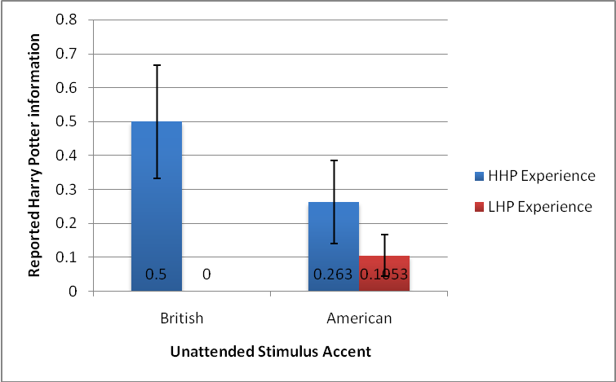

Figure 6. *Harry Potter* Experience x Accent Interaction for reported *Harry Potter* information

In addition, an Accent x Speech Type x *Harry Potter* Experience interaction was found, F(1, 36) = 4.225, p = .047, *ηp²* = .105. In order to further explore this interaction, separate Accent x Speech Type repeated measures ANOVAs were run those with HHP experience and LHP experience.

61

For those with LHP experience, there were no significant differences in amount of *Harry Potter* information reported when the speech was Natural (*M* = .105, *SD* = .268) or Synthetic (*M* = .000, *SD* = .000), *F*(1, 18) = 2.939, *p* = .104, *ηp²* = .140. Further, for those with LHP   
experience, there were no significant differences in amount of *Harry Potter* information reported when the accent was British (*M* = .000, *SD* = .000) or American (*M* = .105, *SD* = .267), *F*(1, 18) = 2.939, *p* = .104, *ηp²* = .140. The means for the amount of *Harry Potter* information reported in each condition by the LHP experience participants is demonstrated in Figure 7.

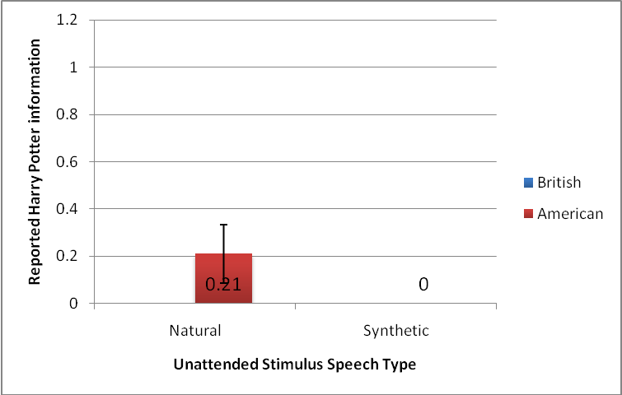

Figure 7. Means of LHP Experience participants for amount of *Harry Potter* information reported in each condition

For those with HHP experience, significantly more *Harry Potter* information was reported when the speech was Natural (*M* = .553, *SD* = .797) rather than Synthetic (*M* = .211, *SD* = .509), *F*(1, 18) = 6.642, *p* = .019, *ηp²* = .270. Further, for those with HHP experience,   
significantly more *Harry Potter* information was reported when the accent was British (*M* =

62

.500, *SD* = .726), rather than American, (*M* = .263, *SD* = .537), *F*(1, 18) = 6.025, *p* = .025, *ηp²* = .251. The means for the amount of *Harry Potter* information reported in each condition by the HHP experience participants is demonstrated in Figure 8.

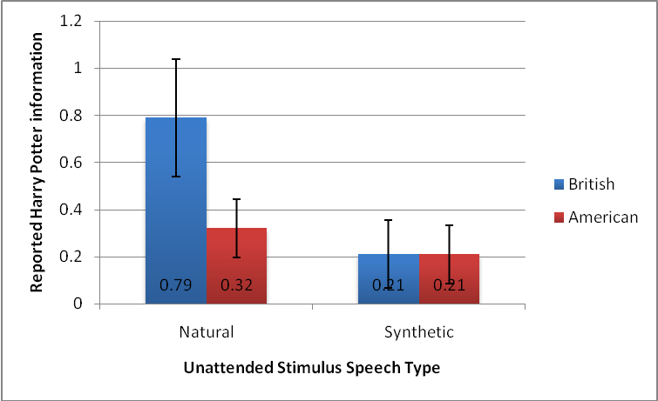

Figure 8. Means of HHP Experience participants for amount of *Harry Potter* information reported in each condition

**Investigating impact of Harry Potter Experience on Harry Potter information reported**  In order to determine if any particular type of *Harry Potter* experience was contributing to the ability to report *Harry Potter* information when the unattended channel was British Natural, a multiple regression analysis with the independent variables of total *Harry Potter* novels read, total *Harry Potter* books listened to, and total *Harry Potter* films watched was run.

The overall regression model was found to be significant, *R²* = .581, *F*(3, 37) = 15.741, *p*< .001. As can be seen in Table 3, Total *Harry Potter* audiobooks listened to had a significant positive weight, indicating that participants who had listened to more *Harry Potter* audiobooks

63

were expected to report more unattended *Harry Potter* information than those who had listened to less. The amount of *Harry Potter* films watched and *Harry Potter* books read did not contribute to the multiple regression model.

Table 3. *Linear Regression for Type of Experience and Amount of Harry Potter Information Reported*

|  |  |  |  |  |  |
| --- | --- | --- | --- | --- | --- |
| Harry Potter Experience | *B* | *SE B* | *β* | *t* | *significance* |
| Audiobooks | .451 | .075 | .744 | -.912 | *p* < .001 |
| Novels | -.023 | .042 | -.073 | -.536 | *p* = .596 |
| Films | .071 | .046 | .195 | 1.567 | *p* = .126 |

**Reported Attended Information**   
 A 2 (Accent) x 2 (Type of Speech) x 2 (*Harry Potter* Experience) Mixed ANOVAs was performed using PASW SPSS 18.0, for amount of correct attended information reported.

There was a main effect for type of Accent in regard to how much correct attended information was reported, *F*(1, 36) = 22.179, *p* < .001, *ηp²* = .381. Significantly more correct attended information was reported when the unattended stimulus had a British accent (*M* = 38.368, *SD* = 16.169) than an American accent (*M* = 31.382, *SD* = 14.848). There were no significant differences between the amount of correct attended information reported when the speech type was Natural (*M* = 34.684, *SD* = 16.120) rather than Synthetic (*M* = 35.066, *SD* = 15.402), *F*(1, 36) = .053, *p* = .820, *ηp²* = .001. There were no significant differences in the amount of attended information reported by those with LHP experience (*M* = 34.461, *SD* = 14.854) and HHP experience (*M* = 35.289, *SD* = 15.227), *F*(1, 36) = .029, *p* = .866, *ηp²* = .001.

64

There was an Accent x Speech Type interaction, *F*(1, 36) = 23.936, *p* < .001, *ηp²* = .399.

To investigate this interaction, four paired-samples *t*-tests were run. In order to account for the number of tests run, the *p*-value for significance was divided by 4, and results were considered significant at the *p* < .025 level. No significant differences were found between the amount of attended information reported when the stimulus was British Natural (*M* = 33.61, *SD* = 17.346) or American Natural (*M* = 35.76, *SD* = 16.867), *t*(37) = 1.161, *p* = .253, *ηp²* = .035. However, significantly more attended information was reported when the stimulus was British Synthetic (*M* = 43.13, *SD* = 19.832) rather than American Synthetic (*M* = 27.00, *SD* = 15.098), *t*(37) = 5.804, *p* <.001, *ηp²* = .477. Significantly more attended information was reported when the speech was British Natural (*M* = 33.61, *SD* = 17.346) than British Synthetic (*M* = 43.13, *SD* = 19.832), *t*(37) = 3.172, *p* = .003, *ηp²* = .214. Further, significantly more attended information was reported when the speech was American Natural (*M* = 35.76, *SD* = 16.867) than American Synthetic (*M* = 27.00, *SD* = 15.098), *t*(37) = 4.517, *p* = .003, *ηp²* = .355. See Figure 9 for a visual representation of this interaction.

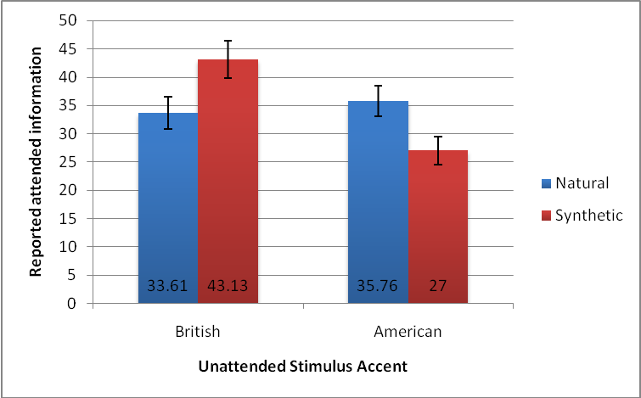

Figure 9. Accent x Speech Type interaction for reported attended information 65

**Shadowing Accuracy**   
 A series of 2 (Accent) x 2 (Type of Speech) x 2 (*Harry Potter* Experience) Mixed ANOVAs were performed using PASW SPSS 18.0, for each of the dependent variables regarding shadowing accuracy. The first twenty seconds of shadowing (without the unattended channel present) were not analyzed, as this period served as a practice.

**Shadowing Accuracy without Low-Threshold words**. There was a main effect of Accent for shadowing accuracy without low-threshold words, *F*(1, 36) = 8.075, *p* = .007, *ηp²* = .183. Shadowing accuracy was significantly higher when the American accent (*M* = 78.30%, *SD* = 16.63%) was present in the unattended channel than when the British accent was present (*M* = 74.02%, *SD* = 17.65%). There also was a main effect of unattended Speech Type for shadowing accuracy without low-threshold words, *F*(1, 36) = 18.358, *p*< .001, *ηp²* = .338. Shadowing accuracy was significantly higher when the unattended channel contained Synthetic speech (*M* = 78.78%, *SD* = 17.47%) rather than Natural speech (*M* = 73.53%, *SD* = 16.45%). There were no significant differences in shadowing accuracy without low-threshold words for those with HHP experience (*M* = 78.35%, *SD* = 13.95%) and LHP experience (*M* = 74.00%, *SD* = 18.89%), *F*(1, 36) = .663, *p* = .421, *ηp²* = .018.

In addition, there was an Accent x Speech Type interaction for shadowing accuracy without low-threshold words, *F*(1, 36) = 9.391, *p* = .004, *ηp²* = .207. To investigate this   
interaction, four paired-samples *t*-tests were run. In order to account for the number of tests run, the *p*-value for significance was divided by 4, and results were considered significant at the *p* < .025 level. Shadowing accuracy was significantly higher when the stimulus was British Synthetic (*M* = 79.05%, *SD* = 18.66%) rather than British Natural (*M* = 69.00%, *SD* = 18.62%), *t*(37) =

66

5.179, *p* <.001, *ηp²* = .420. However, no significant differences were found between shadowing accuracy when the stimulus was American Natural (*M* = 78.07%, *SD* = 17.055%) or American Synthetic (*M* = 78.52%, *SD* = 18.46%), *t*(37) = .223, *p* = .825, *ηp²* = .001. Shadowing accuracy was significantly higher when the stimulus was American Natural (*M* = 78.07%, *SD* = 17.06%) than British Natural (*M* = 69.00%, *SD* = 18.62%), *t*(37) = 4.032, *p* < .001, *ηp²* = .305. However, there was no significant difference in shadowing accuracy when the stimulus was British Synthetic (*M* = 79.05%, SD = 18.66%) rather than American Synthetic (*M* = 78.52%, *SD* = 18.46%), *t*(18) = .257, *p* = .798, *ηp²* = .002. See Figure 10 for a visual representation of this interaction.

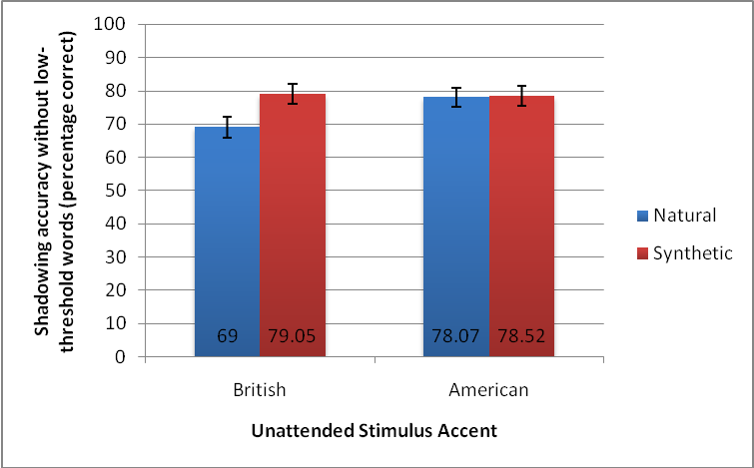

Figure 10. Accent x Speech Type interaction for shadowing accuracy without low-threshold words.

**Shadowing accuracy following Low-Threshold words**. There was a main effect for Accent in regard to shadowing accuracy following the low-threshold, *Harry Potter* words, *F*(1, 36) = 6.880, *p* = .013, *ηp²* = .160. Immediately following *Harry Potter* words, shadowing 67

accuracy was significantly higher when the unattended channel had an American accent (*M* = 75.59%, *SD* = 19.09%) than a British accent (*M* = 67.23%, *SD* = 24.75%). There was no main effect between Natural speech (*M* = 72.11%, *SD* = 19.98%) and Synthetic speech (*M* = 70.72%, *SD* = 24.06%) in regard to shadowing accuracy surrounding *Harry Potter* words, *F*(1, 36) = .190, *p* = .665, *ηp²* = .005. There was no main effect for the between subjects factor of *Harry Potter* experience; those with HHP experience (*M* = 73.30%, *SD* = 18.12%) did not differ significantly from those with LHP experience (*M* = 69.54%, *SD* = 21.78%) in regard to shadowing accuracy following *Harry Potter* words, *F*(1, 36) = .333, *p* = .568, *ηp²* = .009.

There was an Accent x Speech Type x *Harry Potter* Experience interaction for   
shadowing accuracy immediately following *Harry Potter* words, *F* (1, 36) = 6.192, *p* = .018, *ηp²* = .147. In order to further explore this interaction, separate Accent x Speech Type repeated measures ANOVAs were run those with HHP experience and LHP experience.

For those with LHP experience, there were no significant differences in shadowing accuracy immediately following *Harry Potter* words when the stimulus had a British accent (*M* = 66.05%, *SD* = 26.07%) or an American accent (*M* = 73.03%, *SD* = 21.58%), *F*(1, 18) = 2.353, *p* = .142, *ηp²* = .116. Further, there was no difference for those with LHP experience when the stimulus was Natural (*M* = 71.71%, *SD* = 21.83%) or Synthetic (*M* = 67.37%, *SD* = 25.24%), *F*(1, 18) = 1.086, *p* = .311, *ηp²* = .057.

For those with HHP experience, shadowing accuracy immediately following *Harry Potter* words was significantly higher when the stimulus accent was American (*M* = 78.16%, *SD* = 16.41%) rather than British (*M* = 68.42%, *SD* = 24.01%), *F*(1, 18) = 4.760, *p* = .043, *ηp²* = .209. Further, there was no significant difference for those with HHP experience when the

68

stimulus was Natural (*M* = 72.50%, *SD* = 18.54%) or Synthetic (*M* = 74.08%, *SD* = 23.01%), *F*(1, 18) = .109, *p* = .745, *ηp²* = .006.

**Perceived Difficulty of Stimulus**   
 After each stimulus, participants were asked to rate on a scale of 1 to 7 how difficult they believed it was, with 1 being not very difficult, and 7 being very difficult. In order to determine if any specific stimulus was considered more difficult that others, a 2 (Accent) x 2 (Speech Type) x 2 (*Harry Potter* Experience) Mixed ANOVA was performed. There were no main effects for Accent, Speech Type, or *Harry Potter* Experience, *F*(1,34) = .040, *p* = .842, *ηp²* = .001; *F*(1, 34) = 1.541, *p* = .223, *ηp²* = .043; *F*(1, 34) = .435, *p* = .514, *ηp²* = .013.

However, there was a significant Accent x Speech Type interaction, *F*(1, 34) = 11.628, *p* = .002, *ηp²* = .255. To investigate this interaction, four paired-samples *t*-tests were run. In order to account for the number of tests run, the *p*-value for significance was divided by 4, and results were considered significant at the *p* < .025 level. The British Natural stimulus (*M* = 5.33, *SD* = 1.219) was rated as significantly more difficult than the American Natural stimulus (*M* = 4.89, *SD* = 1.326), *t*(35) = 2.597, *p* = .014, *ηp²* = .162. The American Synthetic stimulus (*M* = 5.30, *SD* = 1.309) was rated as significantly more difficult than the British Synthetic stimulus (*M* = 4.81, *SD* = 1.371), *t*(36) = 2.347, *p* = .025, *ηp²* = .133. The British Natural stimulus (*M* = 5.33, *SD* = 1.219) was rated as significantly more difficult than the British Synthetic stimulus (*M* = 4.75, *SD* = 1.339), *t*(35) = 3.326, *p* = .002, *ηp²* = .240. The American Synthetic stimulus (*M* = 5.30, *SD* = 1.309) was rated as significantly more difficult than the American Natural stimulus (*M* = 4.95, *SD* = 1.309), *t*(36) = 2.405, *p* = .021, *ηp²* = .138. Perhaps the British Synthetic stimulus was rated as less difficult because the double-degradation made it less likely for the unattended channel be

69

processed, and resulted in less perceived interruption of the shadowing task. See Figure 11 for a visual representation of this interaction.

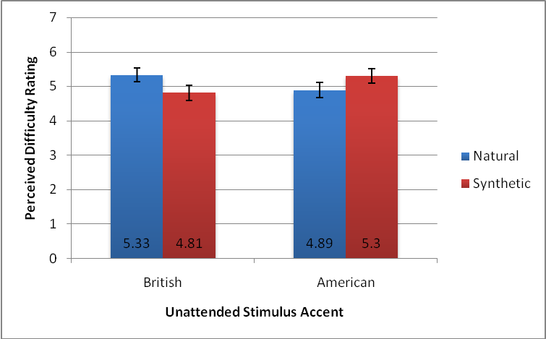

Figure 11. Accent x Speech Type interaction for perceived difficulty of the stimulus **Word Span**   
 Participants were able to receive a minimum word span score of 2, and a maximum score of 6. The overall mean word span of participants was 4.08, and the standard deviation was .673.

Correlations were run between word span and each dependent variable in the study. No significant correlations were found, which implies that the word span of the individual did not impact their performance on the dependent measures.

**Discussion**

**Findings**   
 The type of speech present in the unattended ear impacted the amount of *Harry Potter* information reported and shadowing accuracy. Natural speech resulted in more *Harry Potter*

70

information reported, and lower shadowing accuracy. *Harry Potter* experience did impact the performance of participants in regard to amount of *Harry Potter* information reported, and shadowing accuracy following *Harry Potter* names. Those with high *Harry Potter* experience reported more *Harry Potter* information and had lower shadowing accuracy immediately following *Harry Potter* names when the unattended speech was British Natural.

The hypothesis that more *Harry Potter* information would be reported when the unattended stimuli were Natural rather than Synthetic, regardless of accent was supported.

Overall, more of the low-threshold information broke into attention when Natural speech was present in the unattended ear. Since the British Natural condition was considered mildly degraded in comparison to the American Natural speech that participants are used to, it seems to indicate that there is something specific about synthetic speech that makes it more difficult to process (the lack of prosody, inflection and tone).

The hypothesis that less attended information would be recalled when Natural speech was in the unattended ear was not supported. In fact, there was a main effect and interaction for Accent as related to information reported from the attended ear. More correct attended   
information was reported when the unattended stimuli had a British accent rather than an American accent. Further, British Synthetic speech actually resulted in the most amount of attended information being recalled, and American Synthetic the worst. The double-degradation of the unattended British Synthetic stimulus most likely made it easier to block out than all other stimuli, resulting in more attended recall and a lower perceived difficulty. On the other hand, the odd characteristics of the Attended Synthetic category likely made it more distracting to the participant, and harder to process, which resulted in less attended information being recalled.

71

Since the accent is similar to the participant’s native accent it is possible that additional working memory is actually being used to attempt to break the information down and process it. When the unattended stimulus is British Synthetic it is likely easier to be blocked out, because it is

dissimilar enough from one’s native accent to be too large of a challenge for the working memory to process.

The hypothesis that shadowing accuracy would be lower when the unattended ear contained Natural speech was supported. Shadowing was more accurate when the unattended stimulus was Synthetic as opposed to Natural. It is believed that this happened because the unattended Natural speech was being more fully processed than the Synthetic speech. This extra processing may be because less working memory is required to process the Natural speech rather than the Synthetic speech. This results in more interruption of the shadowing procedure when the stimulus is Natural rather than the Synthetic. In addition, for shadowing accuracy without low-threshold words, there was a main effect for accent, as well as an interaction between speech type and accent. Overall shadowing accuracy was higher when an American accent was present in the unattended ear rather than a British accent. Upon examining the interaction it was revealed that British Natural speech was more disruptive to shadowing accuracy than American Natural speech, and British Synthetic speech. Perhaps the extra demands of trying to process a speech that is slightly degraded, but not fully degraded caused more interruption in the task of   
shadowing. This finding is similar to the reduced ability of participants to report attended information when the unattended stimulus was American Synthetic. The British Natural speech may be similar enough to one’s own speech that the working memory attempts to process it, but it requires extra attention, which results in more disruption in shadowing ability.

72

The hypothesis that shadowing accuracy immediately following *Harry Potter* names would be lower for those with high *Harry Potter* experience rather than low experience was partially supported. Overall, shadowing accuracy following *Harry Potter* words was more accurate when the unattended channel contained an American accent rather than a British one.

Further, for those with low *Harry Potter* experience there were no differences in shadowing accuracy following *Harry Potter* words as a result of Accent or Speech Type. However, for those with high *Harry Potter* experience, speech type did not impact shadowing accuracy following *Harry Potter* words, but accent did. When the unattended stimulus had a British accent the shadowing accuracy following *Harry Potter* words of those with high *Harry Potter* experience was lower than when it had an American accent. Therefore, for those with high *Harry Potter* experience British speech in the unattended ear was more disruptive to shadowing ability following *Harry Potter* words. This finding implies that the level of distraction that the *Harry Potter* words offered impacted those with more *Harry Potter* experience.

The hypothesis that those with high *Harry Potter* experience would report more unattended *Harry Potter* information than those with low experience was supported. Further, Accent, Speech Type and *Harry Potter* experience interacted and impacted the amount of unattended information recalled. For those with low *Harry Potter* experience, accent and speech type did not impact the ability to report unattended information. For those with high *Harry Potter* experience more unattended information was retained when the unattended stimulus had a British accent rather than an American accent. Further, those with high *Harry Potter* experience reported significantly more information when the speech was Natural rather than Synthetic.

73

**Theoretical Implications**   
 The amount of *Harry Potter* experience does appear to impact the ability for unattended *Harry Potter* information to be noticed, and actually aids in recall from the slightly degraded speech, British Natural. In both the high and low *Harry Potter* experience conditions 15.8% of participants reported *Harry Potter* names from American Natural speech. This percentage is lower than the traditional 33% of participants who recall their names in cocktail party effect experiments, and also lower than the percentage that recalled *Harry Potter* names in Study 1. It is possible that by using different speakers in the attended and unattended ears the effect was slightly lessened. Regardless, 15.8% of participants is a noticeable amount, and it appears that

fictional character names can break through into attention in a similar way to one’s own name.

Interestingly, those with low *Harry Potter* experience were unable to recall any *Harry Potter* information when the speech was British Natural, and for them it was no different than the more degraded synthetic speech conditions. . The percent of participants in the high *Harry Potter* condition that reported a *Harry Potter* name was 36.8%, which was higher than the amount that reported names in the unattended American Natural speech (15.8%) condition. For those with high *Harry Potter* experience, their experience appears to have assisted with the unattended processing and reduced the workload on the working memory such that British Natural speech was actually further processed than American Natural speech. A regression analysis indicated experience with the *Harry Potter* audiobooks was particularly driving this effect. It is possible that having previous experience listening to *Harry Potter* audiobooks with a British accent has a training effect such that the task is now easier for these participants. This training effect may make it such that less working memory power must be devoted to understanding this slightly

74

degraded stimulus. It has previously been established that while it is difficult for participants to understand synthetic speech at first, with practice and training they can get better at it. Further, previous research has shown that these training effects are even still in place six months after initial training (Schwab, Nusbaum, & Pisoni, 1985). It is possible that by listening to these *Harry Potter* audiobooks previously those in the high *Harry Potter* experience group have essentially been trained to be more proficient at understanding the British Natural accent while performing other tasks. All of the participants that reported having listened to audiobooks had done so between 3 to 5 years earlier, implying that this training had long lasting effects. Of note is that of the 7 participants that reported listening to audiobooks, only the participants that were in the high *Harry Potter* experience group reported unattended *Harry Potter* information in the British Natural condition. This suggests, that it is not just listening to a *Harry Potter* audiobook that could be causing this effect, but listening to it and also having a great deal of overall *Harry Potter* experience.

This study has demonstrated that the names of fictional characters can break through into attention in a dichotic listening task. Further, the level of experience and previous training listening to similar audio can assist in making the fictional character names break into attention.

This information can be applied to training using auditory information, and as with Study 1, implies that the use of familiar character names can assist us in recalling information.

**Limitations and Future Directions**   
 The current study examined the impact of passages from the *Harry Potter* series in the unattended ear. It is not entirely clear if having previously listened to a *Harry Potter* audiobook has provided training in performing in a dual-task situation, or in understanding British Natural

75

speech. Future research should examine the impact of training participants with the audiobook, and the impact of the training on dichotic listening performance.

In addition, future research should examine if using a different less familiar story will lead to similar performance in a dichotic listening task. Further, it is important in the future to examine the effect that shadowing the familiar *Harry Potter* story may have on performance in a dichotic listening task. This information is of interest as it would support the idea that there is something special about *Harry Potter*, rather than it just being that any story is being used.

76

**CHAPTER FOUR: PILOT STUDY FOR FUTURE WORK**

**Introduction**

A pilot study for future work was designed in order to examine if familiarity or   
unfamiliarity of unattended and shadowed stories can impact performance in a dichotic listening task. Only natural spoken male voices with US English accents were used in the current study, as the impact of degradation was not of interest. Participants shadowed one passage from *Harry Potter and the Deathly Hallows* while the less familiar, *The Secret Garden* was in their   
unattended ear, and a passage of *The Secret Garden* while a passage from *Harry Potter and the Deathly Hallows* was in the unattended ear.

It was hypothesized that participants would report more names and be more likely to identify the story that the unattended passage came from when *Harry Potter* was present in the unattended ear than *The Secret Garden*. It was also hypothesized that less attended information would be reported when *Harry Potter* was present in the unattended ear (as it would be more distracting), and that shadowing accuracy would be lower when *Harry Potter* was present in the unattended ear. Further, it was hypothesized that those with more *Harry Potter* experience would be more likely to report *Harry Potter* information from the unattended ear. Finally, it was hypothesized that when those with high *Harry Potter* experience shadow the *Harry Potter* passage they will be able to report more attended information from it than when they shadow *The Secret Garden*.

77

**Method**

**Participants**   
 Sixteen college students were recruited from the extra credit pool at the University of Central Florida. One participant was not included in the analysis because he or she had no *Harry Potter* experience (he or she had not read a book, seen a movie, or listened to an audiobook).

The final sample of 15 participants was twenty-percent male, and eighty-percent female. The participants were between the ages of 18 and 23 (*M*=19.13, *SD*=1.552). All of the participants were found to have normal hearing, according to the hearing test given at the beginning of the study.

*Harry Potter* experience was determined by adding together the number of *Harry Potter* novels, audiobooks and movies that the participant had read or watched. After the participant with no *Harry Potter* experience was removed, the sample was then broken into two groups based on the amount of *Harry Potter* experience the remaining participants had. If participants had a *Harry Potter* experience score of 9 or above they were considered to have high *Harry Potter* experience (HHP experience), if they had a score of 8 or lower, they were considered to have low *Harry Potter* experience (LHP experience). The number used for the split (9) was consistent with having seen all of the *Harry Potter* movies available at the time, plus having either read one novel or listened to one audiobook. Eight participants were in the HHP   
experience category, and 7 in the LHP experience category. See the Results section for additional information regarding the participants in both categories.

Of the 15 participants, 53.3% reported that they had read at least one *Harry Potter* novel, 0% reported having listened to at least one *Harry Potter* audiobook, and 100% reported having

78

watched at least one film in the series. Six point seven percent of participants stated that they had read the novel used in the unattended ear, *The Secret Garden*, no participants reported listening to an audiobook version of it, and 26.7% of participants reported having watched a film version.

**Design**   
 The study employed a mixed design, such that all participants were in all conditions. The between-subjects variable was *Harry Potter* experience group. The independent variables that were manipulated were the audio passage which was playing in the unattended ear (*Harry Potter* or *The Secret Garden*), and the audio passage (either *Harry Potter* or *The Secret Garden*) in the attended ear (shadowed). The dependent variables were the amount of low-threshold information reported (*Harry Potter* names, *Secret Garden* names), amount of attended information reported, shadowing accuracy without low-threshold information, and shadowing accuracy immediately following the low-threshold names.

**Procedure**   
 Passages from *The Secret Garden* (Burnett, 1911), and *Harry Potter and the Deathly Hallows* (Rowling, 2007a) were used to create two dichotic stimuli, and had a *Fleisch-Kincaid* reading levels of 9 to 10 and ease scores ranging between 60 to 64. An additional passage from the novel, *TheGolden Compass* (Pullman, 1995)*,* which had a Lexile score of 930L was selected in order to provide a practice stimulus that was unrelated to either *Harry Potterand the Deathly Hallows*, 980L or *The Secret Garden*, 970L. Audio recordings of the passages were made by two different males with American accents. The passages were then edited into dichotic stimuli using *Adobe Soundbooth CS5* software. The stimuli were played off of a pair of *Bose Quietcomfort 15* noise-cancelling headphones, which were hooked up to an *iPod Touch*.

79

When the participants arrived, as in Studies 1 and 2, they were given an informed consent and sat at a table in a small room in front of a blank white wall. After signing the informed consent, the participants took a brief hearing test using noise cancelling headphones and an *iPod Touch*. After the hearing test, the experiment was explained to the participants, and they were told that they would be repeating what they heard in their right ears, while ignoring what was in their left ears. All participants shadowed a passage from *The Golden Compass* as practice, and were given a survey asking them what they recalled from their attended and unattended ears. Following the practice session, the participants were once again told to shadow their right ears while ignoring their left ears. The randomization to which the participant was assigned   
determined the order in which he or she received the two dichotic stimuli. Participants shadowed a passage from *Harry Potter* with *The Secret Garden* present in their unattended ears, and also shadowed *TheSecret Garden* with *Harry Potter* present in the unattended ear. After each minute of participation, the participants were given a survey that asked them to recall anything they could from their attended and unattended ears. Once they had completed the dichotic listening portion of the experiment, participants engaged in a word span test. Finally, they filled out questionnaires and a demographics form. After the completion of the entire session the   
participants were given debriefing forms and allowed to ask any questions that they might have.

**Coding**   
 **Shadowing accuracy.** As in Studies 1 and 2, accuracy checking sheets were created for each of the attended passages. See Appendix G for examples of the shadowing accuracy checking sheets. The sheets contained the correct text of the attended passages that were to be shadowed. The experimenter used these sheets to mark when the participants shadowed the

80

passage incorrectly. An experimenter listened to the audio of the participant’s shadowing and crossed out the parts of the original audio that were not shadowed accurately. The sheets were then used in order to determine three different percentages, which were comparable between passages: the first twenty seconds of shadowing (without speech in the left ear), shadowing accuracy following the *Harry Potter* and the *Secret Garden* names, and shadowing accuracy for the passage which did not include the range immediately following the *Harry Potter* and *Secret Garden* names. As in Study 2, the shadowing accuracy following low-threshold names was examined for five words following the presence of the name in the unattended ear.

**Reported unattended information.** Two independent coders coded the unattended information that was reported by the participants. The coding scheme used was very similar to the one used in Studies 1 and 2. It had the same divisions: Physical characteristics, and Low-Threshold information. Participants could receive up to 2 points for Physical characteristics (1 point for reporting presence of a voice; 1 point for reporting the gender of the speaker). Two points were possible for Low-Threshold information (1 point was given if a low-threshold name was reported; 1 point was given if the source book was identified as the source of the unattended passage).

**Correct reported attended information.** As in Studies 1 and 2, participants were asked to report any information that they could remember from what they shadowed. Many of the participants were able to report exact words or the gist of the passage they repeated. As with the previous two studies, the participants were not consistent with their punctuation. As a result of this inconsistency, the number of words provided that represented correct information were used to code for attended information.

81

**Results**

Means and standard deviations for each of the dependent variables in the pilot study are provided in tables in Appendix Q.

**Harry Potter Experience Groups**   
 A series of independent samples t-tests were run in order to confirm that those in the high *Harry Potter* experience (HHP experience) and low *Harry Potter* experience (LHP experience) differed on their amount of experience, and were the same on important attributes. As expected, it was found that those in the HHP experience group (*M* = 12.63, *SD* = 1.155) did have   
significantly more experience with *Harry Potter* than those in the LHP experience group (*M* = 6.57, *SD* = 2.573), *t*(13) = 4.456, *p* = .001. There were 7 females in the LHP experience group, and 5 in the HHP experience group. There were 0 males in the LHP experience group, and 3 males in the HHP experience group.

Further, as expected, there were no significant differences in age and *Secret Garden* experience for those in the HHP experience (*M* = 19.25 years, *SD* = 1.909 years; *M* = .500, *SD* = .756) and LHP experience (*M* = 19.00 years, *SD* = 1.155 years; *M* = .143, *SD* = .378) groups, *t*(13) = .301, *p* = .768; *t*(13) = 1.129, *p* = .279. Those with HHP experience (*M* = 4.50, *SD* = .756) were found to have a significantly higher Word Span scores than those in the LHP experience group (*M* = 3.57, *SD* = .535), *t*(13) = 2.706, *p* = .018.

One hundred percent of participants with HHP experience had seen at least 1 film, 0% had listened to at least 1 audiobook, and 100% had read at least 1 novel. One hundred percent of the participants with LHP experience had seen at least 1 film, 0% had listened to at least 1 audiobook, and 0% had read at least 1 novel.

82

**Percentages of Reported Information**   
 The number of participants reporting *Harry Potter* and *Secret Garden* names was calculated. When the unattended ear contained *Harry Potter*, 6.67% of participants (1   
participant) reported a *Harry Potter* name, and 6.67% identified that the unattended passage was from the *Harry Potter* series. The participant that reported the *Harry Potter* name was in the LHP experience group. When the unattended channel was *The Secret Garden*, 13.33% of participants (2 participants) reported the *Secret Garden* name, Mary, and 0% of participants identified the source as *The Secret Garden*. Both of the participants that reported the name Mary were in the LHP experience group.

**Reported Unattended Information**   
 A series of 2 (Story) x 2 (*Harry Potter* experience) Mixed ANOVAs were run for each of the unattended related dependent variables.

**Physical characteristics**. There were no significant differences in the number of physical characteristics reported when the *Secret Garden* was present in the unattended ear (*M* = 1.07, *SD* = .704) rather than *Harry Potter* (*M* = 1.13, *SD* = .743), *F*(1, 13) = .156, *p* = .700, *ηp²* = .012. There also were no significant differences in number of physical characteristics reported between those with HHP experience (*M* = .938, *SD* = .776) and LHP experience (*M* = 1.286, *SD* = .488), *F*(1, 13) = 1.042, *p* = .326, *ηp²* = .074. These results were as expected, as in traditional dichotic listening tasks physical characteristics of the unattended stimuli were often reported.

**Low-Threshold information**. There were no significant differences in the amount of low-threshold reported when the *Secret Garden* was present in the unattended ear (*M* = .13, *SD* = .352) rather than *Harry Potter* (*M* = .13, *SD* = .516), *F*(1, 13) = .013, *p* = .912, *ηp²* = .001. There

83

also were no significant differences between those with HHP experience (*M* = .125, *SD* = .354) and LHP experience (*M* = .143, *SD* = .244), *F*(1, 13) = .013, *p* = .912, *ηp²* = .001.

**Reported Attended Information**   
 A 2 (Story) x 2 (*Harry Potter* experience) Mixed ANOVA was run for amount of attended information reported.

There were no significant differences in the amount of reported attended information when the *Harry Potter* was present in the attended ear (*M* = 36.27, *SD* = 24.870) rather than *Secret Garden* (*M* = 36.13, *SD* = 17.521), *F*(1, 13) = .028, *p* = .870, *ηp²* = .002. There also were no significant differences in the amount of reported attended information between those with HHP experience (*M* = 41.375, *SD* = 25.312) and LHP experience (*M* = 30.286, *SD* = 10.901), *F*(1, 13) = 1.148, *p* = .303, *ηp²* = .081.

However, there was a significant interaction between *Harry Potter* experience and the story playing in the attended ear, *F*(1, 13) = 9.953, *p* = .008, *ηp²* = .434. To explore this interaction separate paired samples *t*-tests were run for those with HHP experience and LHP experience. Those with LHP experience reported significantly more attended information when they shadowed *The Secret Garden* (*M* = 35.43, *SD* = 11.458) as opposed to *Harry Potter* (*M* = 25.14, *SD* = 11.894), *t*(6) = 3.247, *p* = .018, *ηp²* = .637. The amount of attended information reported by those with HHP experience was not significantly different when they shadowed *The Secret Garden* (*M* = 36.75, *SD* = 22.372) or *Harry Potter* (*M* = 46.00, *SD* = 29.727), *t*(7) = 1.824, *p* = .111, *ηp²* = .322. However, the direction indicates that those with more *Harry Potter* experience reported more information when they shadowed *Harry Potter.* Perhaps with more

84

participants and power this effect would be significant. See Figure for 12 for a graph of the interaction.

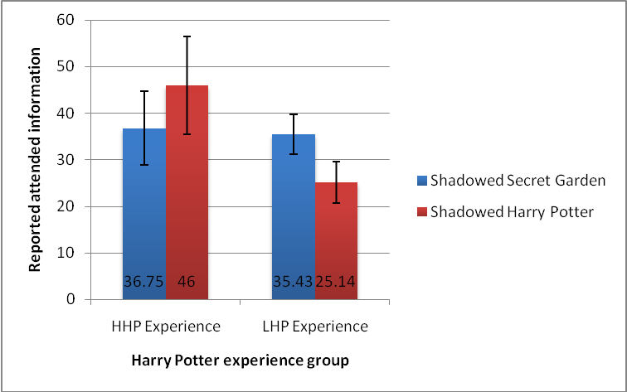

Figure 12. Story x *Harry Potter* Experience Interaction for reported attended information **Shadowing Accuracy**   
 A series of 2 (Story) x 2 (*Harry Potter* experience) Mixed ANOVAs was run for each of the shadowing accuracy related dependent variables. The first twenty seconds of shadowing (without the unattended channel present) were not analyzed, as this period served as a practice.

**Shadowing accuracy without low-threshold words**. Shadowing accuracy without low-threshold words was significantly higher when *The Secret Garden* (M = 83.20%, SD = 14.78%) was shadowed as opposed to *Harry Potter* (M = 75.81%, SD = 16.29%), *F*(1, 13) = 5.920, *p* = .030, *ηp²* = .313. There was no significant difference between those with HHP (M = 82.67%, SD = 6.19%) experience and LHP experience (M = 75.90%, SD = 20.36%) in regard to shadowing accuracy without low-threshold words, *F*(1, 13) = .807, *p* = .385, *ηp²* = .058.

85

**Shadowing accuracy following low-threshold names**. Shadowing accuracy following character names was significantly higher when *The Secret Garden* (*M* = 86.33%, *SD* = 15.86%) was shadowed as opposed to *Harry Potter* (*M* = 76.00%, SD = 20.11%), *F*(1, 13) = 7.222, *p* = .019, *ηp²* = .357. There was no significant difference between those with HHP (*M* = 83.13%, *SD* = 12.73%) experience and LHP experience (*M* = 78.93%, *SD* = 20.41%) in regard to shadowing accuracy following low-threshold names, *F*(1, 13) = .235, *p* = .636, *ηp²* = .018.

**Perceived Difficulty of Stimulus**   
 A (Story) x 2 (*Harry Potter* experience) Mixed ANOVA was run for the reported difficulty of the stimuli.There were no significant differences in reported difficulty in the task of shadowing *The Secret Garden* (*M* = 5.00, *SD* = 1.069) as opposed to shadowing *Harry Potter* (*M* = 5.13, *SD* = .915), *F*(1, 13) = .552, *p* = .471, *ηp²* = .041. Further, there were no significant differences in difficulty ratings given by those with HHP experience (*M* = 5.375, *SD* = .791) and LHP experience (*M* = 4.714, *SD* = 1.035), *F*(1, 13) = 1.961, *p* = .185, *ηp²* = .131.

**Word Span**   
 Participants were able to receive a minimum word span score of 2, and a maximum score of 6. The overall mean word span of participants was 4.07, and the standard deviation was .799.

Correlations were run between word span and each dependent variable in the study. While the high and low *Harry Potter* experience groups differed on word span, no significant correlations were found for participants overall between word span and the dependent variables. This implies that the word span of the individual did not impact their performance on the dependent measures.

86

**Discussion**

**Findings and Theoretical Implications**   
 The hypothesis that the presence of *Harry Potter* in the unattended ear would lead to more names being reported than from *The Secret Garden* was not supported. It is possible that by participants shadowing material from the same story before it appeared in the unattended ear it may have primed participants and made them more sensitive to hearing the name ―Mary‖. It is also possible that the reason that so few *Harry Potter* names were reported was because the sample size for the study was small, and of those with high *Harry Potter* experience, none had listened to audiobooks (which was an important factor in Study 2 performance).

The hypotheses that shadowing accuracy without low-threshold words and shadowing accuracy following names would be lower when *Harry Potter* was in the unattended ear was not supported. In fact, the opposite happened. Shadowing accuracy without low-threshold words was significantly higher when *The Secret Garden* was in the attended ear, and *Harry Potter* in the unattended ear. It is possible that this difference is a result of the *Harry Potter* material being more complex to shadow than *The Secret Garden* (even though the Lexile and reading level scores were similar). There was no impact of *Harry Potter* experience on either type of   
shadowing accuracy.

The hypothesis that less attended information would be reported when the unattended stimulus was a *Harry Potter* passage was not supported. There were no differences between the two unattended passages and their impact on attended information.

Those with low *Harry Potter* experience significantly more attended information when they shadowed *The Secret Garden* as opposed to *Harry Potter*. There was no significant

87

difference for those with high *Harry Potter* experience in amount of attended information reported from either story. However, the data appeared to trend such that those with high *Harry Potter* experience reported more attended information when they shadowed *Harry Potter* rather than *The Secret Garden*. Perhaps with a large sample size and increased power this difference would be significant. It appears that inexperience with *Harry Potter* may have made information about the topic less likely to be recalled, while those who had experience with it may have been able to fit it into the pre-existing schema for the series, thus assisting recall. This suggests that by actively tying information to something that is important to someone and that they have a good deal of experience with they may be more likely to recall it.

**Limitations and Future Directions**   
 The current study was a pilot study, and had a very small sample size, which may be one of the reasons that some of the hypotheses were not supported. It is recommended that a similar study be performed in the future with an increased amount of participants. Further, the level of *Harry Potter* experience in the pilot study was not as varied as in Study 2 (none of the   
participants had listened to audiobooks). Finally, it may be beneficial for a future study to use passages from multiple books and stories as not to prime the participant by repeating material that is similar to passages that will then be playing in their unattended ear in another condition.

88

**CHAPTER FIVE: GENERAL DISCUSSION**

**Overall Findings and Theoretical Implications**   
 Overall, the findings of Studies 1, 2, and the pilot study for future work demonstrate that

fictional character names can break through into attention similarly to one’s own name in a dichotic listening task. Further, the additional working memory resources that are required to process speech that is degraded (accented and/or synthetic) can reduce the impact of these low-threshold names. Study 1 showed that degrading the speech that one is shadowing does not tax the working memory enough to impact unattended information that breaks through the   
attentional barrier. When the unattended channel is degraded, however, less unattended low-threshold information can be processed. The traditional alert word ―fire‖ did not have any impact on performance in the dichotic listening task, while *Harry Potter* names behaved similarly to one’s own name in traditional cocktail party effect studies, but to a lesser magnitude (Moray, 1959). The main goal of Study 2 was to examine if there is something unique about synthetic speech that led to it being easily blocked out, or if a less degraded stimulus would behave in the same manner. Study 2 showed that when using a lower form of stimulus degradation in the unattended ear, an accent other than one’s own (British Natural speech), experience in the subject matter determined whether or not the information broke through the barrier into attention.

Those who had low *Harry Potter* experience reported no *Harry Potter* information from the British Natural, American Synthetic and British Synthetic stimuli. For those with high *Harry Potter* experience, the British Natural condition resulted in more reported unattended low-threshold information than the American Natural condition (the native accent of the participants).

89

It is believed that previous experience having listened to a *Harry Potter* audiobook served as

training, which allowed processing of this slightly degraded material to be higher than in one’s own native accent. This effect appears to be fairly strong, as the participants who had listened to *Harry Potter* audiobooks previously reported having done so between 3 to 5 years earlier. It is possible that this effect is driven by the amount of working memory that is necessary to process a degraded stimulus. By having previous training with listening to the British Natural accent it likely took fewer working memory resources to process the unattended information than in the other conditions. The pilot study for future work was designed in order to examine the impact of attended and unattended story familiarity on performance in a dichotic listening task. The pilot study demonstrated a trend that indicated level of experience with a particular story may impact the amount of information recalled about it.

These results combined with previous research regarding the self-reference effect and performance on the IAT (Lombardo, Barnes, Wheelwright & Baron-Cohen, 2007; Gabriel & Young, 2011) suggest that we may store that information about a fictional character in a way that is similar to how we store information about ourselves, or people that we know. This research also shows that the level of experience someone has with a fictional character, as well as the importance that they place on them may lead to a reduction in working memory necessary to process information about them. This is an interesting finding, as it shows that the classic phenomenon of the cocktail party effect applies to fictional characters, and that they can be subjectively important enough to a person to break through into his or her attention when they are performing a difficult task. In fact, these fictional characters may be important enough to people that they are more likely to gain attention rather than an alert word such as ―fire‖. Further,

90

degrading an unattended stimulus by using synthetic speech appears to prevent these low-threshold names from breaking into attention. When a stimulus is slightly degraded, such as being in a different accent, training appears to benefit those with a high amount of experience and familiarity with the topic.

Both Baddeley and Hitch’s working memory model, and Wickens’ multiple resource theory suggest that working memory has different systems (language and visual) which deal with specific types of information (Baddeley & Hitch, 1974; Wickens, 2008). It is possible that since the dichotic listening task consists of two different auditory tasks being performed at once, auditory processing in the working memory may be over taxed. It is also possible that natural and synthetic speech use different pools of resources. Perhaps, evolutionarily, humans have adapted resources that can easily process natural speech, while synthetic speech uses different resources that require additional practice to understand.

In Conway, Cowan, and Bunting (2001) it was found that when monosyllabic words were used as stimuli those with a low working memory span were more likely to hear their own names in the unattended channel than those with high working memory spans. In the current studies, scores from word span tests of working memory were not correlated with any of the dependent variables. In the Conway, Cowan, and Bunting (2001) study there was no context provided for the unattended words, whereas in the current studies stories were used. While having a more efficient working memory may have kept participants more focused without contextual cues, it is possible that the opposite is happening when a story is present in the unattended channel. The working memory works on processing both auditory channels, and within the context of a story it may be very easy for the working memory to process unattended information. Further,

91

familiarity and experience with a story may make it such that information from it takes less working memory to process, and that it is essentially low-threshold. This would suggest that it is not necessary for a person to have a high working memory capacity in order to process unattended information, but rather experience and training can result in their working memory being more efficient in the particular situation.

The current studies demonstrated that the stimulus used in a dichotic listening task is extremely important. While early work was not always consistent with their stimuli, the current work suggests that careful consideration should be given to choosing what the participant will be shadowing, and blocking out. It appears that narrative stories are more likely to be processed and retained from the unattended ear than unrelated words or numbers.

The level of experience that one has with a particular stimulus (such as British Natural) may make it easier for one to understand, and process unattended speech, thus requiring less working memory processing than other stimuli. Processing synthetic speech is believed to require more working memory than natural speech (Paris, Thomas, Gilson & Kincaid, 2000).

Therefore, it is possible that the degraded unattended stimuli used in the study were not processed to the same degree as the natural unattended stimuli because they required more resources from the working memory. It is likely that due to the experience or training those who listened to *Harry Potter* audiobooks had with the British Natural accent, that the amount of working memory resources necessary to process the degraded information was reduced. This then resulted in those with this experience recalling more unattended *Harry Potter* information than those who did not have the previous training. This training only appeared to impact those who had listened to the *Harry Potter* audiobook, and who were in the high *Harry Potter*

92

experience group. This finding is of particular interest because it indicates that it may not only be training with the subject matter that is important, but also the amount of importance placed on it, and experience.

**Practical Implications**   
 The results of this study can be applied to a number of different areas including safety, alerts, education, and even advertising. The current studies have shown that if something is subjectively important to someone it will break into their attention when they are engaged in a difficult task. It may be beneficial to determine what words may be of importance to someone who will need to listen for an alert (such as a call-sign or name of one’s unit in the military), and utilize these in trying to get their attention in emergency situations. It also may be important to particularly train people with the speech they will be hearing in an emergency alert situation, which would make it more likely for them to understand it while under stress. In education, the names of popular fictional characters can be used to assist in the recall of material. By using examples from film or television that students are familiar with, it may aid in their understanding of concepts and even grab their attention. Further, advertising may want to continue and add to the practice of using familiar celebrities or characters in advertising their products. The results of the current studies imply that popular characters are memorable and can get one’s attention,

therefore it would be beneficial to link a product to ―someone‖ a person feels is important. This could be especially helpful with television commercials, where people are generally not focused on the ad itself.

The results of the current studies also suggest that synthetic speech is a degraded stimulus, which takes more processing power and working memory resources to attend to than

93

natural speech. Synthetic speech lacks intonation, and has different pronunciation and pacing than natural speech. It is important to be aware of the extra demands that synthetic speech requires and to adjust alerts using synthetic speech accordingly. Careful consideration should be used when determining whether synthetic speech is appropriate for use in specific situations, such as avoiding its use in multi-tasking situations.

**Limitations and Future Directions**   
 The current studies used mixed designs that included a within-subjects component. By using this design there was the possibility of practice effects as the participant continued into each individual condition. To counteract this, counterbalancing was utilized. While a between-subjects design appears to be ideal in studies such as these, it would not account for individual differences in shadowing performance as well as a within-subjects design can. By using a mixed design all participants were able to be included regardless of their shadowing accuracy, as their accuracy with each stimulus was being compared to their accuracy with the other stimuli. If not for this, a strict requirement would need to be set for shadowing accuracy in order to be included in the data set. By setting an inclusion limit it would be detrimental, as those who are not as good at the task would be unrepresented in the findings.

Study 2 utilized a passage from the *Harry Potter and the Deathly Hallows* audiobook for the British Natural stimulus. Future studies should examine if similar effects are found when an actual natural British speaker reads a passage (not a professional narrator). This would help determine if those who had listened to the audiobook previously had a training effect that was specific to the audiobooks, or if it would carry over into a stimulus with a similar accent. Future research can also examine the impact of training participants with the unattended stimulus before

94

engaging in the dichotic listening task. It would also be beneficial to examine the role of experience when the voice of a non-native English speaker (such as a speaker whose first language is Chinese speaking English) is used as unattended stimuli. It is expected that the difference of pacing and lack of prosody would also result in performance being similar to that of synthetic speech.

A high level of individual variability in reporting *Harry Potter* information was demonstrated in both Studies 1 and 2. This was demonstrated as the standard deviation of reported *Harry Potter* information was often higher than the mean. This suggests that there may be individual differences such having previously listened to *Harry Potter* audiobooks that are contributing to specific participants hearing and reporting the low-threshold information. Future research should attempt to identify what factors lead to individuals reporting unattended information.

As previous research had not developed coding schemes for analyzing dichotic listening tasks, three different metrics were developed for the current studies. As a dichotic listening task has two individual tasks (attended and unattended), future research may want to explore developing a combined metric that examines the interdependency that exists in performance.

There is still a great deal of research into attention that can be done using the dichotic listening task paradigm. The current studies utilized the tasks in a new way that allows the examination of what people feel is subjectively important to themselves and to demonstrate the excess working memory resources that degraded speech requires. This paradigm is particularly useful as it provides a situation in which a participant’s attention is fully engaged with a difficult and task. The stimuli in both the attended and unattended ears can then be manipulated in order

95

to see what additional attentional demands they result in. Future research can also examine the specific ways that we store information about fictional characters and the importance that we place on them. By having a better understanding of the way we store information about these characters we can then adapt training and educational tasks that utilize the advantage that they provide to memory.

96

**APPENDIX A: EXAMPLE OF RECALL QUESTIONNAIRE**

97

Minute 1

What do you remember from the story you repeated in your right ear? (Please list anything you remember):

What do you recall from your left ear, which you were ignoring? (Please list everything you remember):

Did you hear anything interesting in your left ear? If so, what was it?

How would you rate the difficulty of this task on a scale of 1 to 7 (1 being not difficult, 7 being very difficult)? (circle one)

|  |  |  |  |  |  |  |
| --- | --- | --- | --- | --- | --- | --- |
| 1 | 2 | 3 | 4 | 5 | 6 | 7 |
| Not difficult | Very difficult |

98

**APPENDIX B: FAMILIARITY QUESTIONNAIRE**

99

**Harry Potter and The Secret Garden Familiarity Questionnaire** Have you read any Harry Potter novels? (circle one) YES NO   
 If yes please continue to the section labeled novels. If not, please move on to the next section.

NOVELS   
**For each Harry Potter novel please indicate whether or not you have read it.**

|  |  |
| --- | --- |
| **Novel Title** | **Have you read the novel? (Please circle one)** |
| **1)Harry Potter & the Sorcerer’s Stone** | **YES NO** |
| **2)Harry Potter & the Chamber of Secrets** | **YES NO** |
| **3)Harry Potter & the Prisoner of Azkaban** | **YES NO** |
| **4)Harry Potter & the Goblet of Fire** | **YES NO** |
| **5)Harry Potter & the Order of the**  **Phoenix** | **YES NO** |
| **6)Harry Potter & the Half Blood Prince** | **YES NO** |
| **7)Harry Potter & the Deathly Hallows** | **YES NO** |

When was the last time you read a Harry Potter novel? _____

100

Have you listened to any Harry Potter audiobooks? (circle one) YES NO   
If yes please continue to the section labeled audiobooks. If not, please move on to the next section.

AUDIOBOOKS   
**For each Harry Potter Audiobook please indicate whether or not you have listened to it.**

|  |  |
| --- | --- |
| **Audiobook Title** | **Have you listened to the audiobook? (Please circle one)** |
| **1)Harry Potter & the Sorcerer’s Stone** | **YES NO** |
| **2)Harry Potter & the Chamber of Secrets** | **YES NO** |
| **3)Harry Potter & the Prisoner of Azkaban** | **YES NO** |
| **4)Harry Potter & the Goblet of Fire** | **YES NO** |
| **5)Harry Potter & the Order of the**  **Phoenix** | **YES NO** |
| **6)Harry Potter & the Half Blood Prince** | **YES NO** |
| **7)Harry Potter & the Deathly Hallows** | **YES NO** |

When was the last time you listened to a Harry Potter audiobook? _____

101

Have you watched any Harry Potter films? (circle one) YES NO   
If yes please continue to the section labeled films. If not, please move on to the next section.

FILMS   
**For each Harry Potter film please indicate whether or not you have watched it.**

|  |  |
| --- | --- |
| **Film Title** | **Have you watched the movie? (Please circle one)** |
| **1)Harry Potter & the Sorcerer’s Stone** | **YES NO** |
| **2)Harry Potter & the Chamber of Secrets** | **YES NO** |
| **3)Harry Potter & the Prisoner of Azkaban** | **YES NO** |
| **4)Harry Potter & the Goblet of Fire** | **YES NO** |
| **5)Harry Potter & the Order of the Phoenix** | **YES NO** |
| **6)Harry Potter & the Half Blood Prince** | **YES NO** |
| **7)Harry Potter & the Deathly Hallows Part 1** | **YES NO** |
| **8)Harry Potter & the Deathly Hallows Part 2** | **YES NO** |

When was the last time you watched a Harry Potter film? ______

102

For the following questions please circle your answer.

Do you consider yourself to be a Harry Potter fan? YES NO

Have you been to the Wizarding World of Harry Potter at Universal Orlando? YES NO

When was the last time you were at the Wizarding World of Harry Potter? _______________

If you have not been to the Wizarding World of Harry Potter, do you plan to go there in the future? YES NO

On a scale of 1 to 7 please rate how familiar you are with…

The novel Harry Potter and the Deathly Hallows   
1 2 3 4 5 6 7 Not familiar at all Very familiar

The character Harry Potter   
1 2 3 4 5 6 7 Not familiar at all Very familiar

The character Hermione Granger   
1 2 3 4 5 6 7 Not familiar at all Very familiar

The character Ron Weasley   
1 2 3 4 5 6 7 Not familiar at all Very familiar

The character Lord Voldemort   
1 2 3 4 5 6 7 Not familiar at all Very familiar

The character Dumbledore   
1 2 3 4 5 6 7 Not familiar at all Very familiar

The Order of the Phoenix   
1 2 3 4 5 6 7 Not familiar at all Very familiar

Gryffindor   
1 2 3 4 5 6 7 Not familiar at all Very familiar

103

Have you read The Secret Garden (circle one)? YES NO

If so, when was the last time you read it? _____

Have you listened to an audiobook of The Secret Garden? YES NO

If so, when was the last time you listened to it? _____

Have you seen a film version of The Secret Garden (circle one)? YES NO

If so, when was the last time you watched it? _____

On a scale of 1 to 7 please rate how familiar you are with…

The novel The Secret Garden   
1 2 3 4 5 6 7 Not familiar at all Very familiar

The Secret Garden character, Mary   
1 2 3 4 5 6 7 Not familiar at all Very familiar

The Secret Garden character, Dickon   
1 2 3 4 5 6 7 Not familiar at all Very familiar

The Secret Garden character, Mrs. Medlock   
1 2 3 4 5 6 7 Not familiar at all Very familiar

The Secret Garden character, Ben Weatherstaff   
1 2 3 4 5 6 7 Not familiar at all Very familiar

The Secret Garden character, Martha   
1 2 3 4 5 6 7 Not familiar at all Very familiar

Do you consider yourself to be a fan of The Secret Garden? YES NO

104

Have you read a Golden Compass (His Dark Materials) Novel? YES NO

**For each Golden Compass novel please indicate whether or not you have read it.**

|  |  |
| --- | --- |
| **Novel Title** | **Have you read the novel? (Please circle one)** |
| **1)**  **The Golden Compass** | **YES NO** |
| **2)**  **The Subtle Knife** | **YES NO** |
| **3)**  **The Amber Spyglass** | **YES NO** |

When was the last time you read a Golden Compass novel? ___________

Have you listened to a Golden Compass Audiobook? YES NO

**For each Golden Compass Audiobook please indicate whether or not you have listened to it.**

|  |  |
| --- | --- |
| **Audiobook Title** | **Have you listened to the audiobook? (Please circle one)** |
| **1)**  **The Golden Compass** | **YES NO** |
| **2)**  **The Subtle Knife** | **YES NO** |
| **3)**  **The Amber Spyglass** | **YES NO** |

When was the last time you listened to a Golden Compass audiobook? ___________

Have you seen the film The Golden Compass? YES NO   
When was the last time you watched the film The Golden Compass? _______________ On a scale of 1 to 7 please rate how familiar you are with…

The novel The Golden Compass   
1 2 3 4 5 6 7 Not familiar at all Very familiar

The Golden Compass character, Lyra   
1 2 3 4 5 6 7 Not familiar at all Very familiar

The Golden Compass character, Will   
1 2 3 4 5 6 7 Not familiar at all Very familiar

Do you consider yourself to be a fan of The Golden Compass (His Dark Materials)? YES NO

105

**APPENDIX C: NAME QUESTIONNAIRE**

106

**Name Questionnaire (9/29/11)**

For the following questions, please answer if you know anyone with the indicated name, and if

so, how you know that person.

**Examples**: Friend, Mother, Father, Brother, Sister, Son, Daughter, etc.

1)Do you know anyone named **Harry**? If so, how do you know him?

2)Do you know anyone named **Ron**? If so, how do you know him?

3)Do you know anyone named **Hermione**? If so, how do you know her?

4)Do you know anyone named **Voldemort**? If so, how do you know him?

5)Do you know anyone named **Dumbledore**? If so, how do you know him?

6)Do you know anyone named **Mary**? If so, how do you know her?

7)Do you know anyone named **Dickon**? If so, how do you know him?

8)Do you know anyone named **Ben**? If so, how do you know him?

9)Do you know anyone named **Martha**? If so, how do you know her?

10)Do you know anyone named **Mrs. Medlock**? If so, how do you know her?

11)Do you know anyone named **Lyra**? If so, how do you know her?

107

**APPENDIX D: ACCENT QUESTIONNAIRE**

108

Do you have an English (British) accent?

Do you know anyone who has an English (British) accent? If so, how do you know them?

Have you ever been to England? If so, when was the last time you were in England?

109

**APPENDIX E: DEMOGRAPHICS QUESTIONNAIRE**

110

Demographics Age: ____

|  |  |  |
| --- | --- | --- |
| Gender (circle one): | Male | Female |

Major: ________________________   
What is your highest current year in college? (circle one)   
Freshman Sophomore Junior Senior Non-Degree Seeking Are you right handed or left handed? (circle one) Right Left What is your ethnicity? _____________________________   
Do you have normal hearing? (circle one): Yes No   
 If no, please elaborate: ___________________________________   
Do you wear a hearing aid? (circle one): Yes No   
Is your English your first language? (circle one): Yes No   
 If not, what is your first language? __________________________   
Please list any languages you speak other than English:   
______________________________________________________________   
Do you use headphones often? (circle one) Yes No   
Have you used noise cancelling headphones before today? (circle one) Yes No Have you ever used Text-to-Speech Software? (circle one) Yes No   
Do you often listen to audio books? (circle one) Yes No   
Please check the following systems which you have interacted with in the past:   
Automated Phone Calls (i.e. calling to get a prescription refilled) ____   
ATMs ____   
Self Check Out Lanes ____   
Kindle ____   
Other _____________________   
Have you taken a course in Cognitive Psychology? (circle one): Yes No

111

**APPENDIX F: EXPERIMENTAL SCRIPT**

112

Dissertation Dichotic Listening Study – **Fall 2011**   
Script Draft **10/2/11**   
Compiled and Written by: Anne Sinatra, Lara Herman, Rachel Mullins & Maxine Najle

*Thank you for coming to participate in our study. Can I please see an ID that includes your birthdate? Thank you. If you have a cell phone with you please turn it to silent.*

•If the participant is under 18 we cannot run them. Their birthday needs to be before **1993**  of the **current year**.

**Randomization/Order**   
 •Look at the Randomization Sheet. Choose the next Order on the list. Once you have chosen it for a participant put a line through it and write the participant # next to it. If the

participant has to leave early, or is ―thrown out‖ make a note, and make sure the next participant is in the Order that was not properly completed.

•The Letter indicates which of the 4 letter playlists to play. If it is A, then play the one that starts with A (ABCD), if it is B play the one that starts with B (BCDA), etc. All of the playlists will begin with audio 1 (which is the practice stimuli), then continue on to the correct order of the audio.

**Informed Consent**

*Before you begin please read this informed consent form. If you agree please sign it and return it to me. Feel free to ask me any questions or concerns that you might have.*

Hand Participant informed consent. Answer any questions they may have without giving away the purpose of the study.

•Separate and put signed form into the Informed Consent Folder (it is in the cabinet) •The participant may keep the Informed Consent, but flip it over/make sure it is out of their view (on the side of the table away from them).

•Turn on Field Recorder and state Participant #

•

**Pick up the noise cancelling headphones**   
**\*\*TURN ON THE HEADPHONES\*\***

**Explaining the headphones**   
*These are noise-canceling headphones. This means that once this switch on the headphones is turned on, all background noise becomes muted. It can be different at first so we are going to try them out so you can be comfortable with them. Are you wearing any hearing devices?*

113

If they answer yes:

*I encourage you to remove any hearing devices that you may have as it may be uncomfortable with the headphones. If you choose to leave a hearing device in and experience any discomfort please remove the headphones immediately.*

*Please put the headphones on, making sure that your ears are not covered by your hair. During the study you will be putting the headphones on and off. Please make sure that the switch is on the right side when you do so. After a moment I will gesture for you to remove the headphones.*  •Participant should listen to the headphones for about 15 seconds.

*Please remove the headphones.* **(Make motion)**

**Explaining the iPod**   
**Show them the iPod Touch.**

*This is an iPod Touch. You will be tapping its screen to respond in the next portion of the study. It is very responsive and only needs to be tapped lightly to receive your response. Please lightly tap on its screen now.*

•If they tap it too hard say…

*That tap was harder than is necessary. Please try tapping again lightly.* •If they press the button instead of the screen say…

*You have pushed on the home button. Please tap the screen lightly.*

**Hearing Test**   
*You will now be doing a brief hearing test. You will put the headphones on, and then you are going to listen for the tone. The tone is going to be 3 beeps in a row. This is what the screen will look like:*   
 •*(***Show screenshot of Square***)*

*You will tap the blue square on the screen as soon as you notice the sound. As the test progresses the tones will change. Each time you hear the tone you will tap the blue square that says “Heard it!”. When the test is over I will motion for you to take off the headphones and we will move onto the next task.*

*Are you wearing a hearing aid?*

•**If yes… tell them…**

*I recommend that you remove it for the hearing test, and the experiment. If you choose not to, please let me know at any time if you experience any discomfort and need to stop.*

•Make a note if they have a hearing aid, and if they kept it in or took it out.

•**If no…continue…**

*Do you have any questions?*

114

*Please put on the headphones. The red dot and switch should be on the right side.*

•Open the app Vol Control   
•Make sure it is set to .5 dB. If not use the adjustments to set it there.

•Open up the app uHear.

•Click on the hearing sensitivity test (the top one; it is in blue)   
•Confirm that the Volume is at approximately 50% according to the screen.

•Check that the participant headphones are on the correct sides (left & right).

•Click the **headphones** option on the screen to begin the test.

•Make sure the participant does not see their results.

•When the test is complete enter the participants number and take a screen shot to save the results. (Push the on switch and home button at the same time)   
*The test is now complete. If you are interested in the results I can go over them with you after the experiment is over.*

**Before moving on to the next step:**   
 •Open Vol Control

•Check that it is at .5 db. If it is not, adjust it. (If it is not, also make a note of it).

***EXPERIMENT***   
**Turn on handheld Recorder**   
 •Hold the recorder up to your mouth…

•Say *Participant # ___ Experiment*   
*We will now begin the next task.*

**For Minute 1**   
*For this portion of the task, you will hear speech in only your* ***right*** *ear. When the speech starts please repeat what it is saying. Ignore your left ear. Try to be as accurate as possible when repeating, but just keep going if you lose your place or make a mistake. After you have repeated the speech for a minute I will motion for you to take off your headphones, and I will give you a paper survey to fill out. Here is what the survey you will be completing will look like:*   
 •**Show the participant the first survey**

*Please put the headphones on.*

•**Make sure that their hair is not covering their ears.**

•**Make sure the headphones are on the correct ear**

115

**Say (for the recorder)**   
*Participant # ___ Minute 1*   
 •**Play the appropriate first clip** (SEE NOTES ON RANDOM ASSIGNMENT) •Watch the clip to see when it ends. When it does, push pause.

•**If the participant does not start repeating, pause it and say:** *Please repeat what you hearing in your right ear.*

•**Then make a note of it, and begin the appropriate clip again.**

•**Motion for the participant to take the headphones off.**

*Please remove the headphones*   
 •**Hand the participant the survey for minute 1.**

*Please fill out this page of the survey and include everything you can remember in your answers. Let me know when you are done.*

•**Collect the survey when they are done.**

•**Take the pen away from the participant.**

**For Minute 2**   
*Starting now you are going to hear speech in* ***both*** *ears. The speech will start with the right ear first, then after 20 seconds speech will begin in your left ear. You will be repeating after what you hear in your* ***right*** *ear, like you did before.* ***Ignore*** *the speech in your* ***left*** *ear. ALWAYS listen to and repeat ONLY your* ***right*** *ear. Try to be as accurate as possible when repeating, but just keep going if you lose your place or make a mistake. When the speech ends I will motion for you take off your headphones, and give you a survey.*

*Please put the headphones on.*

**Say (for the recorder)**   
*Participant # ____ Minute 2*   
 •**Play the appropriate second clip.**

•**Push pause when the clip is done.**

•**Motion to take off the headphones.**

*Please remove the headphones*   
 •**Hand the participant the survey for minute 2.**

•**Take the pen away from the participant when they are done.**

*Please fill out this page of the survey and include everything you can remember in your answers. Let me know when you are done.*

116

**FOR MINUTES 3, 4, and 5:**   
*You will be repeating after what you hear in your* ***right*** *ear, like you did before.* ***Ignore*** *the speech in your* ***left*** *ear. ALWAYS listen to and repeat ONLY your* ***right*** *ear. Try to be as accurate as possible when repeating, but just keep going if you lose your place or make a mistake. When the speech ends I will motion for you take off your headphones, and give you a survey.*

*Please put the headphones on.*

**Say (for the recorder)**   
*Participant # ____ Minute (Appropriate Minute)*  •**Play the appropriate clip.**

•**Push pause when the clip is done.**

•**Motion to take off the headphones.**

*Please remove the headphones.*

•**Hand the participant the survey for appropriate minute.**

•**Take the pen away from the participant when they are done.**

*Please fill out this page of the survey and include everything you can remember in your answers. Let me know when you are done.*

*\*\**(Repeat above for Minutes 3, 4, and 5)**   
*You have now completed this portion of the study.*

**\*\*TURN OFF THE HEADPHONES\*\***   
Working Memory Test   
 •Do not give the participant any feedback about whether they are right or wrong during

this test.

•**NOTE**: The cover page does not currently have a tab on it. **Please flip the cover**

**manually.**

**Say into recorder: *Participant # ___ Word***   
*We are going to do a short test. I will explain it first, then you will have an opportunity to practice before we begin. I will be showing you a series of words. You will need to read the word aloud. After you finish reading it the next one will be presented immediately. Once the set is over, and you see a blank page please recall the words out loud in order.*

*Let’s practice.*

… (show first word…Spun)   
… (show second word…Bird)   
*…(Blank Page)*   
 •**If the participant does not read the word aloud, prompt them to do so:**

*Please read the word aloud.*

117

•**If participant does not recall the words when shown the blank page, prompt them to**  **do so:**

*What were the words in order? Remember – during the test please recall the words in order when you see a blank page.*

*Let’s practice one more time.*

… (show first word…Sat)   
…(show second word…Seal)   
*…(Blank Page)*   
*That is the task that we will be doing for the next few minutes. As time passes the amount of words you will be asked to recall will increase.*

*Do you have any questions before we begin?*

*Let’s get started…*   
 •Flip each page as the participant says the word. When a blank page is reached stop.

•If the participant does not recall the words on their own prompt with the following…

*Please recall the words in order.*

•Make a note that prompting was required for that set.

•Have the participant **complete the entiretest**. You will score it later.

*You have completed the test. We will begin the next segment of the experiment momentarily.*  •**Turn off handheld recorder.**

**Score the Word Span Test while they are filling out demographics forms.**

**Surveys/Demographics Form**   
*You will now be completing a few surveys and demographics forms. Please let me know once you have completed them.*

•Make sure the participant number is written on all of the Papers.

•Hand the participant the Need for Cognition Test (NfC).

•Once they are done, hand the participant the Names Questionnaire.

•Once they are done, hand the participant the Familiarity Questionnaire.

*Please be sure to fill in both sides of the questionnaire.*

•Once they are done, hand the participant the Demographics Questionnaire.

•**While they are completing the form bring up their hearing test results on the iPod.**  **Be careful and make sure they are the results for the correct participant.**

•**While they are completing the forms please score the Word Span test.**

118

•**Collect the demographics forms when they are done.**

Debriefing form   
*You have completed the study, thank you for your participation.*  •**Hand participant the debriefing form.**

*This is a sheet that just explains the purpose of our study and some contact information if you have any further questions or concerns.*

*In this study you participated in a Dichotic Listening Experiment. This method has often been used to study attention and working memory. In particular, we are interested in the impact of computer generated and accented speech on the ability to repeat your right ear, and process information from your unattended left ear. We are interested in what you heard and remembered from your left ear, as well as what you recall from the ear you were repeating.*

•**Hand participant the Department Form**

*There is also another sheet that asks about your experience here today. If choose to you can fill it out and bring it to the Psychology Front Desk on the 3rd floor.*

*Do you have any questions about the study? Would you like to see your hearing test results? Thank you again for your participation.*

•**Turn off field recorder.**

•**Take a yellow pronged folder and write the participant number on it (D##). Put all of the participant’s sheets in that folder and seal it with the prongs. Make sure that the informed consent was removed and put in the separate Informed Consent folder.**

•**If you have enough time between participants: name and download the file onto the**  **computer. See additional instructions.**

119

**Experiment Set Up**   
You will need the following items…   
Bose Headphones (check that the battery is working)   
Field Recorder (plug into the wall)   
Handheld Recorder (check batteries)   
Table (set up table if necessary)   
Two chairs (you will sit next to the participant)   
iPod Touch   
iPod Touch charger   
Computer (Download files)   
After each participant go to the computer and download the files. You should name the handheld recorder file D##_Experiment.

Download the recording from the Field Recorder and name it D##_FieldR Download the image from the phone and name it D##_Hearing

Word Span Test Scoring Instructions

**Word Span Scoring Instructions/Score while they are filling out the demographics form.** Put a **number for the order** of recall in the blank next to the words the participant got right. If they recalled a word that was not present **write it down.** If a participant recalled words out of order it is still acceptable. If a participant recalled all the words in the set they Passed it (Put a Check Mark in the Passed Blank). **The Word Span test should be continued until the participant fails all 3 sets of that particular level.** Score the Word Span as the highest Level at which the participant got 2 out of 3 sets correct. Write the Word Span score on the blank at both the top of the first page, and at the bottom of the last page.

**Note on scoring**: We are continuing the word span test after the participant normally would be stopped. Therefore, if the participant fails at level 4, and the test is continued through 6… If they pass level 6, you still need to give them the highest level in which they got 2 out of 3 sets correct **before** failing. Therefore, in this example it would have to be level 4 or less.

120

**APPENDIX G: EXAMPLES OF SHADOWING ACCURACY GRADING SHEETS FROM EACH STUDY**

121

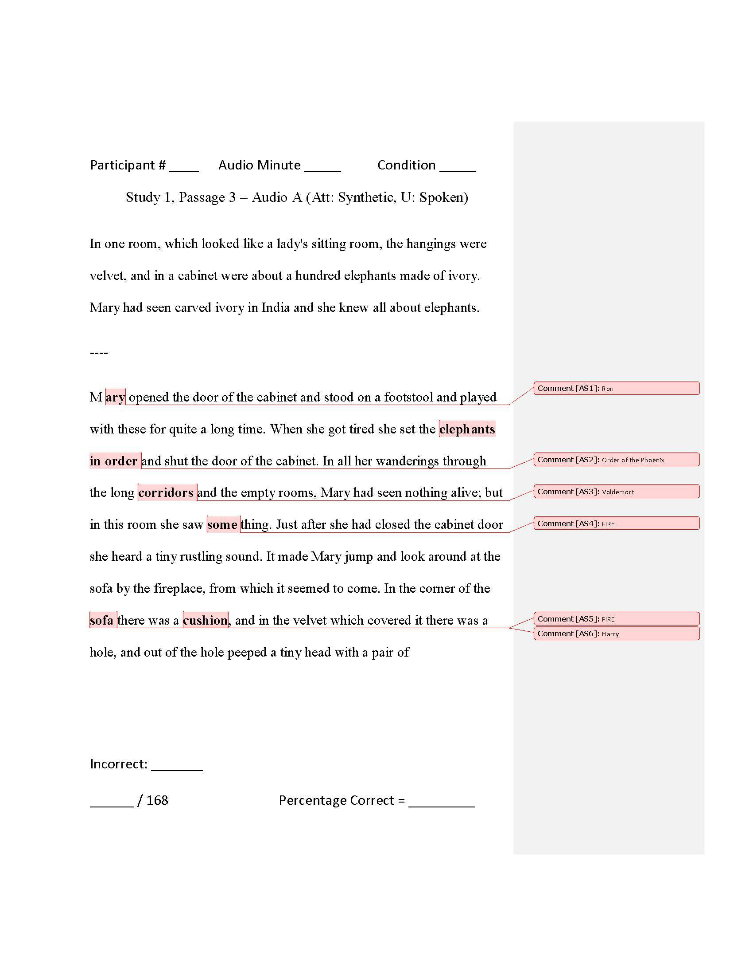

122

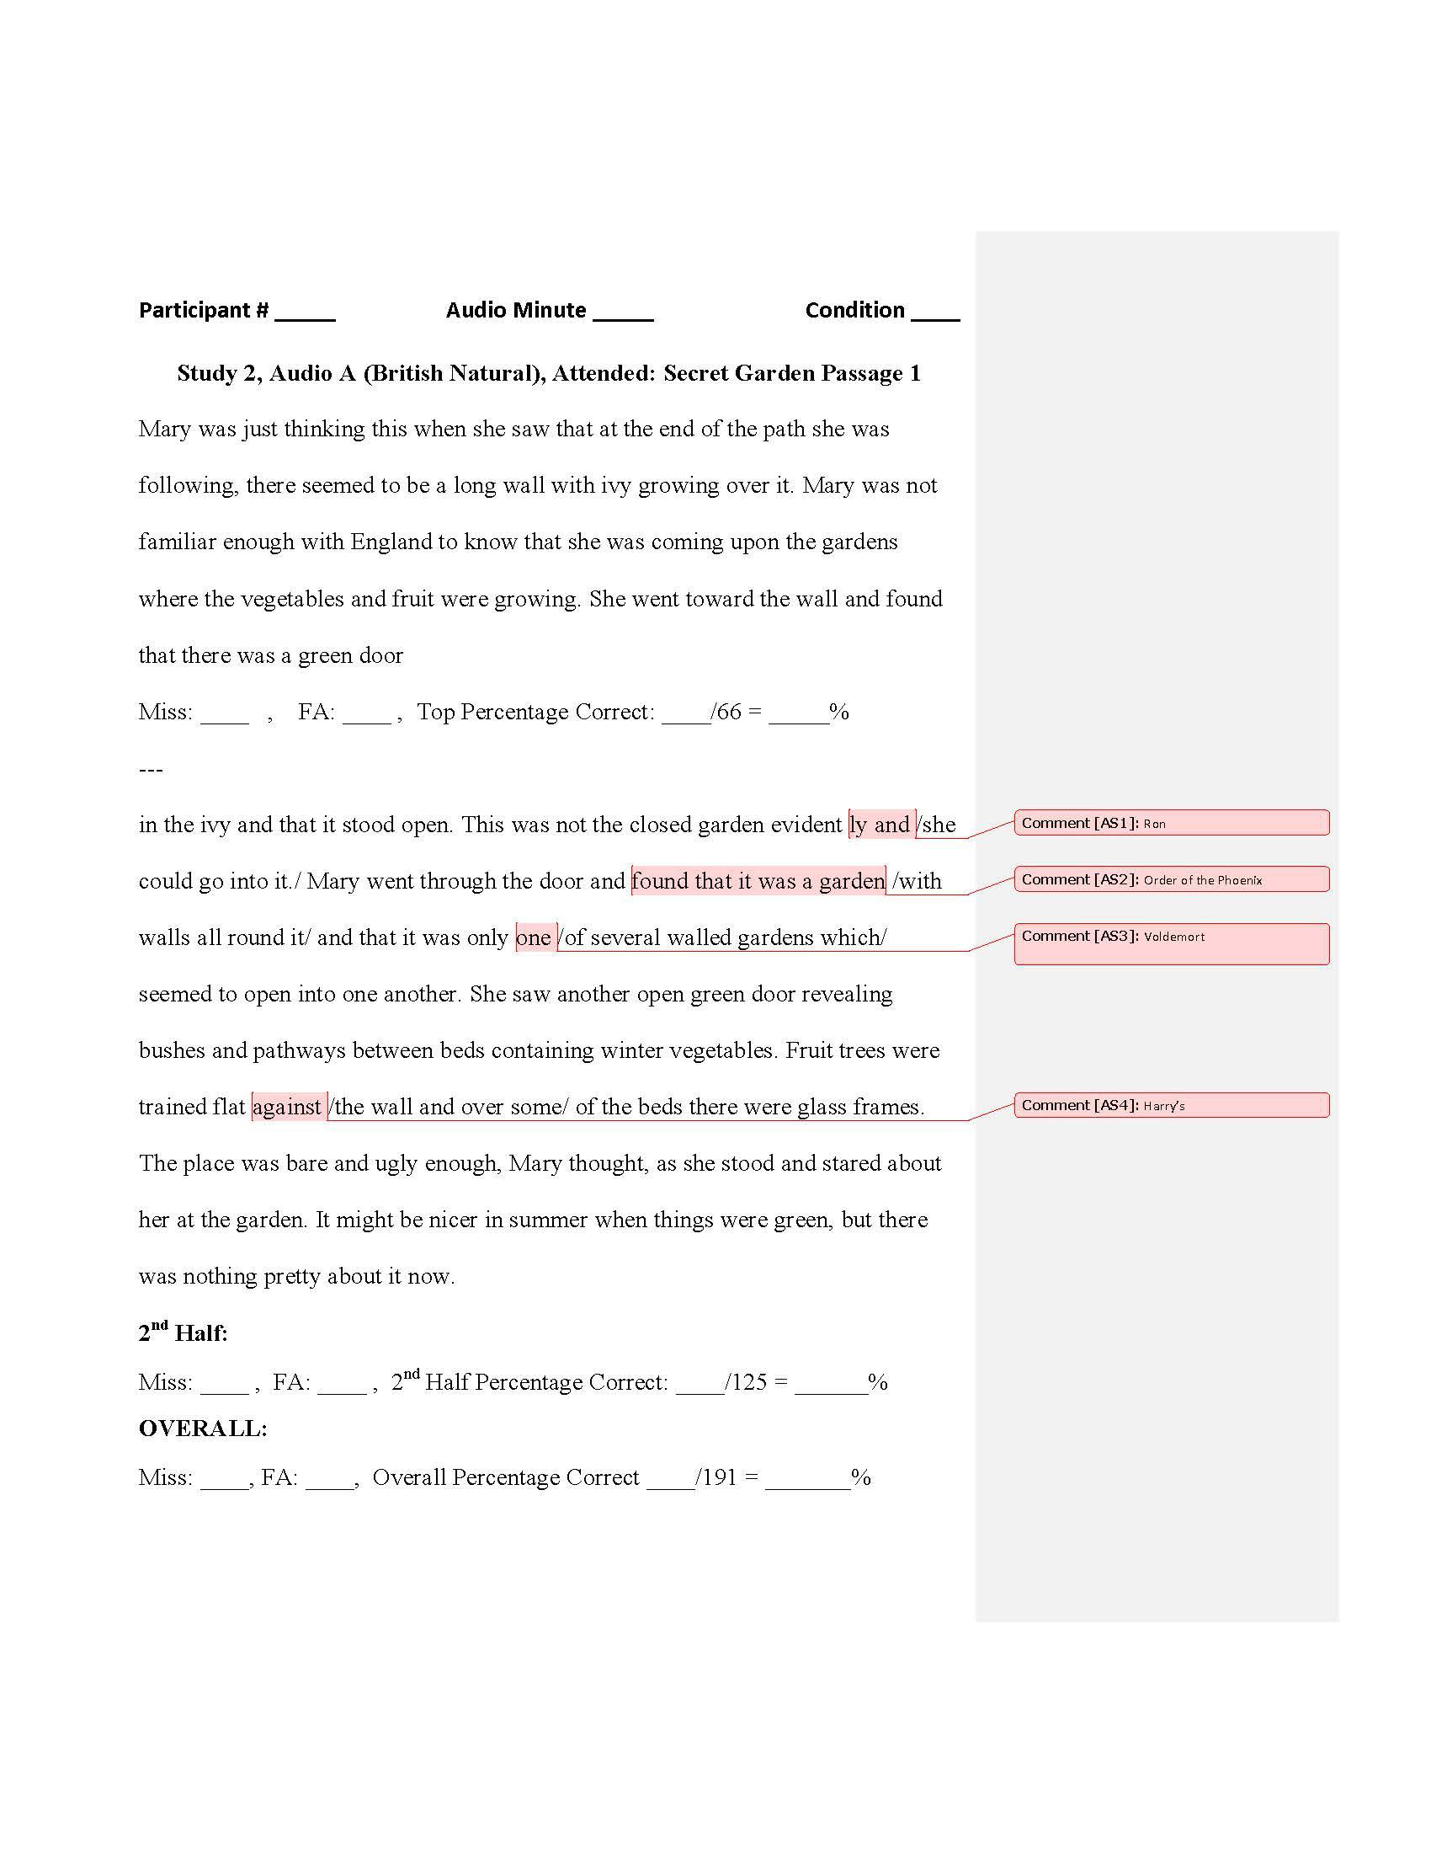

123

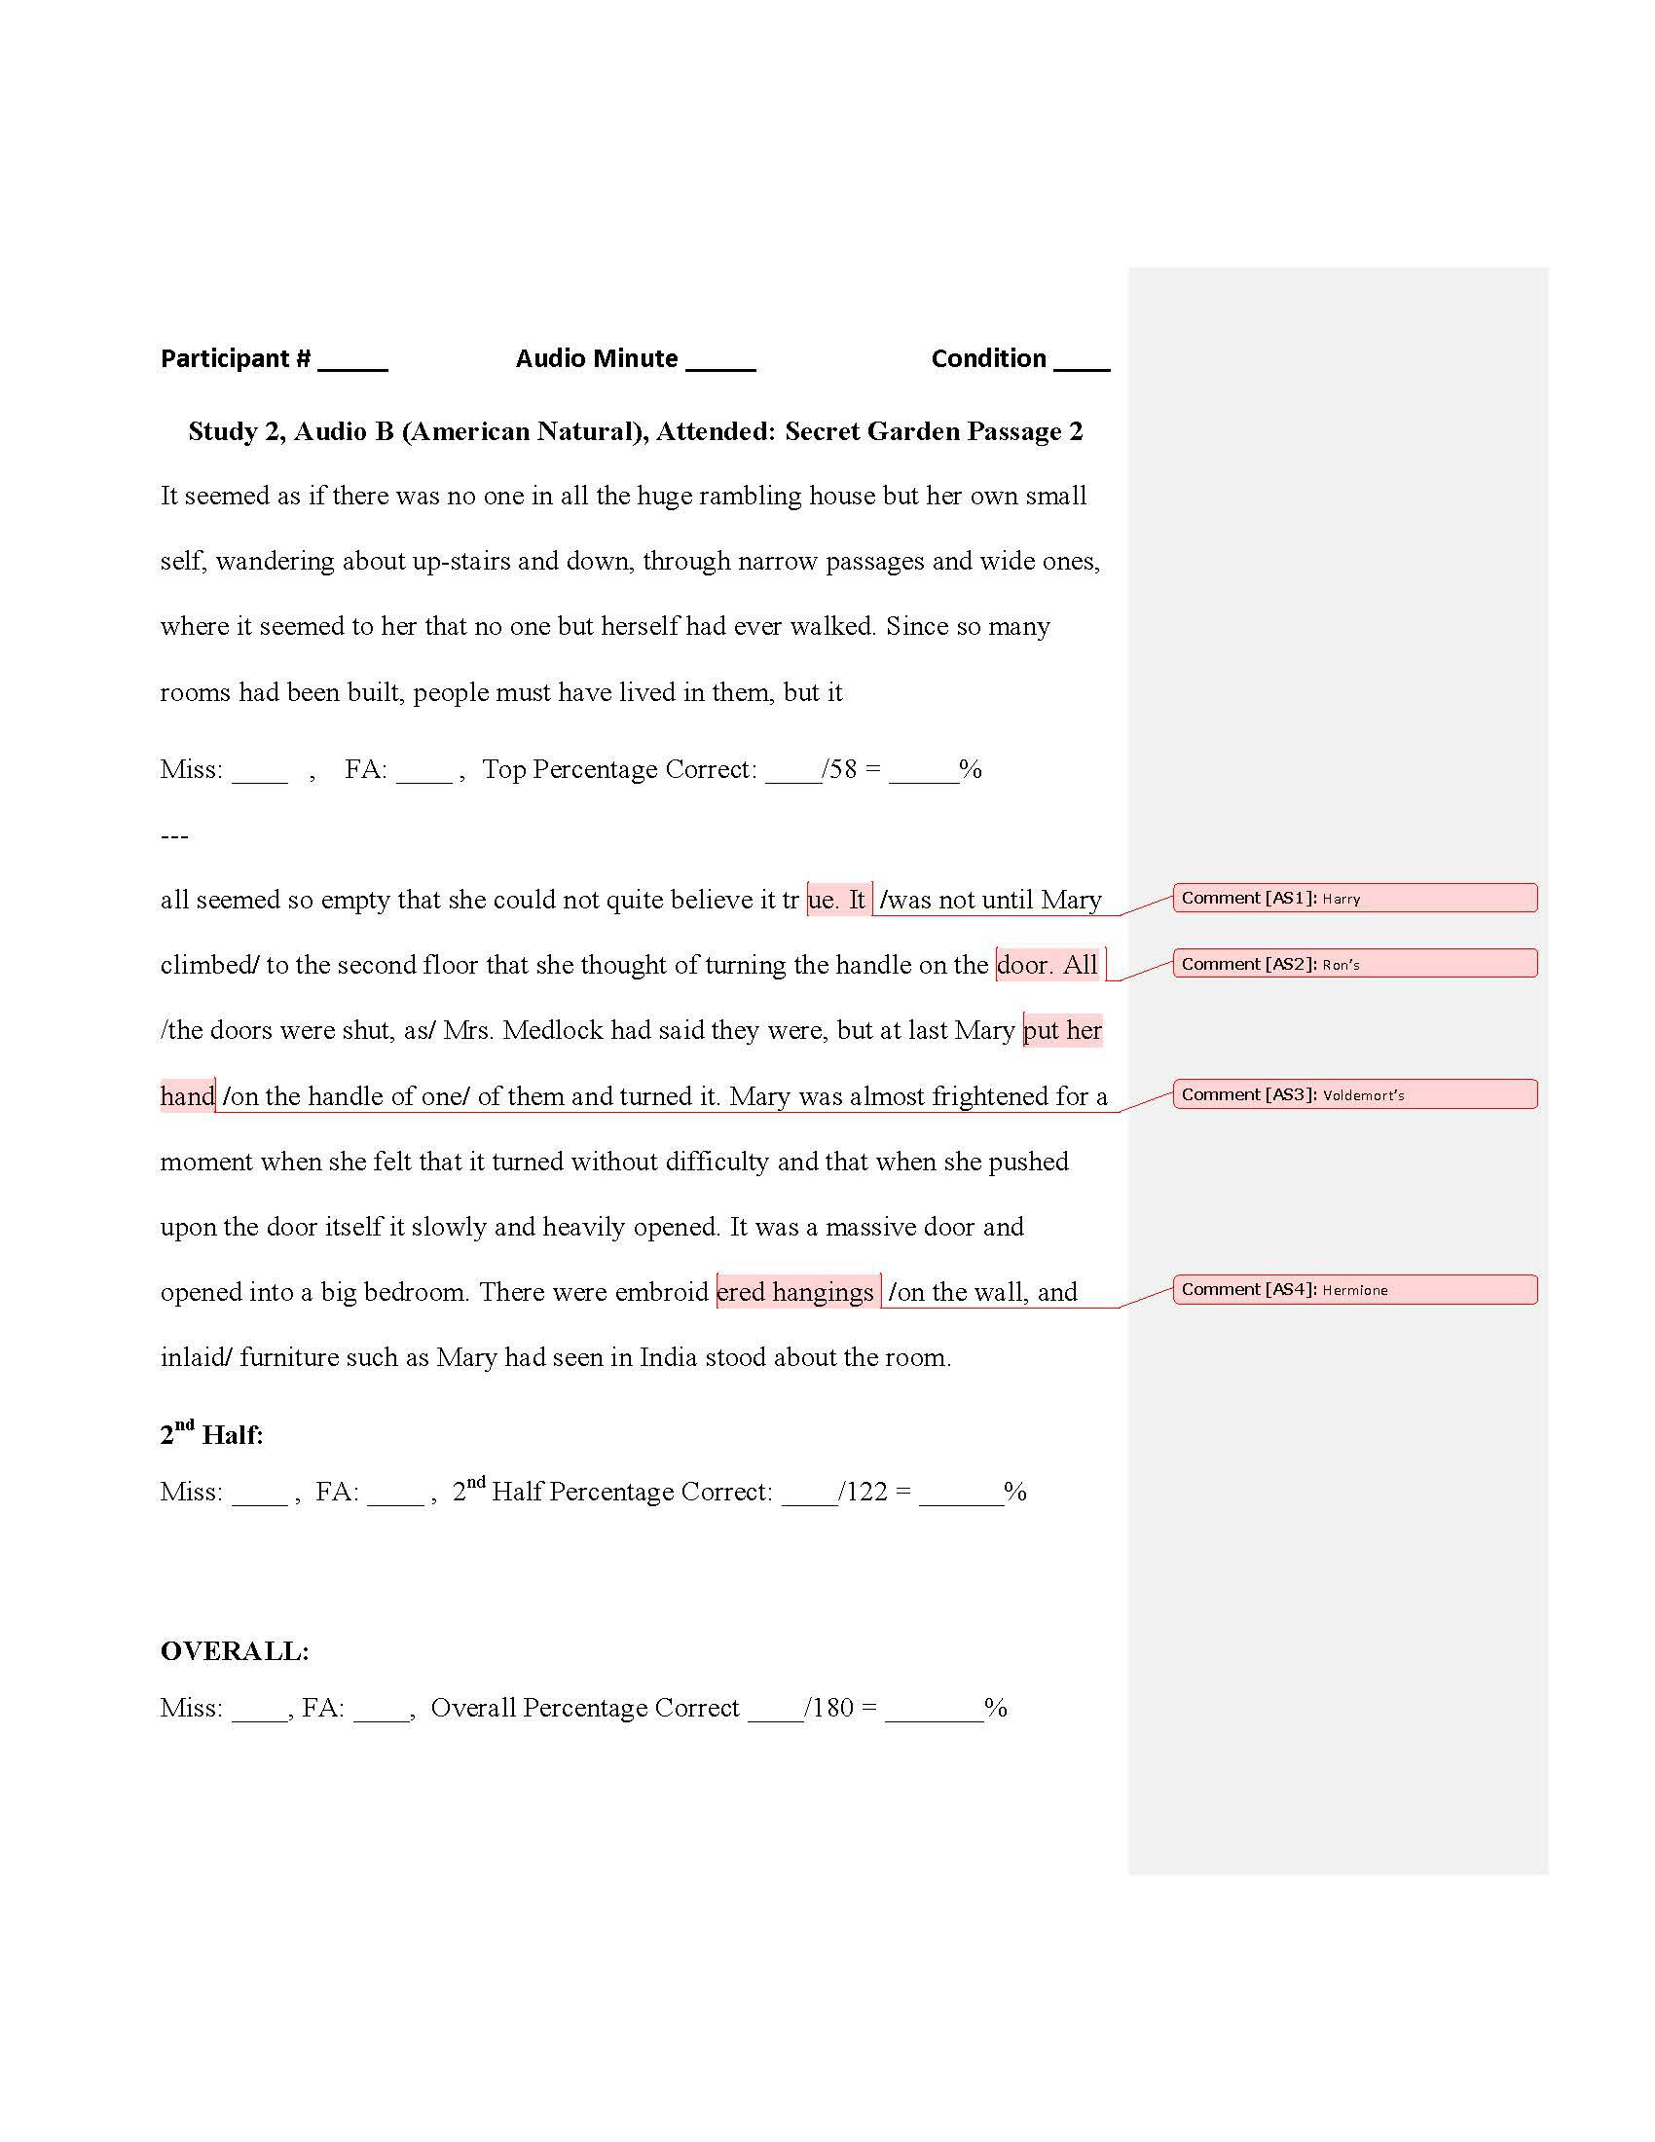

124

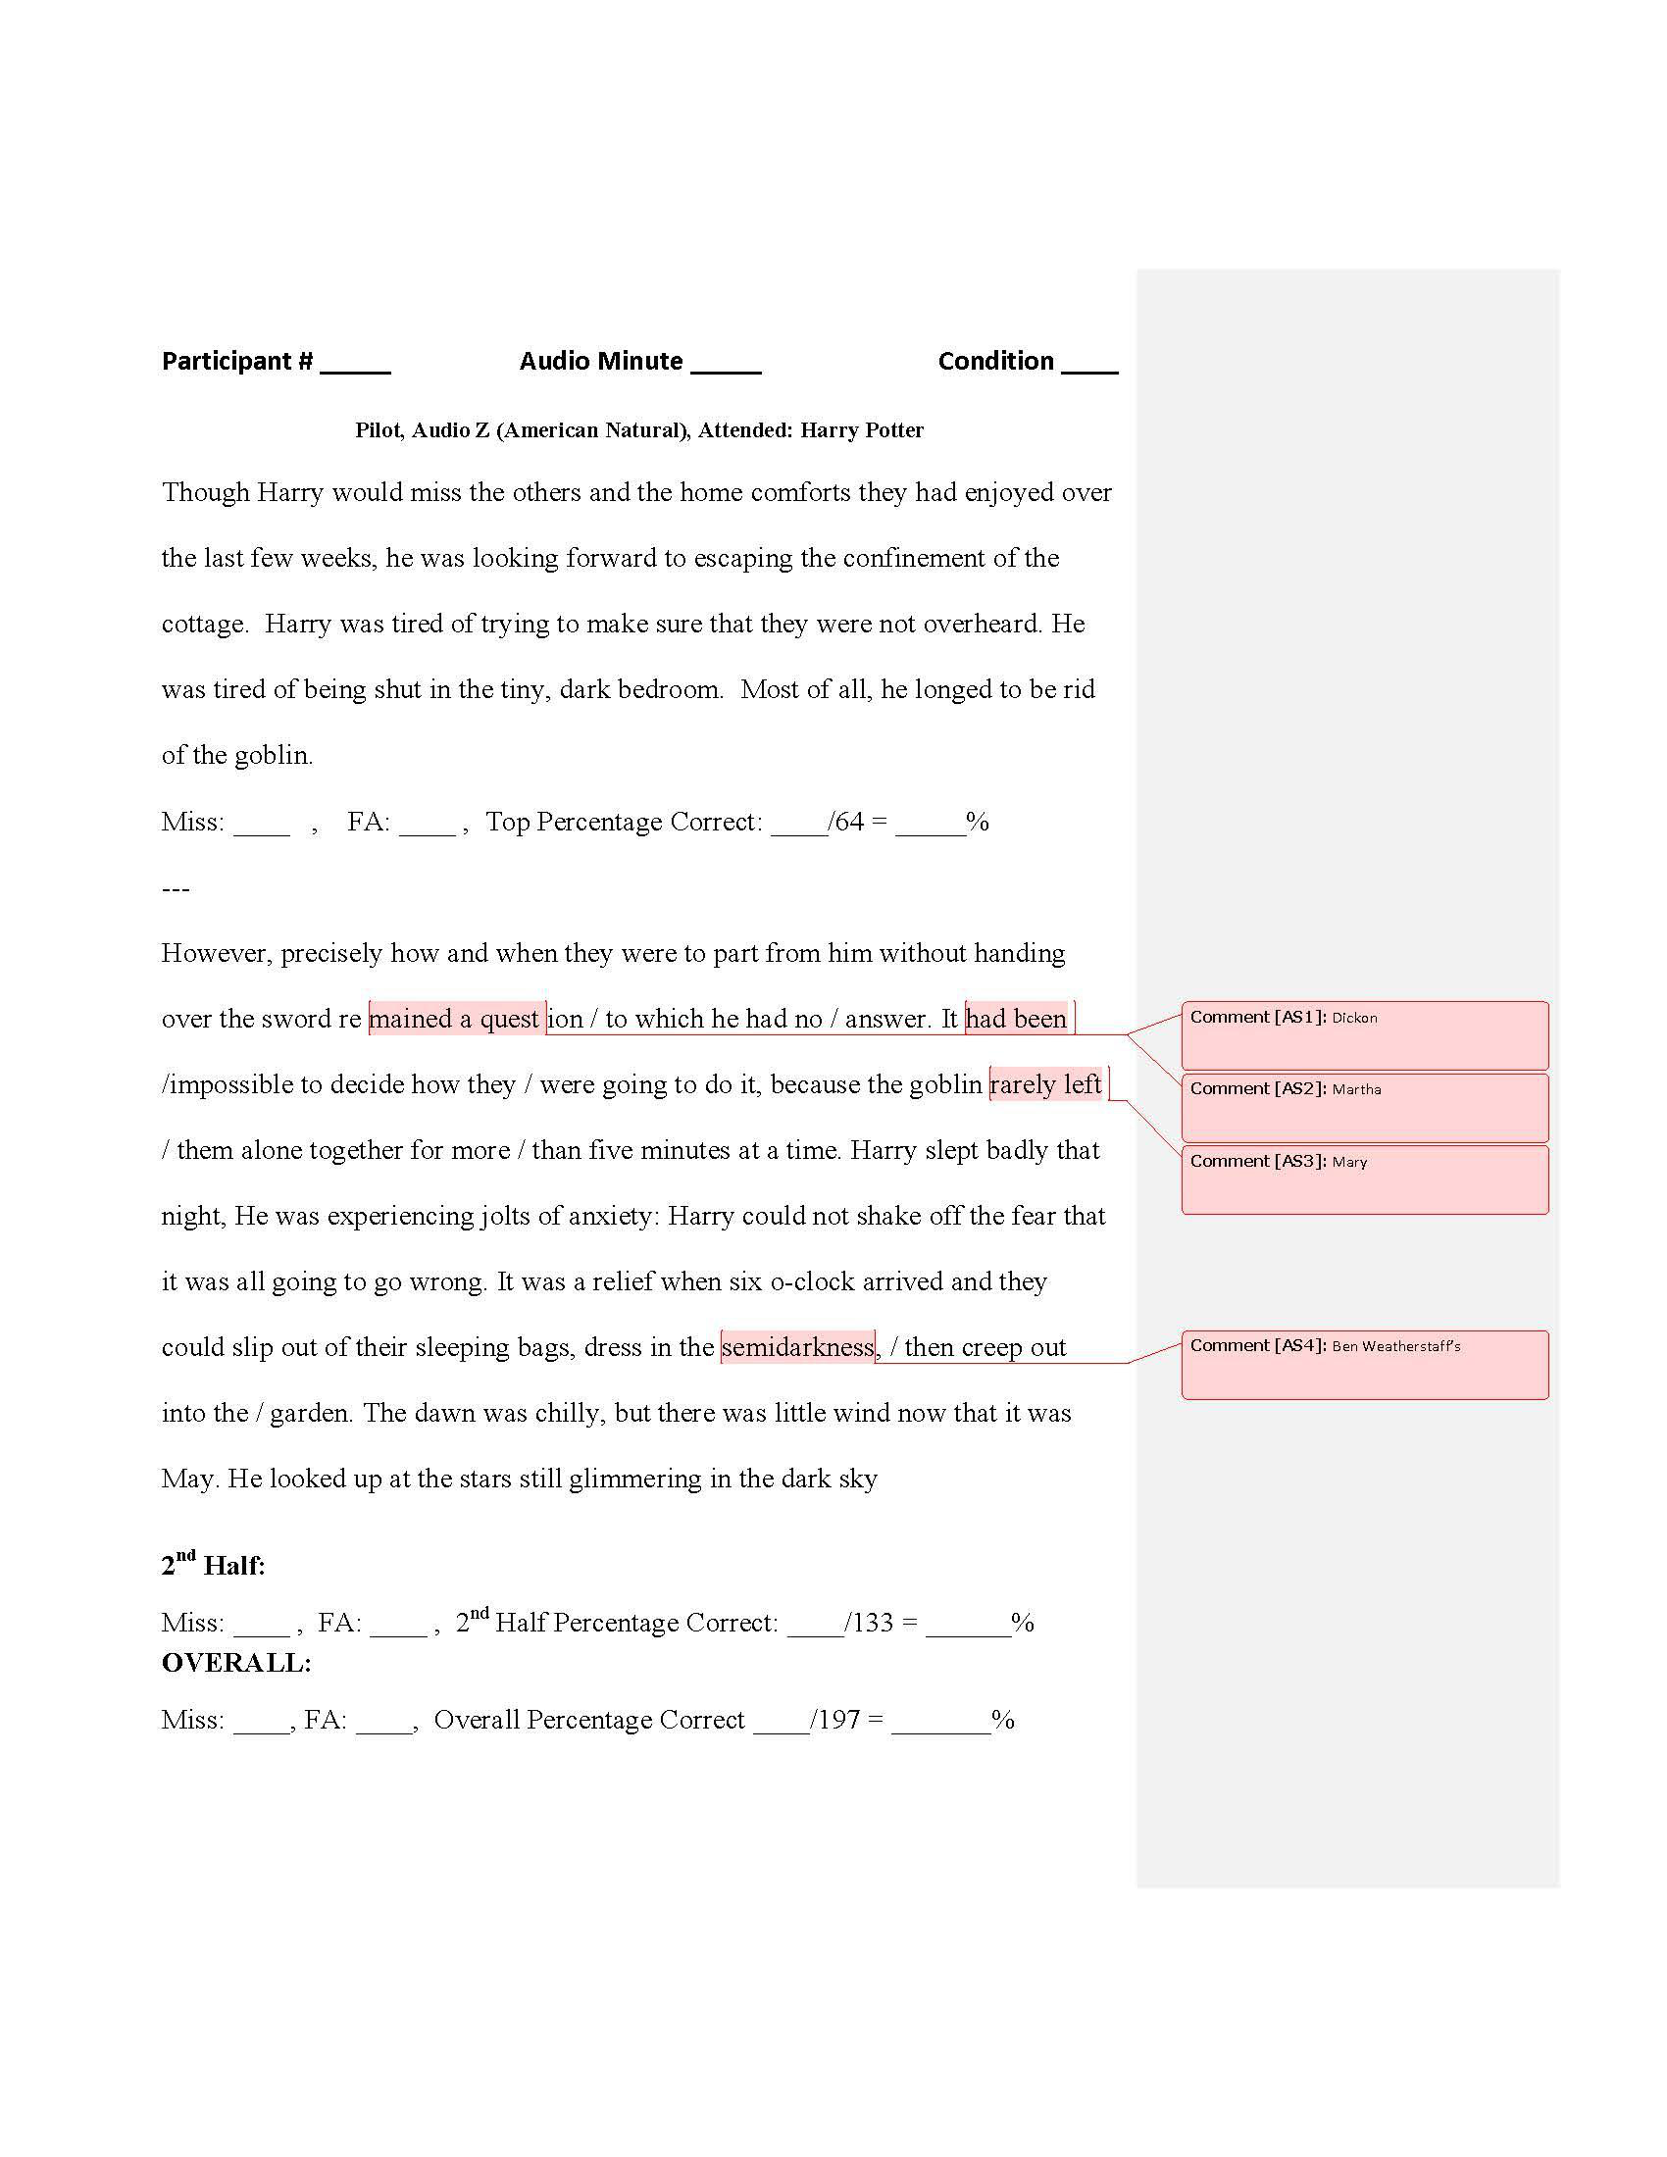

125

**APPENDIX H: PHOTO OF EXPERIMENTAL SETUP**

126

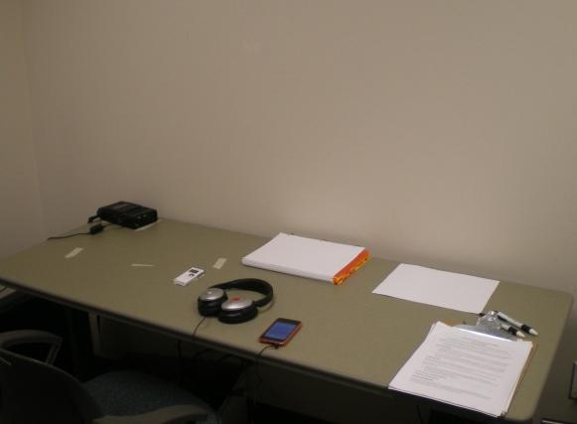

127

**APPENDIX I: PASSAGES USED TO CREATE STIMULI IN STUDY 1**

128

**Unattended Passages:**

**Audio A (Att: Synthetic, U: Natural)**

And **Ron** would turn away, making no effort to hide his disappointment. He knew that he was hoping to hear news of his family or of the rest of the **Order of the Phoenix**, but after all he was not a television. He could only see what **Voldemort** was thinking at the time, not tune in to whatever took his fancy. Apparently **FIRE** he was dwelling endlessly on the unknown youth with the gleeful face, whose name and whereabouts he knew no better than he did. As his scar continued to burn and the merry, blond-haired boy swam in his **FIRE** memory, **Harry** learned to suppress any sign of pain or discomfort. The other two showed nothing but impatience at the…

***121 words***

***Grade Level 10, Ease 61***

**Audio B (Att: Synthetic, U: Synthetic)**

From that moment on, **Mrs. Weasley** kept **Harry**, and them so busy with preparations for the wedding that they hardly had any time to think. The kindest explanation of this behavior would have been that she wanted to distract them all from thoughts of him and their recent journey. After two days of nonstop cutlery

cleaning, of color-matching favors **FIRE**, ribbons, and flowers, of de-gnoming the garden and helping her cook canapés, however, he started to suspect her of a different motive. All the **FIRE** jobs she handed out seemed to keep him, **Ron**, and **Hermione** away from one another; he had not had a chance to speak to them since the…

***112 words***

***Grade Level 10, Ease 58***

129

**Audio C (Att: Natural, U: Synthetic)**

The man lunged at **Hermione**, reaching for her throat. Then, with a bang and a burst of red light he was thrown backward onto the ground and knocked   
unconscious. **Ron** stood there with his wand still outstretched and a look of shock visible behind his beard. Faces appeared at the windows on either side of the street. A **FIRE** little knot of prosperous passersby gathered up their robes and broke into gentle trots, all keen to vacate the scene. Their entrance into **Diagon Alley** could hardly have **FIRE** been more conspicuous; for a moment **Harry** wondered whether it might not be better to leave now and try to think of a different plan. They heard a cry.

***117 words***

***Grade Level 10, Ease Score 58***

**Audio D (Att: Natural, U: Natural)**

Though **Harry** would miss the others and the home comforts they had enjoyed over the last few weeks, he was looking forward to escaping the confinement of the cottage. He was tired of trying to make sure that they were not overheard. He was tired of being shut in the tiny, dark bedroom. Most of all, he longed to be rid of him. However **FIRE** precisely how and when they were to part from the goblin without handing over the **Gryffindor** sword remained a question to which he had no answer. It had been **FIRE** impossible to decide how they were going to do it, because the goblin rarely left him, **Ron** and **Hermione** alone together for more than five minutes at a…

***123 words***

***Grade Level 10, Ease Score 58***

**All of the unattended passages were excerpts from *Harry Potter and the***

***Deathly Hallows (Rowling, 2007a).***

130

**Attended Passages:**

**Practice Audio 1 (Att: Natural, U: None)**

Mary was just thinking this when she saw that at the end of the path she was following there seemed to be a long wall with ivy growing over it. Mary was not familiar enough with England to know that she was coming upon the gardens where the vegetables and fruit were growing. She went toward the wall and found that there was a green door in the ivy and that it stood open. This was not the closed garden evidently and she could go into it. Mary went through the door and found that it was a garden with walls all round it and that it was only one of several walled gardens which seemed to open into one another. She saw another open green door revealing bushes and pathways between beds containing winter   
vegetables. Fruit trees were trained flat against the wall and over some of the beds there were glass frames. The place was bare and ugly enough, Mary thought, as she stood and stared about her at …

**172 words**   
**Grade Level 10, Ease 63**

**Practice Audio 2 (Att: Synthetic, U: None)**

It seemed as if there was no one in all the huge rambling house but her own small self, wandering about up-stairs and down, through narrow passages and wide ones, where it seemed to her that no one but herself had ever walked. Since so many rooms had been built, people must have lived in them, but it all seemed so empty that she could not quite believe it true.

It was not until Mary climbed to the second floor that she thought of turning the handle of a door. All the doors were shut, as Mrs. Medlock had said they were, but at last Mary put her hand on the handle of one of them and turned it. Mary was almost frightened for a moment when she felt that it turned without difficulty and that when she pushed upon the door itself it slowly and heavily opened. It was a massive door and opened into a big bedroom. There were embroidered hangings on the wall, and inlaid furniture…

**169 words**   
**Grade Level 10, Ease 63**

131

**Audio A (Att: Synthetic, U: Natural)**

In one room, which looked like a lady's sitting room, the hangings were velvet, and in a cabinet were about a hundred elephants made of ivory. Mary had seen carved ivory in India and she knew all about elephants. Mary opened the door of the cabinet and stood on a footstool and played with these for quite a long time. When she got tired she set the elephants in order and shut the door of the cabinet. In all her wanderings through the long corridors and the empty rooms, Mary had seen nothing alive; but in this room she saw something. Just after she had closed the cabinet door she heard a tiny rustling sound. It made Mary jump and look around at the sofa by the fireplace, from which it seemed to come. In the corner of the sofa there was a cushion, and in the velvet which covered it there was a hole, and out of the hole peeped a tiny head with a pair of…

**168 words**   
**Grade Level 10, Ease 61**

**Audio B (Att: Synthetic, U: Synthetic)**

The robin was tremendously busy. He was very much pleased to see gardening begun on his own estate. He had often wondered at Ben Weatherstaff. Where gardening is done all sorts of delightful things to eat are turned up with the soil. Now here was this new kind of creature who was not half Ben's size and yet had had the sense to come into his garden and begin at once.

Mistress Mary worked in her garden until it was time to go to her midday dinner. In fact, she was rather late in remembering, and when she put on her coat and hat, and picked up her skipping-rope, she could not believe that she had been working two or three hours. Mary had been actually happy all the time; and dozens and dozens of the tiny, pale green points were to be seen in cleared places, looking twice as cheerful as they had looked before when the grass and weeds had been smothering them.

**165 words**   
**Grade Level 10, Ease 63**

132

**Audio C (Att: Natural, U: Synthetic)**

They ran from one part of the garden to another and found so many wonders that they were obliged to remind themselves that they must whisper or speak low. Dickon showed her swelling leaf buds on rose branches that had seemed dead. He showed Mary ten thousand new green points pushing through the mould. They put their eager young noses close to the earth and sniffed its warmed springtime. They dug and pulled and laughed low with rapture until Mistress Mary's hair was as tumbled as Dickon's and her cheeks were almost as poppy red as his. There was every joy on earth in the secret garden that morning, and in the midst of them came a delight more delightful than all, because it was more wonderful. Swiftly   
something flew across the wall and darted through the trees to a close grown corner, a little flare of red bird with something hanging from its…

**154 words**   
**Grade Level 10, Ease 59**

**Audio D (Att: Natural, U: Natural)**

Mary worked and dug and pulled up weeds steadily, only becoming more pleased with her work every hour instead of tiring of it. It seemed to her like a fascinating sort of play. Mary found many more of the sprouting pale green points than she had ever hoped to find. They seemed to be starting up everywhere and each day she was sure she found tiny new ones, some so tiny that they barely peeped above the earth. There were so many, that she remembered what Martha had said about the "snowdrops by the thousands," and bulbs spreading and making new ones. These had been left to themselves for ten years and perhaps they had spread, like the snowdrops, into thousands. Mary wondered how long it would be before they showed that they were flowers. Sometimes she stopped digging to look at the garden and imagine what it would be like when it was covered with thousands of lovely things in bloom.

**162 words**   
**Grade Level 10, Ease 63**

**All of the attended passages were excerpts from *The Secret Garden* (Burnett, 1911)**

133

**APPENDIX J: PASSAGES USED TO CREATE STIMULI IN STUDY 2**

134

**Unattended Passages:**

**Audio A - Passage 1 (Audiobook edited excerpt, British Natural):**

And he would turn away, making no effort to hide his disappointment. He knew that **Ron** was hoping to hear news of his family or of the rest of the **Order of the Phoenix**, but after all he was not a television. He could only see what **Voldemort** was thinking at the time, not tune in to whatever took his fancy. Apparently he was dwelling endlessly on the unknown youth with the gleeful face, whose name and whereabouts he felt sure he knew no better than he did. As **Harry’s** scar continued to burn and the merry, blond-haired boy swam tantalizingly in his memory, he learned to suppress any sign of pain or discomfort. For the other two showed nothing but impatience at the mention of the thief. He could not entirely blame them

134 words   
Grade: 11, Ease: 56

**Audio B - Passage 3 (American Natural):**

His eyes flew open as he wrenched himself back to the present. **Harry** was lying on the bank of the lake in the setting sun, and they were looking down at him.

Judging by **Ron’s** worried look, and by the continued pounding of his scar, his sudden excursion into **Voldemort's** mind had not passed unnoticed. The flapping of enormous wings echoed across the black water; the dragon had drunk its fill and risen into the air. They paused in their preparations and watched it climb higher and higher, now black against the rapidly darkening sky, until it vanished over a nearby mountain. Then **Hermione** walked forward and took her place between the other two. He pulled the Cloak down as far as it would go, and together they turned on the

131 words   
Grade: 10, Ease: 60

135

**Audio C - Passage 2 (British Synthetic):**

Though he would miss the others and the home comforts that they had enjoyed over the last few weeks, **Harry** was looking forward to escaping the confinement of the cottage. He was tired of trying to make sure that they were not overheard. Most of all, he longed to be rid of him. Precisely how and when they were going to part from the goblin without handing over the **Gryffindor** sword remained a question to which he had no answer. It had been impossible to decide how they were going to do it. The goblin rarely left him and **Ron** alone together for more than five minutes at a time. **Hermione** disapproved so much of the planned double cross that he had given up attempt

125 words   
Grade: 10, Ease: 57

**Audio D - Passage 4 (American Synthetic):**

By day, they devoted themselves to trying to determine the possible locations of the sword, but the more they talked about the places in which **Dumbledore** might have hidden it, the more desperate and far-fetched their speculation became. **Harry** could not remember him ever mentioning a place in which he might hide   
something. There were moments when he did not know whether he was angrier with **Ron** or with him. He had left them with virtually nothing. Hopelessness threatened to engulf him. He knew nothing, he had no ideas, and he was   
constantly, painfully on the alert for any indications that **Hermione** too was about to tell him that she had had enough. That she was leaving. They were spending many evenings

122 words

Grade: 10, Ease: 51

**All 4 unattended passages were excerpts from *Harry Potter and the Deathly Hallows* (Rowling, 2007a).**

136

**Attended Passages:**

**Study 2, Practice Stimuli - Secret Garden Passage 4**

The robin was tremendously busy. He was very much pleased to see gardening begun on his own estate. Where gardening is done all sorts of delightful things to eat are turned up with the soil. Now here was this new kind of creature who was not half Ben's size and yet had had the sense to come into the garden and begin at once. Mistress Mary worked in her garden until it was time to go to her midday dinner. In fact, Mary was rather late in remembering, and when she put on her coat and hat, and picked up her skipping-rope, she could not believe that she had been working two or three hours. Mary had been actually happy all the time; and dozens and dozens of the tiny, pale green points were to be seen in cleared places, looking twice as cheerful as they had looked before when the grass and weeds had been smothering them. Then she ran lightly across the grass, pushed open the slow old door and slipped through it under the ivy.

185 words; Grade: 10, Ease: 62

**Study 2, Audio A - Attended: Secret Garden Passage 1**

Mary was just thinking this when she saw that at the end of the path she was following, there seemed to be a long wall with ivy growing over it. Mary was not familiar enough with England to know that she was coming upon the gardens where the vegetables and fruit were growing. She went toward the wall and found that there was a green door in the ivy and that it stood open. This was not the closed garden evidently and she could go into it. Mary went through the door and found that it was a garden with walls all round it and that it was only one of several walled gardens which seemed to open into one another. She saw another open green door revealing bushes and pathways between beds containing winter   
vegetables. Fruit trees were trained flat against the wall and over some of the beds there were glass frames. The place was bare and ugly enough, Mary thought, as she stood and stared about her at the garden. It might be nicer in summer when things were green, but there was nothing pretty about it now.

191 words, Grade: 10, Ease: 52

137

**Study 2, Audio B - Attended: Secret Garden Passage 2**

It seemed as if there was no one in all the huge rambling house but her own small self, wandering about up-stairs and down, through narrow passages and wide ones, where it seemed to her that no one but herself had ever walked. Since so many rooms had been built, people must have lived in them, but it all seemed so empty that she could not quite believe it true. It was not until Mary climbed to the second floor that she thought of turning the handle of a door. All the doors were shut, as Mrs. Medlock had said they were, but at last Mary put her hand on the handle of one of them and turned it. Mary was almost frightened for a moment when she felt that it turned without difficulty and that when she pushed upon the door itself it slowly and heavily opened. It was a massive door and opened into a big bedroom. There were embroidered hangings on the wall, and inlaid furniture such as Mary had seen in India stood about the room.

180 words; Grade: 11, Ease: 59

**Study 2, Audio C – Attended: Secret Garden Passage 3**

In one room, which looked like a lady's sitting room, the hangings were velvet, and in a cabinet were about a hundred elephants made of ivory. Mary had seen carved ivory in India and she knew all about elephants. Mary opened the door of the cabinet and stood on a footstool and played with these for quite a long time. When she got tired she set the elephants in order and shut the door of the cabinet.

In all her wanderings through the long corridors and the empty rooms, Mary had seen nothing alive; but in this room she saw something. Just after she had closed the cabinet she heard a tiny rustling sound. It made Mary jump and look around at the sofa by the fireplace, from which it seemed to come. In the corner of the sofa there was a cushion, and in the velvet which covered it there was a hole, and out of the hole peeped a tiny head with a pair of frightened eyes in it. Mary crept softly across the room to look. The bright eyes belonged to a little gray mouse.

188 words; Grade: 10, Ease: 57

138

**Study 2, Audio D - Attended: Secret Garden Passage 5**

Mary worked and dug and pulled up weeds steadily, only becoming more pleased with her work every hour instead of tiring of it. It seemed to her like a fascinating sort of play. Mary found many more of the sprouting pale green points than she had ever hoped to find. They seemed to be starting up everywhere and each day she was sure she found tiny new ones, some so tiny that they barely peeped above the earth. There were so many, that she remembered what Martha had said about the "snowdrops by the thousands," and bulbs spreading and making new ones. These had been left to themselves for ten years and perhaps they had spread, like the snowdrops, into thousands. Mary wondered how long it would be before they showed that they were flowers. Sometimes she stopped digging to look at the garden and imagine what it would be like when it was covered with thousands of lovely things in bloom. She was beginning to like to be outdoors.

170 words; Grade: 10, Ease: 58

**All of the Attended passages were excerpts from The Secret Garden (Burnett, 1911)**

139

**APPENDIX K: PASSAGES USED TO CREATE STIMULI IN PILOT STUDY FOR FUTURE WORK**

140

**Unattended Passages:**

Passage 3 (Pilot) – Audio Y – *Harry Potter and the Deathly Hallows* (Rowling, 2007a)

His eyes flew open as he wrenched himself back to the present. **Harry** was lying on the bank of the lake in the setting sun, and they were looking down at him.

Judging by **Ron’s** worried look, and by the continued pounding of his scar, his sudden excursion into **Voldemort's** mind had not passed unnoticed. The flapping of enormous wings echoed across the black water; the dragon had drunk its fill and risen into the air. They paused in their preparations and watched it climb higher and higher, now black against the rapidly darkening sky, until it vanished over a nearby mountain. Then **Hermione** walked forward and took her place between the other two. He pulled the Cloak down as far as it would go, and together they turned on the   
131 words   
Grade: 10, Ease: 60

Passage 5 (Pilot) – Audio Z – *The Secret Garden* (Burnett, 1911)

She walked away, slowly thinking. She had begun to like the garden just as she had begun to like **Dickon** and the robin. She was beginning to like **Martha**, too. That seemed a good many people to like —when you’re not used to liking. **Mary** thought of the robin as one of the people. She went to her walk outside the long, ivy-covered wall over which she could see the tree-tops. And the second time she walked up and down the most interesting and exciting thing happened to her, and it was all through **Ben Weatherstaff's** robin. She heard a chirp, and when she looked at the bare flower-bed at her left side there he was hopping about pretending 119 words   
Grade: 9, Ease: 64

141

**Attended Passages:**

**Pilot, Practice Stimuli - Attended: The Golden Compass (Pullman, 1995)**

The ship was moving oddly, rocking from side to side instead of the plunging and soaring. Lyra was on deck a minute after she woke up, gazing greedily at the land: such a strange sight, after all that water, for though they had only been at sea a few days, Lyra felt as if they’d been on the ocean for months. Directly ahead of the ship a mountain rose, green flanked and snowcapped, and a little town and harbor lay below it: she saw wooden houses with steep roofs, cranes in the harbor, and clouds of gulls wheeling and crying. Seals frisked around the ship, showing their faces above the water before sinking back without a splash. The wind that lifted spray off the whitecapped waves was monstrously cold, and searched out every gap in Lyra’s wolfskin, and her hands were soon aching and her face numb. It was too cold to stay outside for long without work to do, even to watch the seals, and Lyra went below to eat her breakfast porridge and to look through the porthole in the saloon.

183 words; Grade: 13, Ease: 53

**Pilot, Audio Y – Attended: Secret Garden Passage (Burnett, 1911)**

Mary was just thinking this when she saw that at the end of the path she was following, there seemed to be a long wall with ivy growing over it. Mary was not familiar enough with England to know that she was coming upon the gardens where the vegetables and fruit were growing. She went toward the wall and found that there was a green door in the ivy and that it stood open. This was not the closed garden evidently and she could go into it. Mary went through the door and found that it was a garden with walls all round it and that it was only one of several walled gardens which seemed to open into one another. She saw another open green door revealing bushes and pathways between beds containing winter   
vegetables. Fruit trees were trained flat against the wall and over some of the beds there were glass frames. The place was bare and ugly enough, Mary thought, as she stood and stared about her at the garden. It might be nicer in summer when things were green, but there was nothing pretty about it now.

191 words, Grade: 10, Ease: 52

142

**Pilot, Audio Z - Attended: Harry Potter Passage (Rowling, 2007a)**

Though Harry would miss the others and the home comforts they had enjoyed over the last few weeks, he was looking forward to escaping the confinement of the cottage. Harry was tired of trying to make sure that they were not overheard. He was tired of being shut in the tiny, dark bedroom. Most of all, he longed to be rid of the goblin. However, precisely how and when they were to part from him without handing over the sword remained a question to which he had no answer. It had been impossible to decide how they were going to do it, because the goblin rarely left them alone together for more than five minutes at a time. Harry slept badly that night, He was experiencing jolts of anxiety: Harry could not shake off the fear that it was all going to go wrong. It was a relief when six o-clock arrived and they could slip out of their sleeping bags, dress in the semidarkness, then creep out into the garden. The dawn was chilly, but there was little wind now that it was May. He looked up at the stars still glimmering in the dark sky.

197 Words; Grade: 10, Ease: 63

143

**APPENDIX L: IRB APPROVAL LETTER**

144

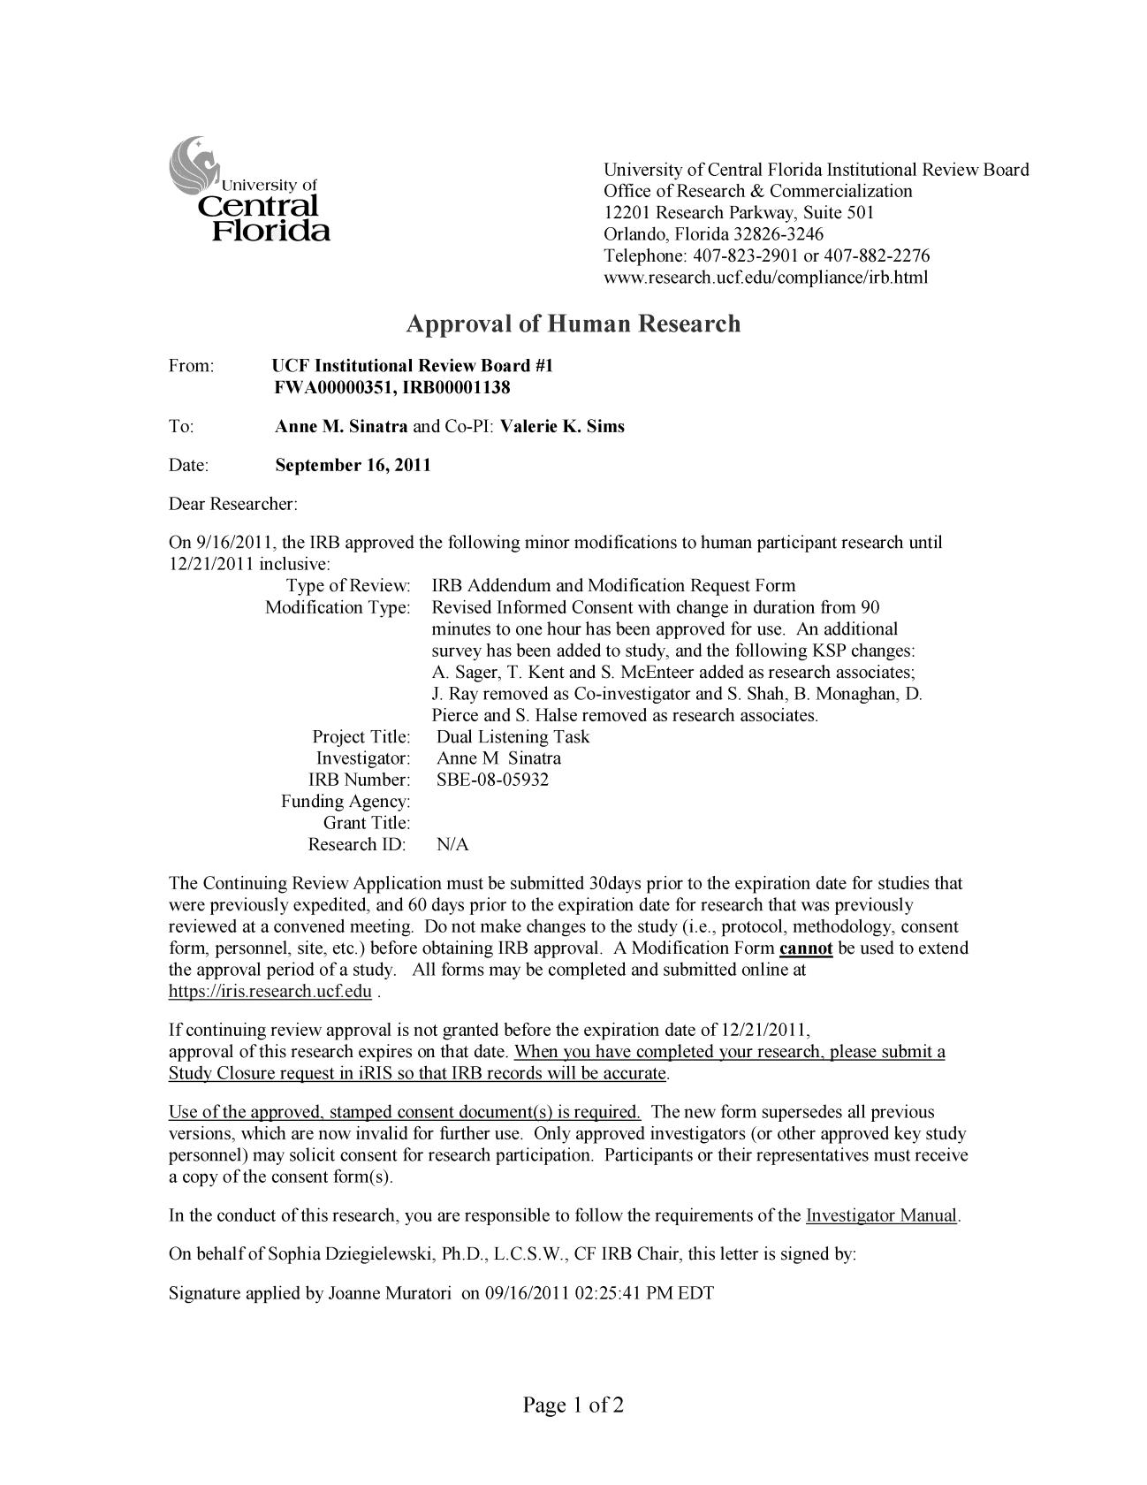

145



146

**APPENDIX M: INFORMED CONSENT FORM**

147

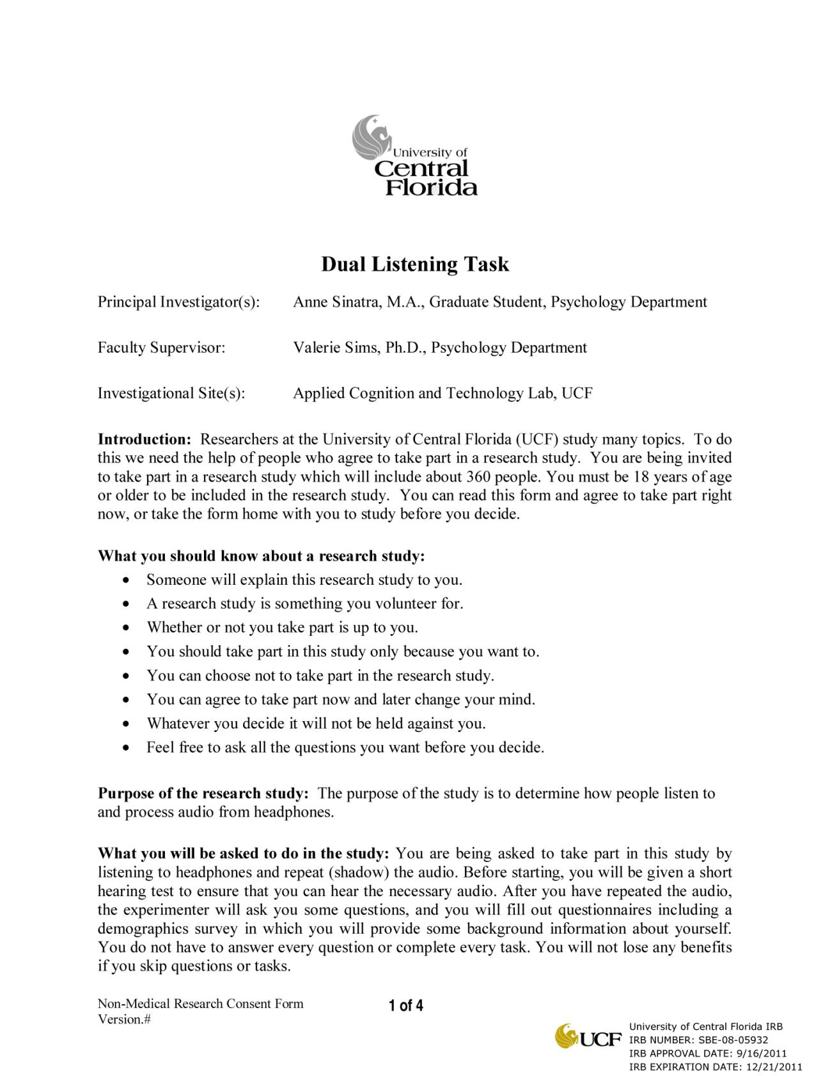

148

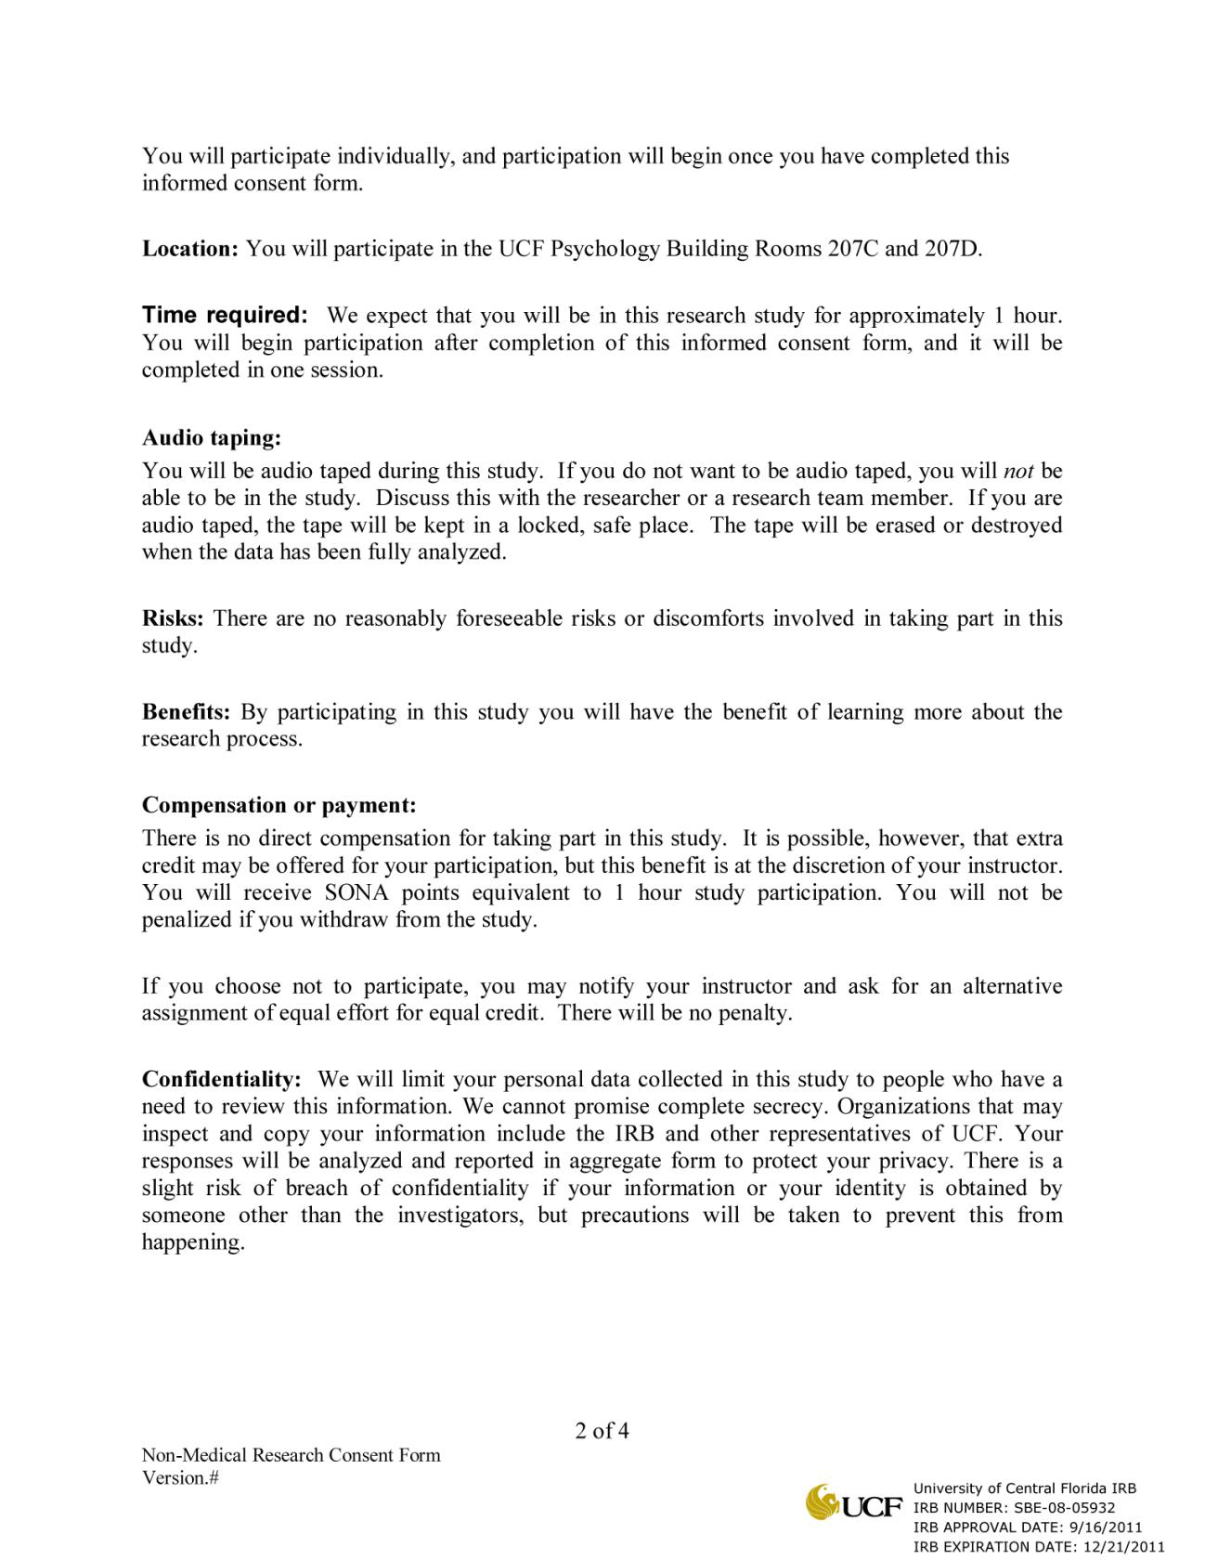

149

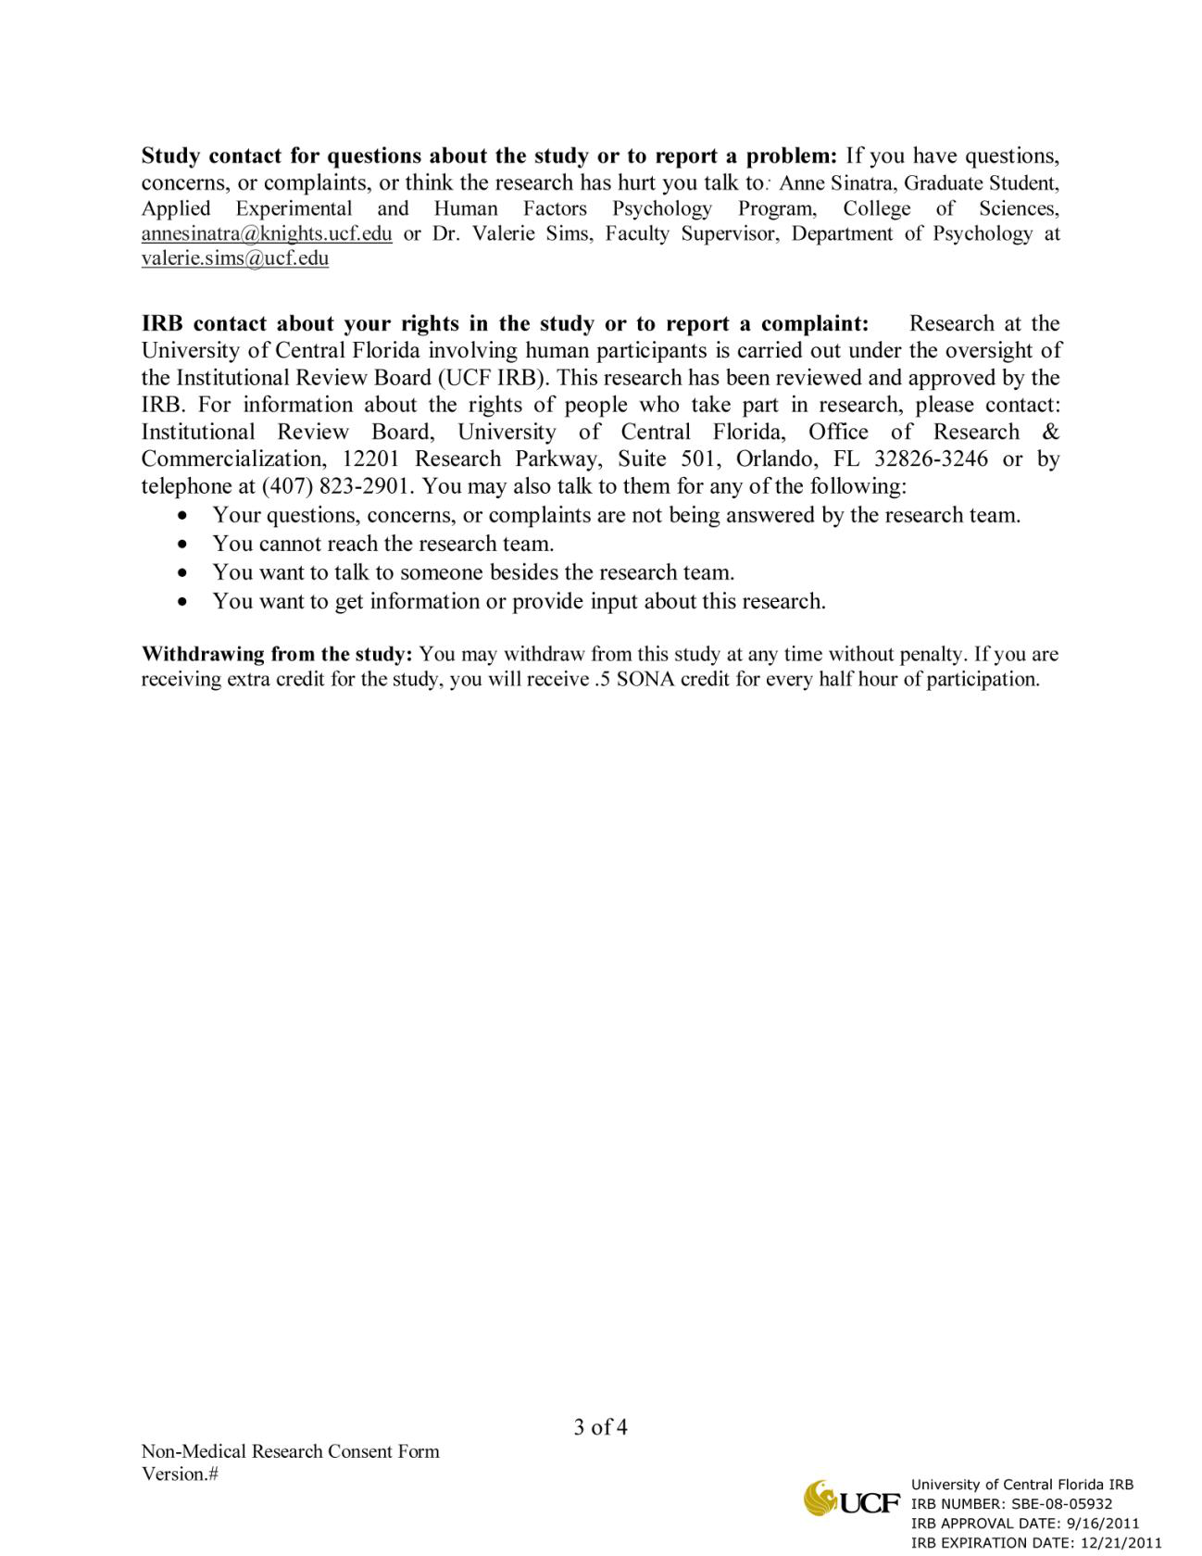

150

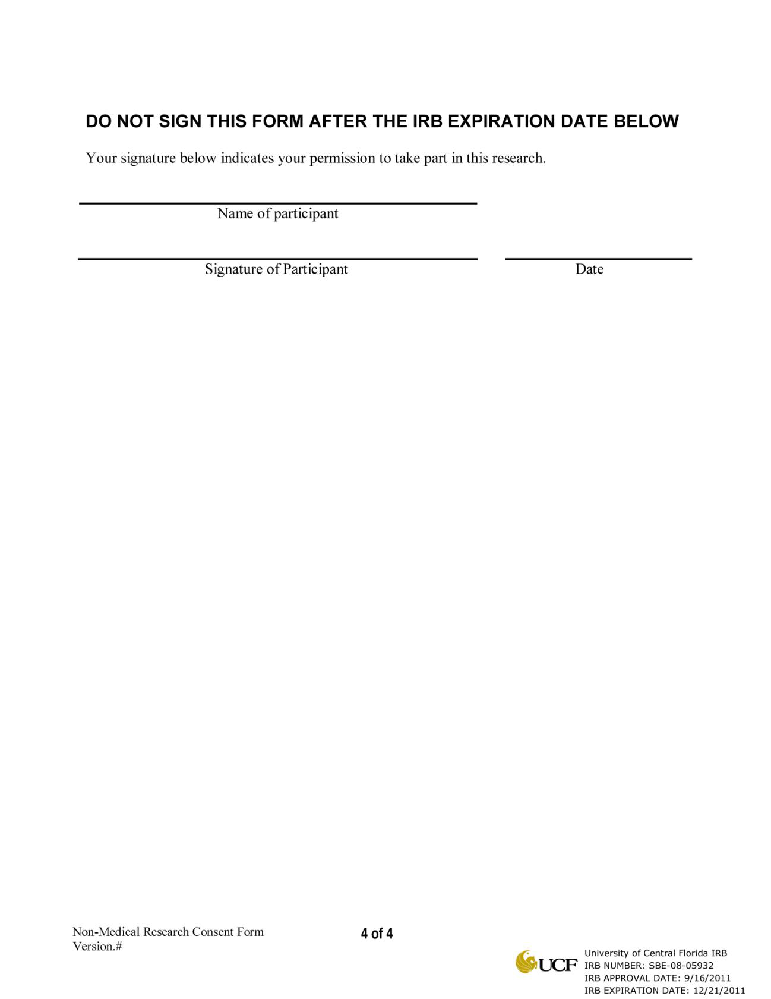

151

**APPENDIX N: POST PARTICIPATION FORM**

152

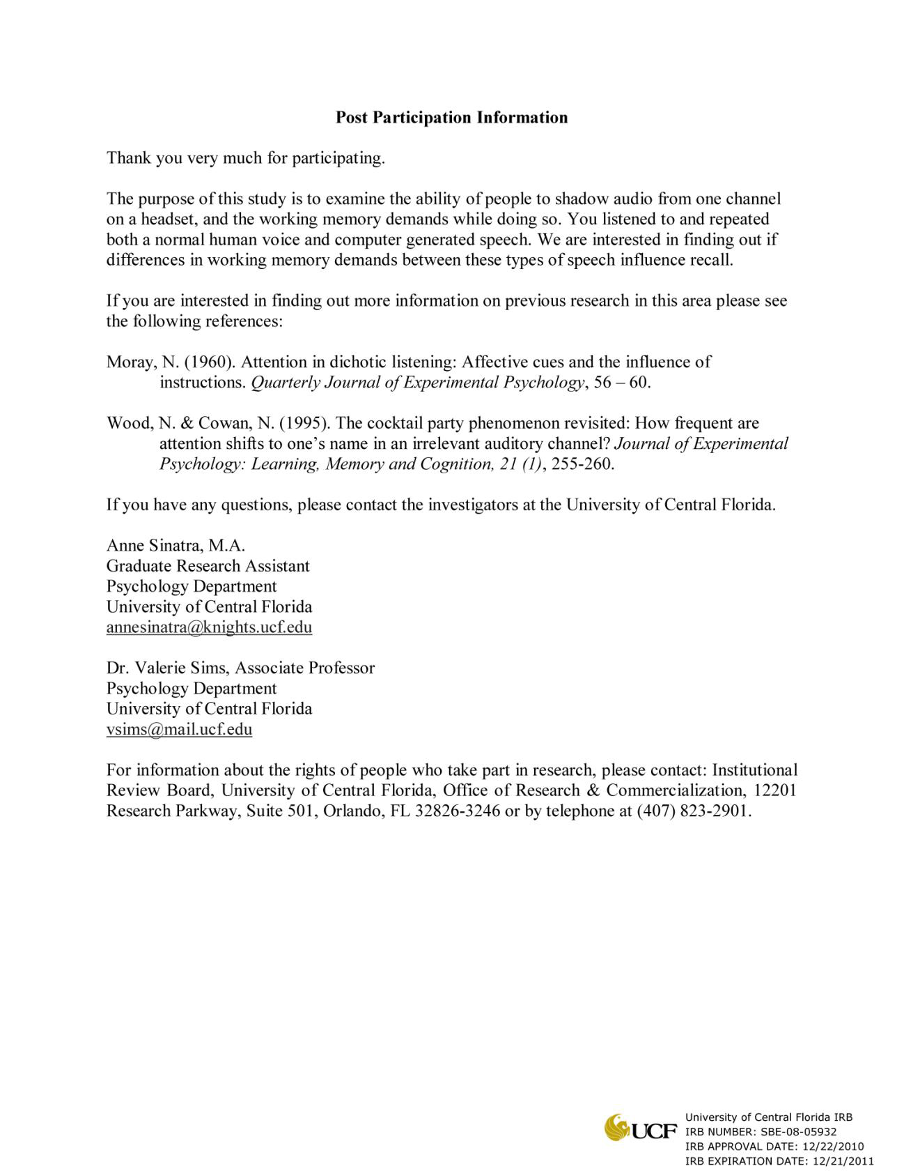

153

**APPENDIX O: MEANS AND STANDARD DEVIATIONS FOR STUDY 1**

154

Appendix Table 1.

*Reported Physical Characteristics, Means and Standard Deviations, Study 1*

|  |  |
| --- | --- |
| **High Harry Potter Experience** | Unattended Audio  Natural-Natural Synthetic-Natural  (Audio D) (Audio A) |

|  |  |
| --- | --- |
| Natural-Synthetic (Audio C) | Synthetic-Synthetic (Audio B) |

|  |  |  |  |  |
| --- | --- | --- | --- | --- |
| Mean | .70 | .60 | .50 | .60 |
| Standard Deviation | .675 | .699 | .707 | .699 |

**Low Harry Potter**   
**Experience**

|  |  |  |  |  |
| --- | --- | --- | --- | --- |
| Mean | .92 | 1.25 | .83 | .92 |
| Standard Deviation | .669 | .754 | .718 | .669 |

Appendix Table 2.

*Reported Harry Potter Information, Means and Standard Deviations, Study 1*

|  |  |
| --- | --- |
| **High Harry Potter Experience** | Unattended Audio  Natural-Natural Synthetic-Natural  (Audio D) (Audio A) |

|  |  |
| --- | --- |
| Natural-Synthetic (Audio C) | Synthetic-Synthetic (Audio B) |

|  |  |  |  |  |
| --- | --- | --- | --- | --- |
| Mean | .60 | .40 | .20 | .00 |
| Standard Deviation | .966 | .843 | .632 | .000 |

**Low Harry Potter**   
**Experience**

|  |  |  |  |  |
| --- | --- | --- | --- | --- |
| Mean | .25 | .33 | .00 | .08 |
| Standard Deviation | .622 | .492 | .000 | .289 |

155

Appendix Table 3.

*Number of Words Reported Representing Correct Attended Information, Means and Standard Deviations, Study 1*

|  |  |  |  |  |
| --- | --- | --- | --- | --- |
| Unattended Audio  Natural-Natural Synthetic-Natural  (Audio D) (Audio A) | | | Natural-Synthetic (Audio C) | Synthetic-Synthetic (Audio B) |
| **High Harry Potter**  **Experience** | | | 33.40 | 30.90 |
| Mean | 33.70 | 49.80 |
| Standard Deviation | 15.159 | 26.670 | 19.115 | 12.252 |

**Low Harry Potter**   
**Experience**

|  |  |  |  |  |
| --- | --- | --- | --- | --- |
| Mean | 31.17 | 34.92 | 30.83 | 22.25 |
| Standard Deviation 18.920 | | 29.923 | 18.080 | 13.261 |

Appendix Table 4.

*Shadowing Accuracy without Low-Threshold Words, Means and Standard Deviations, Study 1*

|  |  |  |  |  |
| --- | --- | --- | --- | --- |
| Unattended Audio  Natural-Natural Synthetic-Natural  (Audio D) (Audio A) | | | Natural-Synthetic (Audio C) | Synthetic-Synthetic (Audio B) |
| **High Harry Potter**  **Experience** | | | 81.86% | 77.22% |
| Mean | 78.83% | 74.36% |
| Standard Deviation | 14.10% | 17.20% | 14.68% | 16.26% |

**Low Harry Potter**   
**Experience**

|  |  |  |  |  |
| --- | --- | --- | --- | --- |
| Mean | 83.63% | 74.22% | 84.31% | 74.49% |
| Standard Deviation 13.77% | | 13.18% | 12.59% | 8.85% |

156

Appendix Table 5.

*Shadowing Accuracy following “fire”, Means and Standard Deviations, Study 1*

|  |  |  |  |  |
| --- | --- | --- | --- | --- |
| Unattended Audio  Natural-Natural Synthetic-Natural  (Audio D) (Audio A) | | | Natural-Synthetic (Audio C) | Synthetic-Synthetic (Audio B) |
| **High Harry Potter**  **Experience** | | | 80.00% | 72.50% |
| Mean | 92.50% | 100% |
| Standard Deviation | 16.87% | 0.00% | 25.82% | 29.93% |

**Low Harry Potter**   
**Experience**

|  |  |  |  |  |
| --- | --- | --- | --- | --- |
| Mean | 95.83% | 93.75% | 100% | 77.08% |
| Standard Deviation 9.73% | | 15.54% | 0.00% | 24.91% |

Appendix Table 6.

*Shadowing Accuracy following Harry Potter names, Means and Standard Deviations, Study 1*

|  |  |  |  |  |
| --- | --- | --- | --- | --- |
| Unattended Audio  Natural-Natural Synthetic-Natural  (Audio D) (Audio A) | | | Natural-Synthetic (Audio C) | Synthetic-Synthetic (Audio B) |
| **High Harry Potter**  **Experience** | | | 88.75% | 90.00% |
| Mean | 63.75% | 72.50% |
| Standard Deviation | 37.48% | 21.08% | 14.97% | 11.49% |

**Low Harry Potter**   
**Experience**

|  |  |  |  |  |
| --- | --- | --- | --- | --- |
| Mean | 76.04% | 62.50% | 91.67% | 73.96% |
| Standard Deviation 28.93% | | 19.22% | 12.31% | 19.55% |

157

Appendix Table 7.

*Perceived Stimulus Difficulty, Means and Standard Deviations, Study 1*

|  |  |
| --- | --- |
| **High Harry Potter Experience** | Unattended Audio  Natural-Natural Synthetic-Natural  (Audio D) (Audio A) |

|  |  |
| --- | --- |
| Natural-Synthetic (Audio C) | Synthetic-Synthetic (Audio B) |

|  |  |  |  |  |
| --- | --- | --- | --- | --- |
| Mean | 5.50 | 5.70 | 5.50 | 6.10 |
| Standard Deviation | 1.080 | 1.160 | 1.581 | .876 |

**Low Harry Potter**   
**Experience**

|  |  |  |  |  |
| --- | --- | --- | --- | --- |
| Mean | 5.54 | 5.75 | 5.50 | 6.17 |
| Standard Deviation | .838 | .965 | 1.168 | .835 |

158

**APPENDIX P: MEANS AND STANDARD DEVIATIONS FOR STUDY 2**

159

Appendix Table 8.

*Physical Characteristic Percentages, Means and Standard Deviations, Study 2*

|  |  |  |  |  |
| --- | --- | --- | --- | --- |
| Unattended Audio  American British  Natural Natural | | | American  Synthetic | British  Synthetic |
| **High Harry Potter**  **Experience** | | | 36.84% | 31.58% |
| Mean | 35.09% | 40.79% |
| Standard Deviation | 28.27% | 27.90% | 33.14% | 31.00% |

**Low Harry Potter**   
**Experience**

|  |  |  |  |  |
| --- | --- | --- | --- | --- |
| Mean | 42.11% | 39.47% | 47.39% | 32.89% |
| Standard Deviation 29.06% | | 26.77% | 30.05% | 28.93% |

Appendix Table 9.

*Amount of Reported Harry Potter Information, Means and Standard Deviations, Study 2*

|  |  |
| --- | --- |
| **High Harry Potter Experience** | Unattended Audio  American British  Natural Natural |

|  |  |
| --- | --- |
| American Synthetic | British  Synthetic |

|  |  |  |  |  |
| --- | --- | --- | --- | --- |
| Mean | .32 | .79 | .21 | .21 |
| Standard Deviation | .749 | 1.084 | .535 | .631 |

**Low Harry Potter**   
**Experience**

|  |  |  |  |  |
| --- | --- | --- | --- | --- |
| Mean | .21 | .00 | .00 | .00 |
| Standard Deviation | .535 | .000 | .000 | .000 |

160

Appendix Table 10.

*Number of Reported Words Representing Correct Attended Information, Means and Standard*  *Deviations, Study 2,*

|  |  |  |  |  |
| --- | --- | --- | --- | --- |
| Unattended Audio  American British  Natural Natural | | | American Synthetic | British  Synthetic |
| **High Harry Potter**  **Experience** | | | 30.00 | 44.21 |
| Mean | 34.68 | 32.26 |
| Standard Deviation | 18.717 | 16.155 | 15.560 | 19.564 |

**Low Harry Potter**   
**Experience**

|  |  |  |  |  |
| --- | --- | --- | --- | --- |
| Mean | 36.84 | 34.95 | 24.00 | 42.05 |
| Standard Deviation 15.233 | | 18.807 | 14.403 | 20.574 |

161

Appendix Table 11.

*Shadowing Accuracy without Low-Threshold Words, Means and Standard Deviations, Study 2*

|  |  |  |  |  |
| --- | --- | --- | --- | --- |
| Unattended Audio  American British  Natural Natural | | | American  Synthetic | British  Synthetic |
| **High Harry Potter**  **Experience** | | | 81.61% | 82.31% |
| Mean | 79.46% | 70.03% |
| Standard Deviation | 15.06% | 18.50% | 17.32% | 12.64% |

**Low Harry Potter**   
**Experience**

|  |  |  |  |  |
| --- | --- | --- | --- | --- |
| Mean | 76.68% | 67.97% | 75.44% | 75.78% |
| Standard Deviation 19.16% | | 19.19% | 19.49% | 23.09% |

162

Appendix Table 12.

*Shadowing Percent Correct following Harry Potter words, Means and Standard Deviations,*  *Study 2*

|  |  |  |  |  |
| --- | --- | --- | --- | --- |
| Unattended Audio  American British  Natural Natural | | | American  Synthetic | British  Synthetic |
| **High Harry Potter**  **Experience** | | | 73.63% | 74.47% |
| Mean | 82.63% | 62.37% |
| Standard Deviation | 13.78% | 33.18% | 27.68% | 24.60% |

**Low Harry Potter**   
**Experience**

|  |  |  |  |  |
| --- | --- | --- | --- | --- |
| Mean | 72.11% | 71.32% | 73.95% | 60.79% |
| Standard Deviation 27.71% | | 25.05% | 19.90% | 33.88% |

163

Appendix Table 13.

*Perceived Stimulus Difficulty, Means and Standard Deviations, Study 2*

|  |  |
| --- | --- |
| **High Harry Potter Experience** | Unattended Audio  American British  Natural Natural |

|  |  |
| --- | --- |
| American Synthetic | British  Synthetic |

|  |  |  |  |  |
| --- | --- | --- | --- | --- |
| Mean | 5.16 | 5.50 | 5.42 | 4.95 |
| Standard Deviation | 1.259 | 1.150 | 1.170 | 1.353 |

**Low Harry Potter**   
**Experience**

|  |  |  |  |  |
| --- | --- | --- | --- | --- |
| Mean | 4.72 | 5.17 | 5.17 | 4.67 |
| Standard Deviation | 1.447 | 1.295 | 1.465 | 1.414 |

164

**APPENDIX Q: MEANS AND STANDARD DEVIATIONS FOR PILOT STUDY FOR FUTURE WORK**

165

Appendix Table 14.

*Reported Physical Characteristics, Means and Standard Deviations, Pilot Study*

|  |  |  |  |  |
| --- | --- | --- | --- | --- |
| |  |  | | --- | --- | | **High Harry Potter Experience** | Unattended Audio Harry Potter The Secret Garden | | | |
| Mean | .88 | 1.00 |
| Standard Deviation | .835 | .926 |

**Low Harry Potter**   
**Experience**

|  |  |  |
| --- | --- | --- |
| Mean | 1.29 | .448 |
| Standard Deviation | 1.29 | .448 |

Appendix Table 15.

*Reported Name information, Means and Standard Deviations, Pilot Study*

|  |  |  |  |  |
| --- | --- | --- | --- | --- |
| |  |  | | --- | --- | | **High Harry Potter Experience** | Unattended Audio Harry Potter The Secret Garden | | | |
| Mean | .00 | .25 |
| Standard Deviation | .000 | .707 |

**Low Harry Potter**   
**Experience**

|  |  |  |
| --- | --- | --- |
| Mean | .29 | .00 |
| Standard Deviation | .488 | .000 |

166

Appendix Table 16.

*Shadowing Percentage Correct following Names, Means and Standard Deviations, Pilot Study*

|  |  |  |
| --- | --- | --- |
|  | Unattended Audio  Harry Potter The Secret Garden | |
| **High Harry Potter Experience**  Mean  Standard  Deviation | 80.63% | 85.63% |
| 16.13% | 15.54% |

**Low Harry Potter**   
**Experience**

|  |  |  |
| --- | --- | --- |
| Mean | 70.71% | 87.14% |
| Standard Deviation | 24.05% | 17.53% |

Appendix Table 17.

*Shadowing Percentage Correct without Names, Means and Standard Deviations, Pilot Study*

|  |  |  |
| --- | --- | --- |
|  | Unattended Audio  Harry Potter The Secret Garden | |
| **High Harry Potter Experience**  Mean  Standard  Deviation | 79.42% | 85.91% |
| 11.27% | 7.32% |

**Low Harry Potter**   
**Experience**

|  |  |  |
| --- | --- | --- |
| Mean | 71.68% | 80.11% |
| Standard Deviation | 20.82% | 20.64% |

167

**REFERENCES**

Andersson, M., Llera, J.E., Rimol, L.M., & Hugdahl, K. (2008). Using dichotic listening to study bottom-up and top-down processing in children and adults*. Child Neuropsychology, 14*, 470-479.

AT&T labs text-to-speech home. (n.d.) Retrieved from   
 <http://www2.research.att.com/~ttsweb/tts/>  
AT&T [natural voices text-to-speech to be the new](http://www2.research.att.com/~ttsweb/tts/) voice of the NOAA/NWS weather & warning services (2010, December 21). *Wall Street Journal Online*. Retrieved from   
 <http://online.wsj.com/article/PR-CO-20101221-904021.html>  
Baddel[ey, A.D., & Hitch, G. (1974). Working memory. In G.A. Bow](http://online.wsj.com/article/PR-CO-20101221-904021.html)er (Ed.), *The psychology of*  *learning and motivation* (pp. 47-89). New York: Academic Press.

Bartlett, F.C. (1932). *Remembering; a study in experimental and social psychology*. Cambridge, England, The Macmillan Company.

Becker, L.A. (2000). Effect size calculator. Retrieved from   
 http://www.uccs.edu/~faculty/lbecker/   
Broadbent, D. E. (1957). A mechanical model for human attention and immediate memory. *Psychological Review, 64,* 205-215.

Brungart, D.S., Simpson, B.D., Darwin, C.J., Arbogast, T.L., & Kidd, Jr., G. (2005). Across-ear interference from parametrically degraded synthetic speech signals in a dichotic cocktail party listening task. *Journal of the Acoustic Society of America, 117* (1), 292 – 304.

Burnett, F.H. (1911). *The Secret Garden.* New York: Scholastic Inc.

168

Cherry, E.C. (1953). Some experiments on the recognition of speech, with one and two ears. *Journal of the Acoustical Society of America, 25*, 975-979.

Conway, A.R.A., Cowan, N., & Bunting M.F. (2001). The cocktail party phenomenon revisited: The importance of working memory capacity*. Psychonomic Bulletin & Review, 8*, 331-335.

Daneman, M., & Carpenter, P.A. (1980). Individual differences in working memory and reading. *Journal of Verbal Learning and Verbal Behavior, 19*(4), 450-466.

Deutsch, J.A., & Deutsch, D. (1963). Attention: Some theoretical considerations. *Psychological*  *Review, 70* (1), 80 – 90.

Dos Santos Sequeira, S., Specht, K., Moosmann, M., Westerhausen, R., & Hugdahl, K. (2010).

The effects of background noise on dichotic listening to consonant-vowel syllables: An fMRI study*. Laterality, 15*(6), 577 – 596.

Duffy, S.A., & Pisoni, D.B. (1992). Comprehension of synthetic speech produced by rule: A review and theoretical interpretation*. Language and Speech, 35*(4), 351 – 389.

Faul, F., Erdfelder, E., Lang, A.-G., & Buchner, A. (2007). G*Power 3: A flexible statistical power analysis program for the social, behavioral, and biomedical sciences. *Behavior Research Methods, 39*, 175-191.

Foster, L.M., Hynd, G.W., Morgan, A.E., & Hugdahl, K. (2002). Planum temporal asymmetry and ear advantage in dichotic listening in developmental dyslexia and attention-deficit/hyperactivity disorder (ADHD). *Journal of the International Neuropsychological Society, 8*, 22 – 36.

169

Gabriel, S., & Young, A.F. (2011). Becoming a vampire without being bitten: The narrative collective-assimilation hypothesis. *Psychological Science*, *20* (10), 1 – 5.

Henderson, H.A., et al. (2009). Self-referenced memory, social cognition, and symptom presentation in autism. The *Journal of Children Psychology and Psychiatry, 50* (7), 853 – 861.

Howarth, C.I., & Ellis, K. (1961). The relative intelligibility threshold for one’s own name compared with other names. *Quarterly Journal of Experimental Psychology, 13*(4), 236-239.

Hugdahl, K., Carlsson, G., & Eichele, T. (2001). Age effects in dichotic listening to consonant-vowel syllables: Interactions with attention. *Developmental Neuropsychology, 20*(1), 445 – 457.

Janssen Lok, J. (2008, September 18). Audio alert: Danish F-16 tests indicate that 3D audio boosts survivability and reduces workload. *Aviation Week and Space Technology*, 54-55. Lancaster, J. A., Robinson, G. A., & Casali, J. G. (2004). Comparison of two voice synthesis systems as to speech intelligibility in aircraft cockpit engine noise. In *Proceedings of the*  *Human Factors andErgonomics Society 48th Annual Meeting* (pp. 127–131). Santa Monica, CA: Human Factors and Ergonomics Society.

Lewis, J.L. (1970). Semantic processing of unattended messages using dichotic listening. *Journal of Experimental Psychology, 85* (2), 225 – 228.

Lombardo, M.V., Barnes, J.L., Wheelwright, S.J., & Baron-Cohen, S. (2007). Self-referential cognition and empathy in autism. *PLoS ONE, 2*(9), e883.

170

MacKay, D.G. (1973). Aspects of the theory of comprehension, memory and attention*. Quarterly*  *Journal of Experimental Psychology, 25*, 22 – 40.

Martin, J., Jerger, J., & Mehta, J. (2007). Divided-attention and directed-attention listening modes in children with dichotic deficits: An event-related potential study. *Journal of American Academy of Audiology, 18*, 34 – 3.

Moncrieff, D. W., McColl, R. W., Black, J. R. (2008) Hemodynamic differences in children with dichotic listening deficits: preliminary results from an fMRI study during a cued listening task. *Journal of the American Academy of Audiology, 19*, 33-45.

Moray, N. (1959). Attention in dichotic listening: Affective cues and the influence of instructions. *Quarterly Journal of Experimental Psychology, 11*, 56-60.

Norman, D.A. (1969). Memory while shadowing. *Quarterly Journal of Experimental*  *Psychology, 21*, 85 – 93.

Paris, C.R., Gilson, R.D., Thomas, M.H., & Silver, N.C. (1995). Effect of synthetic voice intelligibility on speech comprehension. *Human Factors, 37*(2), 335 – 340.

Paris, C.R., Thomas, M.H., Gilson, R.D., & Kincaid, J.P. (2000). Linguistic cues and memory for synthetic and natural speech. *Human Factors, 42*(3), 421-431.

Pullman, P. (1995). *The Golden Compass*. Yearling.

Readability index calculator. (n.d.). Retrieved from [http://www.standards-](http://www.standards-schmandards.com/exhibits/rix/)  
 [schmandards.com/exhibits/rix/](http://www.standards-schmandards.com/exhibits/rix/)   
[Repp, B. (1977). Measuring laterality e](http://www.standards-schmandards.com/exhibits/rix/)ffects in dichotic listening. *Journal of Acoustic Society of*  *America, 62*(3), 720 – 737.

171

Rogers, C.L., Dalby, J., & Nishi, K. (2004). Effects of noise and proficiency on intelligibility of Chinese-accented english. *Language and Speech, 47*(2), 139 – 154.

Roring, R.W., Hines, F.G., & Charness, N. (2007). Age differences in identifying words in synthetic speech. *Human Factors, 49*(1), 25 – 31.

Rowling, J.K. (2007a). *Harry Potter and the Deathly Hallows*. New York: Scholastic Inc. Rowling, J.K. (2007b). *Harry Potter and the Deathly Hallows Unabridged Audiobook* [Recorded by J. Dale]. New York: Listening Library.

Schmid, P.M., & Yeni-Komshian, G.H. (1999). The effects of speaker accent and target predictability on perception of mispronunciations. *Journal of Speech, Language, and Hearing Research, 42*, 56 – 64.

Schwab, E.C., Nusbaum, H.C., & Pisoni, D.B. (1985). Some effects of training on perception of synthetic speech. *Human Factors, 27* (4), 395 – 408.

Self assessment for hearing loss. (2011). Retrieved from   
 http://unitron.com/unitron/global/en/consumer/your_hearing-  
 c/steps_to_better_hearing/selfassessment.html   
Symons, C.S., & Johnson, B.T. (1997). The self-reference effect in memory: A meta-analysis. *Psychological Bulletin, 121*(3), 371-394.

Techentin, C., & Voyer, D. (2005). Material type and attention control in dichotic listening. *Laterality, 10* (5), 441 – 455.

The lexile framework for reading. (2011). Retrieved from <http://www.lexile.com/>

172

Tiewtrakul, T., & Fletcher, S.R. (2010). The challenge of regional accents for aviation English language proficiency standards: A study of difficulties in understanding in air traffic control-pilot communications*. Ergonomics, 53*(2), 229 – 239.

Treisman, A.M. (1960). Contextual cues in selective listening. *The Quarterly Journal of*  *Experimental Psychology*, *12*(4), 242-248.

Treisman, A.M. (1964). Verbal cues, language, and meaning in selective attention. *The American*  *Journal of Psychology, 77* (2), 206 – 219.

Wickens, C.D. (2008). Multiple resources and mental workload. *Human Factors, 50* (3), 449 – 455.

Wiens, S., & Emmerich, D.S. (1999). Synthetic stimuli attenuate the effect of attention on the dichotic right-ear advantage. *Acta Psychologica, 102*, 13 – 19.

Wood, N., & Cowan, N. (1995a). The cocktail party phenomenon revisited: Attention and memory in the classic selective listening procedure of cherry (1953). *Journal of Experimental Psychology: General, 124*(3), 243 – 262.

Wood, N., & Cowan, N. (1995b). The cocktail party phenomenon revisited: How frequent are attention shifts to one’s name in an irrelevant auditory channel? *Journal of Experimental Psychology, 21*(1), 255 – 260.

Yan, Q. & Vaseghi, S. (2002). A comparative analysis of UK and US english accents in recognition and synthesis. Proceedings of the IEEE International Conference on Acoustics, Speech and Signal Processing. Orlando, 413-416.

173